Ultrahigh-Field Iron MRI Microscopy of Macrophage Infiltration in Breast Cancer

Leftin, A. (Memorial Sloan Kettering Cancer Center, Sloan Kettering Institute) and Rosenberg, J.T. (NHMFL)

Introduction
Macrophage infiltration in breast tumors and metastasis is associated with poor clinical outcome. Macrophages in normal and pathological settings play critical roles in the systemic homeostasis of iron. A characteristic phenotype of macrophages engaged in iron-handling roles is the accumulation of solid iron stores known as hemosiderin. These hemosiderin-laden macrophages (HLMs) also confer high MRI contrast similar to super-paramagnetic iron-oxide (SPIO) nanoparticle contrast agents, which have been used to label and image macrophages in cancer, and thus present themselves as endogenous imaging targets reporting at the axis of systemic iron metabolism and the immune-microenvironment. The overall objective of this proposal was to use the demonstrated advantage of ultrahigh field MRI to enhance the sensitivity of T₂* relaxometry for these cellular iron sources in order to generate high-resolution MRI microscopy maps of iron-laden macrophage deposits in murine breast tumors.

Experimental
Murine breast tumor samples were preserved and immobilized with stereotactic fiducial markers. 2D multi slice T₂* relaxometry was used to map iron concentrations at 7 T at Memorial Sloan Kettering Cancer Center (MSKCC) and at 21.1 T at the NHMFL. Samples were then processed and histological determination of iron containing cells was performed by co-registration with Prussian Blue iron(III) histology.

Results and Discussion
Localized high-iron deposits were detected in breast tumor cross-sections using high-resolution T₂*-relaxometry (Fig 1a). Iron MRI microscopy maps were co-registered with iron histology confirming the co-localization of the high-iron pixel cluster regions in the iron MRI images with iron-laden macrophage deposits (Fig 1b). Relaxivity of soluble and iron nanoparticle solutions increased at high field, and accordingly, significant enhancement of iron deposit detection was observed at 21 T (Fig 1c).
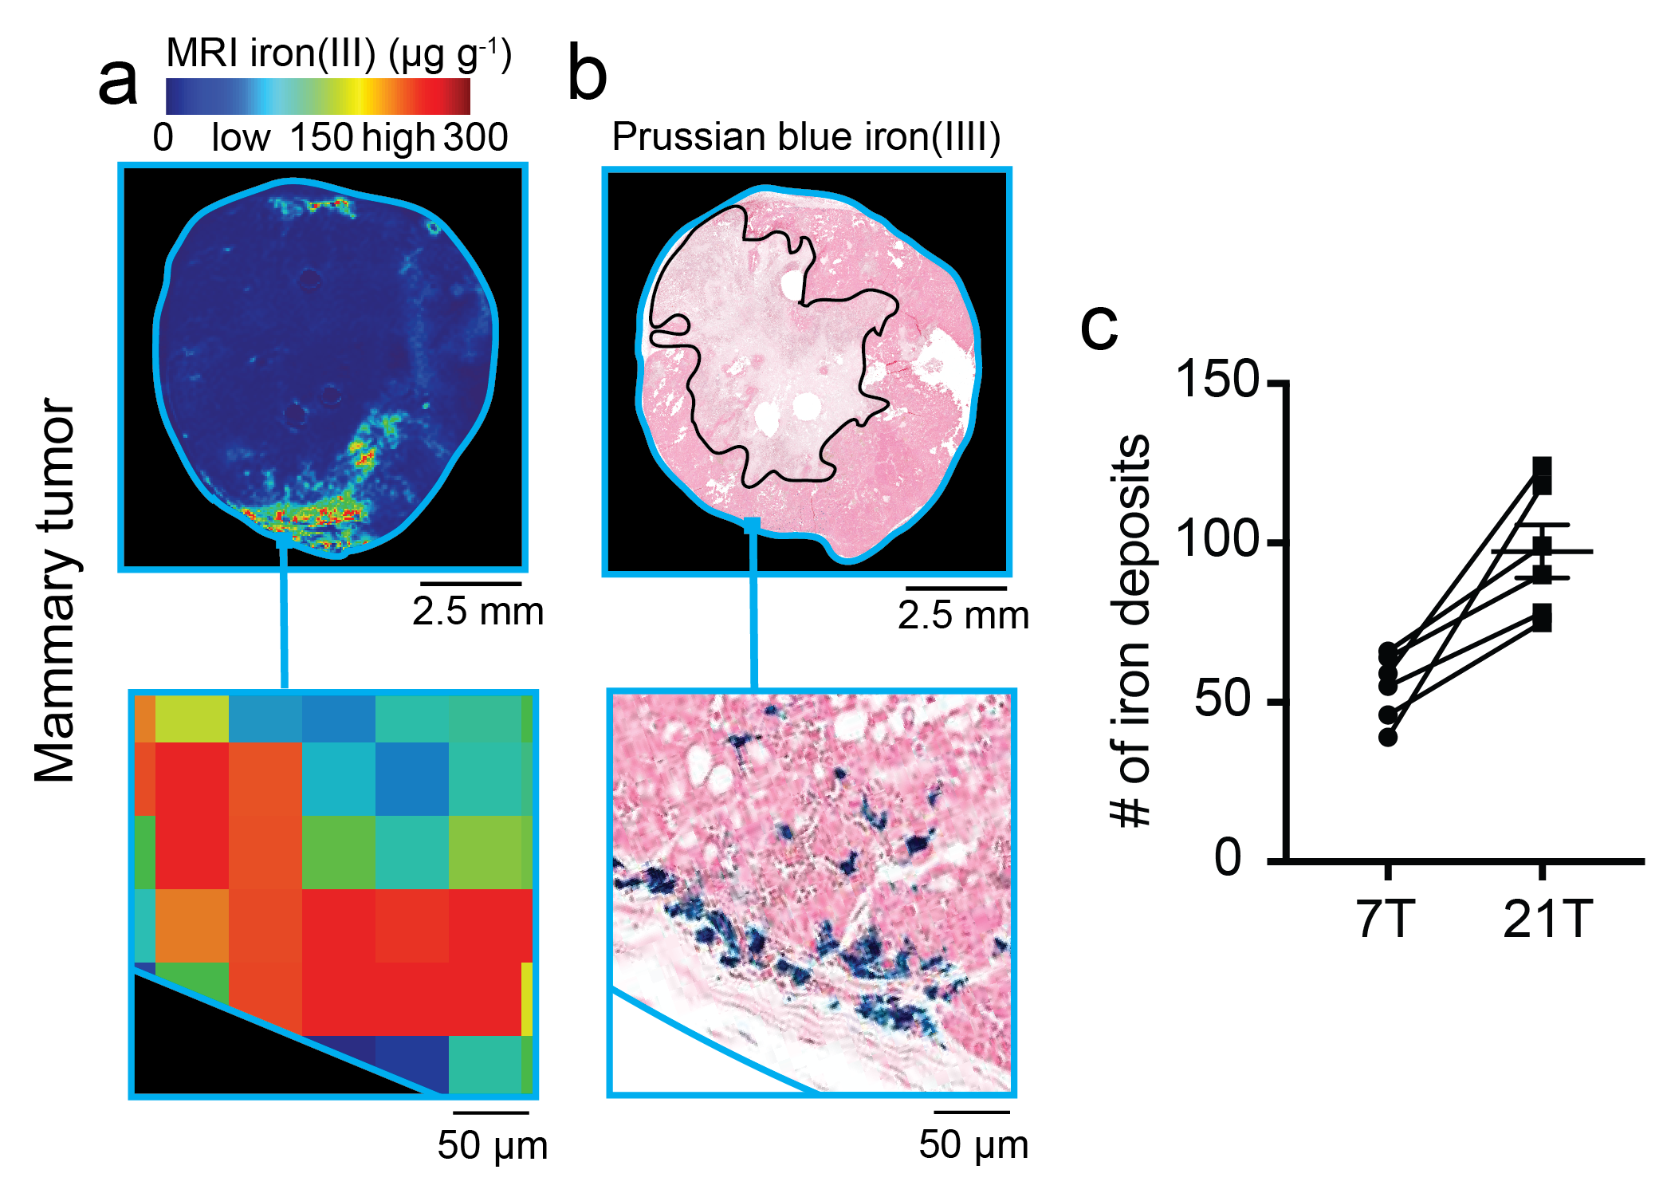
Conclusions
Using the 21.1 T magnet available only at the NHMFL we confirmed high-field sensitivity gains for macrophage iron deposits leading to their enhanced detection in tumors. These observations confirm our previous findings connecting iron and macrophage deposition in prostate and breast cancer [1-2], and further supports the use of iron MRI as a metabolic immune cell imaging method with high-translational potential to provide non-invasive macrophage “biopsy” in cancer.

Acknowledgements
A portion of this work was performed at the National High Magnetic Field Laboratory, which is supported by National Science Foundation Cooperative Agreement No. DMR-1157490 and the State of Florida. Additional support provided by NIH 1F32CA206277.
Figure 1. (a) Iron MRI map (b) Prussian blue iron(III) histology, and (3) field-dependent counts of iron macrophage deposits confirm the sensitivity of MRI relaxometry for macrophage deposits in breast tumors, and reveal that the ultrahigh 21T field enhances their detection compared to 7T.

References
[1] Leftin, A., et al., PLoS One, 12(9), e0184765 (2017).
[2] Leftin, A., et al., Sci Rep, 7(1), 11632 (2017).

