Fluorine-19 Magnetic Resonance at 21.1 Tesla to Detect Brain Inflammation

Waiczies, S. (Max Delbruck Center for Molecular Medicine, Berlin Ultrahigh Field Facility); Rosenberg, J.T. (NHMFL); Prinz, C., Starke, L., Millward, J.M., Delgado, P.R. and Pohlmann, A. (Max Delbruck Center for Molecular Medicine, Berlin Ultrahigh Field Facility); Brey, W.W. (NHMFL); Kuehne, A. and Waiczies, H. (MRI Tools GmbH) and Niendorf, T. (Max Delbruck Center for Molecular Medicine, Berlin Ultrahigh Field Facility)

Introduction
Neuroinflammation can be monitored with ¹⁹F MRI using ¹⁹F-nanoparticles (NPs) that label immune cells in vivo. The migration of these cells into the brain can then be studied in animal models of multiple sclerosis^{1,2}. The low abundance of ¹⁹F nuclei in vivo poses a major challenge for MR detection in neuroinflammation. The theoretical SNR gain including increases in noise from sample and coil losses is about SNR∝ B₀^{1.75} for solenoidal coils³. Recognizing these opportunities and challenges, we investigated the influence of 21.1 T on ¹⁹F relaxation times and SNR gain, compared to 9.4 T.
Experimental
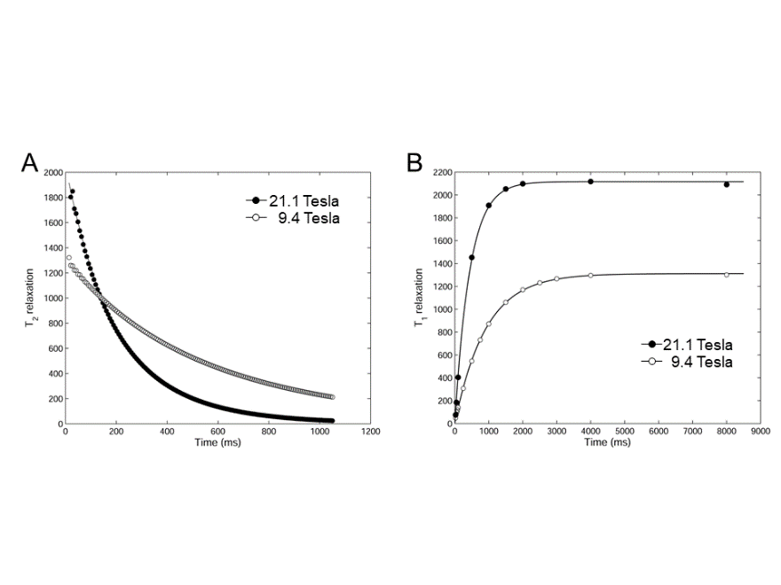
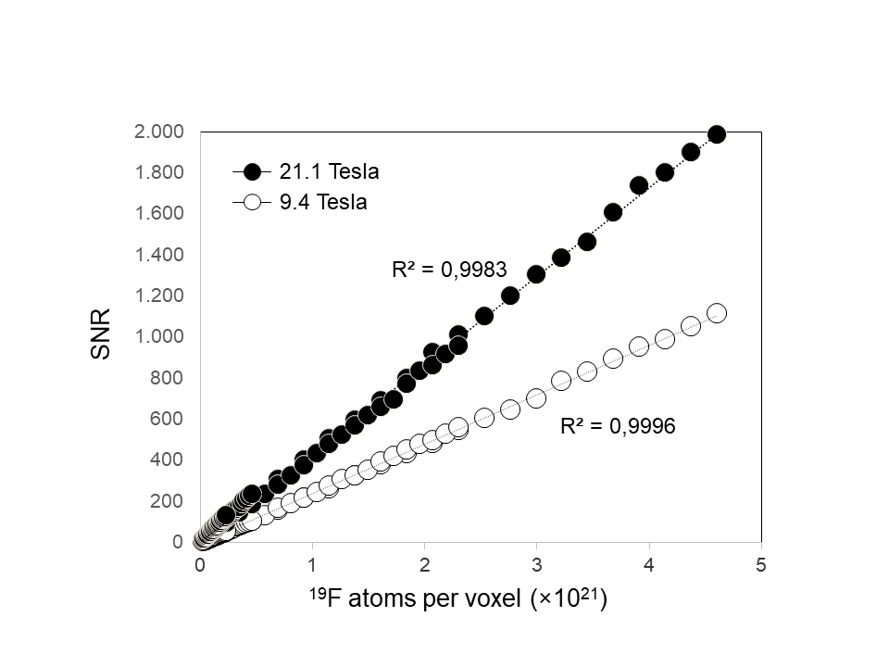
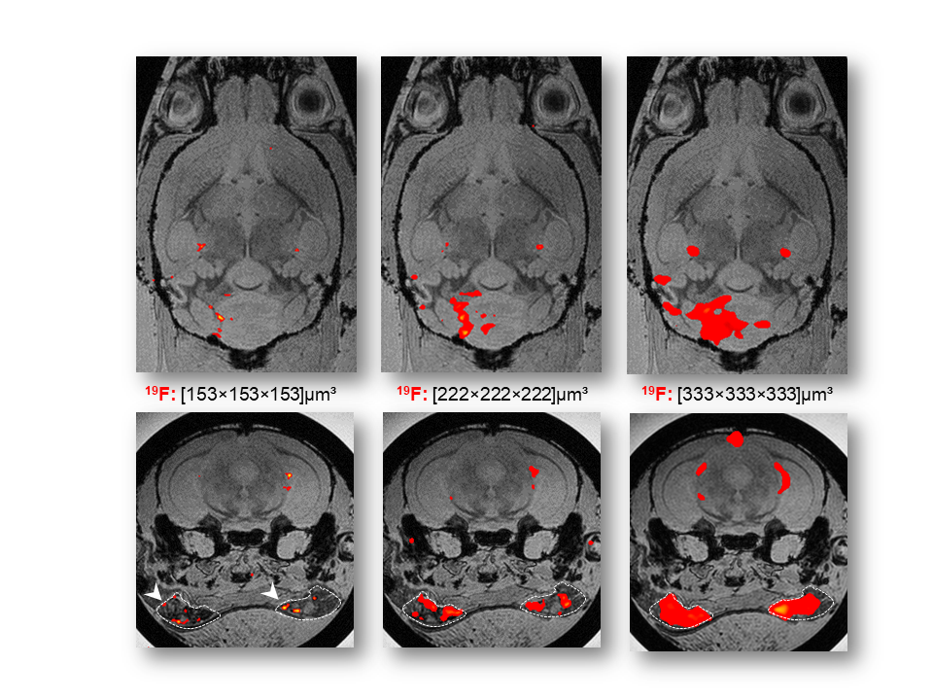
Experiments were carried out on the 21.1 T at the NHMFL and a 9.4 T scanner at the Berlin Ultrahigh Field Facility (B.U.F.F.) using similar birdcage coils (ω_{(1H/19F)} at 21.1 T=900/845 MHz and at 9.4 T=400/376 MHz) and parameters. For relaxation and SNR measurements, tubes of ¹⁹F-NPs (perfluoro-15-crown-5-ether)⁴ dilutions were submerged in saline. T₁ and T₂ mapping was performed on spin echo sequences using one 10-mm axial slices (FOV=30x30mm) with varying repetition times (TR) or echo times (TE). SNR was calculated on an axial 2D-RARE images (TR/TE=4000/9.1ms, slices=1-10mm). Animal experiments were carried out in accordance with local animal welfare protocols. EAE was induced in SJL/J mice and ¹⁹F NPs were administered daily for five days after which mouse tissue was prepared for ex vivo MRI. 3D ¹⁹F RARE sequence was acquired at low (matrix=90x60x60), medium (matrix=135x90x90) and high (matrix=135x90x90) resolution. A FLASH ¹H image was acquired as an anatomical reference to the ¹⁹F image.
21.1 T: T₂ = 195 ms
9.4 T: T₂ = 503 ms
21.1 T: T₁ = 441 ms
9.4 T: T₁ = 913 ms
C
D
Results and Discussion
Both T₁ and T₂ values for the ¹⁹F NPs were influenced by B₀. The transverse relaxation was decreased at 21.1 T (Fig 1A). T₁ of the ¹⁹F NPs decreased by nearly 50% at 21.1 T (Fig 1B), contrary to ¹H T₁ relaxation. For SNR measurements, slice thickness was varied and SNR was obtained as a function of the number of ¹⁹F atoms per voxel (Fig 1C). An SNR gain of 2.1 was achieved at 21.1 T versus 9.4 T using parameters optimized for 9.4 T. High resolved MRI of EAE mice at 21.1 T revealed a greater level of detail of the immune cell migration in the inflamed brain and draining lymph nodes (Fig 1D).
Conclusions
Our data demonstrate the feasibility of ¹⁹F MRI at 21.1 T for detecting inflammation in the brain and adjacent lymphatic system with higher SNR and as a result higher spatial definition. The shortened T₁ is unexpected but consistent with previous studies^{5,6}. The difference in the experimental SNR gain (2.1) and the maximum expected SNR gain (2.8) can be explained by coil and receive chain losses as well as preamplifier noise variations between both setups.
Fig.1A: Signal decay vs. TE yielding T_{2.} Fig 2B: Signal increase vs. TR yielding T₁. Fig 2B: Plots of SNR vs. ¹⁹F atoms per voxel at the two field strengths. Fig 2C: ¹⁹F MRI of an ex vivo EAE mouse brain acquired at 21.1 T and at different spatial resolutions with FLASH images as anatomical reference.
Acknowledgements
A portion of this work was performed at the NHMFL, which is supported by NSF (DMR-1157490) and the State of Florida. The NHMFL Visiting Scientist program also provided travel funding to SW and HW (#269).
References
[1] Waiczies, H., et al., Scientific Reports, 3,1280 (2013). [2] Stadelmann, C., CurrOpinNeurol (2011).
[3] Hoult, D.I., et al., JMagn Reson, 24, 71-85 (1976). [4] Waiczies, H., et al., PloS one, 7, e21981 (2011).
[5] Kadayakkara, D.K., et al., J Magn Reson, 242, 18-22 (2014).
[6] Duong, T.Q., et al., Magn Reson Med, 45, 61-71 (2001).

