Smart Thermosensitive Liposomes for Effective Solid Tumor Therapy and in vivo Imaging at 21.1 T

Affram, K. and Singh, M.S. (FAMU, Pharmacy); Krishnan, S. (U. of Texas, MD Anderson Cancer Center); Reams, R. (FAMU, Pharmacy); Rosenberg, J.T. (NHMFL) and Agyare, E. (FAMU, Pharmacy)

Introduction
MRI has proven to be promising in the diagnosis of early stage tumors (1).Traditional Gd chelates for tumor visualization (2) suffers from rapid extravasation into the extracellular compartment. This translates into a very narrow window for image acquisition. Gemcitabine (Gem) is a drug often used to treat pancreatic cancer (PCa) but suffers from lack of tumor specificity, poor membrane permeability and biochemical instability. Thermosensitive liposomes (TSL) have the potential to overcome these obstacles by providing triggered drug release under conditions of mild hyperthermia. Here, we developed a novel thermosensitive liposomal nanoparticle (TSLnp) capable of carrying Gem and labeled with Gd for in vivo MRI tracking.
Experimental
TSLnp and Gd-TSLnps were prepared as previous reported (3-5). For phantoms, Gd-TSLnps were diluted in ratios of 1:1, 1:5, 1:10 and 1:100. Each dilution was mixed with equal parts of 2% agarose and injected into micro-capillary tubes. MRI was performed on the 21.1 T vertical magnet using a 10-mm birdcage for phantom and ex vivo imaging. Measurements were set up to quantify R₁ (1/T₁) and R₂ (1/T₂) relaxation using SE-RARE sequence with 100x100μm in-plane resolution, with varying the repetition times (TR) and echo times (TE) respectively. The relaxivity was calculated as a function of Gd concentration. For in vivo experiments, the animals were sedated and implanted with a PCa (MiaPaCa-2) tumor in right hind limb. Prior to MRI the animals were injected intraperitoneal with either Gd or Gd-TSLnp just before insertion into the magnet. To probe in vivo contrast and relaxation of either Gd only or Gd-TSLnp, a 32-mm birdcage coil was used. T₁ maps were acquired with a SE-RARE sequence using six incrementing TRs with 250x210 μm in-plane resolution. Dynamic SNR changes were measured with a Turbo SE-RARE sequence using TE/TR=6/1500ms and 90x90 μm in-plane resolution.
Table 1. Relaxation and relaxivity
Results and Discussion
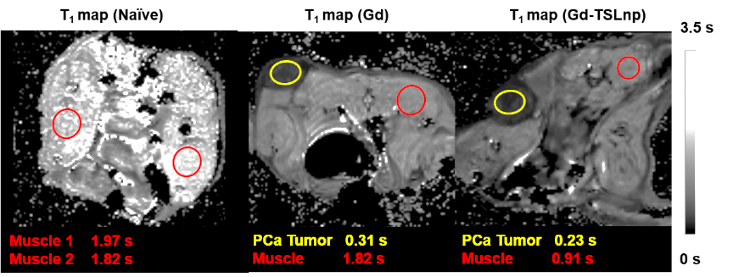
Longitudinal relaxivity was 0.11 s⁻¹mM⁻¹ while transverse relaxation was determined to 1.53 s⁻¹mM⁻¹ as seen in Table 1. In fixed ex vivo tumor tissue no contrast is seen for any time point post injection with Gd only while the Gd-TSLnp show clear hyperintense contrast in the tumor excised after 30 min post injection. The T₁ contrast did not stay in tumors at 60 and 90 min post injection (3). T₁ maps of implanted Gd-TSL-np show 800 ms lower T₁ relaxation in the tumor compared to animals injected with Gd only suggesting higher uptake with the Gd-TSLnp (Fig 1). Dynamic SNR measurements show lack of specificity to the tumor with free Gd, indicating the often seen Gd release to the blood stream followed by re-uptake by the tumor.
A
B
C
Conclusions
This study shows that TSLnps can be used as a drug delivery system for poor membrane permeable drugs and provide MRI contrast in the tumor. The TSLnps is targeting the PCa to deliver both Gem and Gd. To fully evaluate the contrast enhancement capability of Gd-TSLnps, future studies aim to optimize TSLnps for higher Gd payload and to further evaluate dynamic SNR changes in the minutes just after administration of Gd-TSLnp using tail vein injection inside the vertical magnet.
Fig 1: In vivo T₁-maps of naïve mouse and mouse with PCa tumor at 50 min post injection of either Gd only of Gd-TSLnp contrast agent
Acknowledgements
All animal experiments were approved by FSU/FAMU IACUC. Financial support from NIH 5G12MD007582-32 and 5P20CA192990-03. Work was performed at the NHMFL under NSF DMR-1157490 and the State of Florida.
References
[1] Hanada., K., et al., . J Gastroenterol, 50, 147-54 (2015).
[2] Ketan, B., et al., PLoS One, 4, e7628, (2009).
[3] Affram, K., et al., PLoS One , 2, e0185116 (2017).
[4] Udofot, O., et al., Integr Cancer Sci Ther, 2, 245-52 (2015).
[5] Ghaghada, K., et al., Academic Radiology, 15,1259-63 (2008).

