Mapping Perivascular Connectome in Whole Rat Brain in 3D

Sarntinoranont, M. (UF, Mech. & Aerospace Eng); Mareci, T.H. (UF, Biochemistry); Kulam, M. (UF, Mech. & Aerospace Eng); King, M.A. (UF, Pharmacology); Yarrow, J. (Gainesville VA)

Introduction
Perivascular spaces (PVS) are annular gaps that exist between cerebral blood vessels and brain parenchyma. In the absence of lymphatic vessels in the brain, several studies have established that metabolic wastes in the brain extracellular space are transported along these spaces propelled by cardiac pulsations (Iliff et al., 2012; Xie et al., 2013). Abnormalities in the perivascular pathway have been implicated in neurodegenerative disorders such as Alzheimer’s (Iliff et al., 2012) and syringomyelia (Brodbelt et al., 2003). In this study, we have obtained a high-resolution 3D reconstruction of the perivascular network in the rat brain for the first time. The obtained network can be used to simulate transport along these spaces, and further the understanding of perivascular neuropathologies.

Experimental
Experiments were performed on male Sprague-Dawley rats weighing 280-300 g using protocols and procedures approved by the University of Florida Institutional Animal Care and Use Committee. 60 μL of (Gd-DTPA)₃₅ human serum albumin (Robert Brasch’s laboratory, University of California, San Francisco, USA) tagged with Evans blue dye was delivered at 1.5 μL/min into the lateral cerebroventricle of rats anesthetized with 1.5% isoflurane in 1 L/min oxygen. Following the 40-minute infusion, the animal was immediately exsanguinated through transcardial injection of 0.9% saline and fixed with 4% paraformaldehyde. Whole body was stored at 4ºC for 2-2.5 days to complete the fixation process following which the brain was dissected and transferred to fluorinert oil for MR imaging.
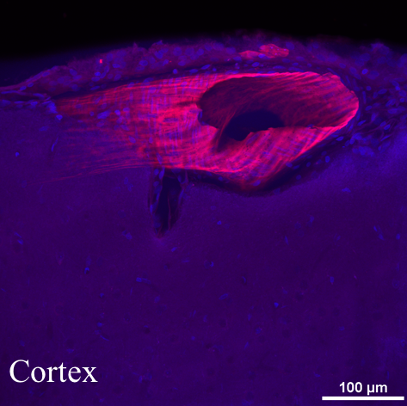
MR measurements were performed at Advanced Magnetic Resonance Imaging & Spectroscopy facility using a Bruker Avance III imaging console connected to 17.6 T vertical bore magnet system with Bruker Micro2.5 gradient system and 21 mm ID quadrature transmit/receive Doty Litzcage probe, data was collected with ParaVision 6.0 (Bruker NMR Instruments, Billerica, MA). Perivascular spaces were visualized using 40 μm isotropic T₁ -weighted 3D spoiled and phase re-wound gradient echo sequence with TR = 100 ms, TE = 3 ms, flip angle = 50º, 20 x 16 x 12 mm³ FOV, matrix size of 500 x 400 x 300, 7 averages with spatial saturation bands added to prevent ghosting artifact from water trapped in the gauze surrounding the brain outside the FOV. The acquired images were processed in FSL using the rBET plugin to extract the brain from the remaining gauze, and PVS network was reconstructed in 3D using maximum intensity projection.

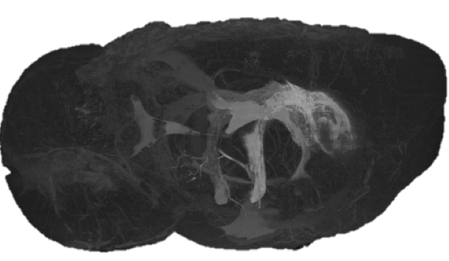
Results and Discussion
The results clearly show the perivascular uptake of Gd-albumin mostly on the ventral surface of the brain following infusion into the lateral ventricles [see Figure to the right]. Such a distribution was previously observed following intrathecal injection of Gd-DTPA, however the cause was unknown (Iliff et al., 2013). Presence of the tracer in PVS was confirmed using confocal fluorescence imaging of a brain slice after MRI [see Figure on top]. Further analysis of the obtained perivascular network connectivity might shed some light on the solute transport along this pathway.

Acknowledgements
A portion of this work was performed at the National High Magnetic Field Laboratory, which is supported by National Science Foundation Cooperative Agreement No. DMR-1157490 and the State of Florida. In addition, this work was partly funded by Chiari & Syringomyelia Foundation (http://www.csfinfo.org/) and supported by resources provided by the North Florida/South Georgia Veterans Health System, Gainesville, FL. The contents do not represent the views of the U.S Department of veterans Affairs or the United States Government.

References
Brodbelt, A.R. et al., 2003. Eur. Spine J. 12, 300–6.
Iliff, J.J. et al., 2012. Sci. Transl. Med. 4, 147ra111.
Iliff, J.J. et al., 2013. J. Clin. Invest. 123, 1299–309.
Xie, L. et al., 2013. Science 342, 373–7.

