Altered bioenergetics in skeletal muscle of young mdx mice

Guice, K. (UF, Physical Therapy); Lopez, C. (UF, Physical Therapy); Zeng, H. (UF, AMRIS); Walter,, G.A. (UF, Physiology and Functional Genomics); Forbes S.C. (UF, Physical Therapy)

Introduction
Duchenne muscular dystrophy (DMD) is an X-linked genetic disorder that affects one in 3,500 male births, and is due to a deficiency in the protein dystrophin on the membrane of muscle fibers (Hoffman et al. 1987). ³¹Phosphorus magnetic resonance spectroscopy (³¹P-MRS) has revealed several metabolic differences between dystrophic and unaffected skeletal muscle (Heier et al., 2014; Percival et al., 2013). However, how metabolic status is affected at a young age during the peak inflammatory phase in mdx mice is unclear. Therefore, in this study we compared mdx to wild-type mice at a young age using ³¹P-MRS.

Experimental
³¹P-MRS data were acquired in male wild-type (n =5) and B10-mdx (n=5) at 6-8 weeks of age using an 11.1 T MR system with a Bruker spectrometer at the Advanced Magnetic Resonance Imaging and Spectroscopy (AMRIS) facility of the University of Florida. Data from the posterior compartment of the left lower hindlimb were acquired at rest and during and following stimulated muscle contractions. Muscle contractions were performed at the rate of 5 Hz for 2 min with 10 min recovery. PCr peaks were fit using principal component analysis. The time constant of PCr recovery (PCrτ) was calculated using a mono-exponential equation.

Results and Discussion
At rest, the ratios of inorganic phosphate (Pi) to phosphocreatine (PCr), phosphomonoesters (PME) to ATP, and phosphodiesterases (PDE) to ATP are elevated in B10-mdx compared to wild-type (Figure 1). Furthermore, PCr recovery was slower in B10-mdx (PCrτ = 216.2 ±13.2s) than wild-type (156.3±10.0s). No differences were observed between groups in pH at rest or at end of exercise.

Conclusions
Overall, our results indicate that metabolic status of dystrophic muscle as assessed with ³¹P-MRS is altered in young mdx mice. The slower PCr recovery in B10-mdx may be due to reduced oxygen delivery and metabolism, possibly as a consequence of lack of nNOS (Sander et al. 2000; Nelson et al. 2015).

Acknowledgements
A portion of this work was performed at the National High Magnetic Field Laboratory, which is supported by National Science Foundation Cooperative Agreement No. DMR-1157490 and the State of Florida. In addition, support was provided NIH/NIAMS R01AR070101.

References
- Hoffman et al. Cell. 51 (6), 919-928, 1987.
2. Heier et al. PLoS One, 12;(11):e112477, 2014.
3. Percival et al., Hum Mol Genet.: 1;22(1):153-67, 2013.
4. Sander et al. Proc Natl Acad Sci U S A.: 5;97(25):13818-23, 2000.
5. Nelson et al. Neurology:10;82(23):2085-91, 2014.
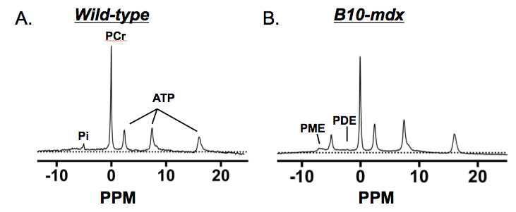
Fig.1. Example ³¹P spectra acquired at 11.1 T in a control (A) and B10-mdx mouse (B). Note the increased inorganic phosphate (Pi) and phosphomonoesters (PME) and reduced phosphocreatine (PCr) in mdx compared to wild-type.

