Neurite Orientation Dispersion and Density Imaging (NODDI) reveals in vivo microstructural alterations produced by synthetic psychoactive cathinone drug

Colon-Perez, L.M., Pompilus, M., Agan, V.A. (UF Psychiatry); Yang, T., Redler, T.Malphurs, W., Zubcevic, J.(UF Physiological Sciences); Febo, M. (UF Psychiatry)

Introduction: There is an alarming rise in the number of synthetic cathinones (bath salts) available for illicit use. Among these, methylenedioxypyrovalerone (MDPV) shows high abuse potential and is associated with severe adverse behavioral effects. The neurobiological basis for the adverse effects of MDPV use is not well understood but has been associated with profound inflammatory effects, which are similarly observed with chronic use of other amphetamine-like drugs. To directly measure the potential impact of MDPV administration on microstructural and cellular/subcellular organization we used Neurite Orientation Dispersion and Density Imaging (NODDI). In addition to providing useful data on neuroinflammation/edema related free water, these magnetic resonance imaging (MRI) acquisition and analysis approaches provide diffusion based metrics reflecting cellular, neurite and axonal dispersion environments. A major objective of this research was to determine the effects of chronic MDPV on white and grey matter microstructural integrity in cortical and limbic brain regions.
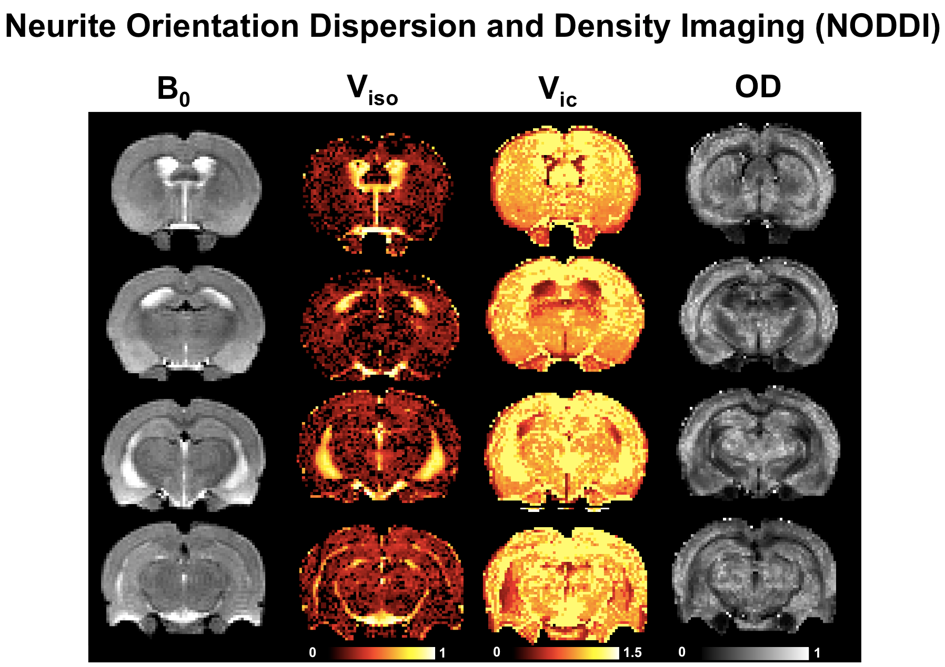
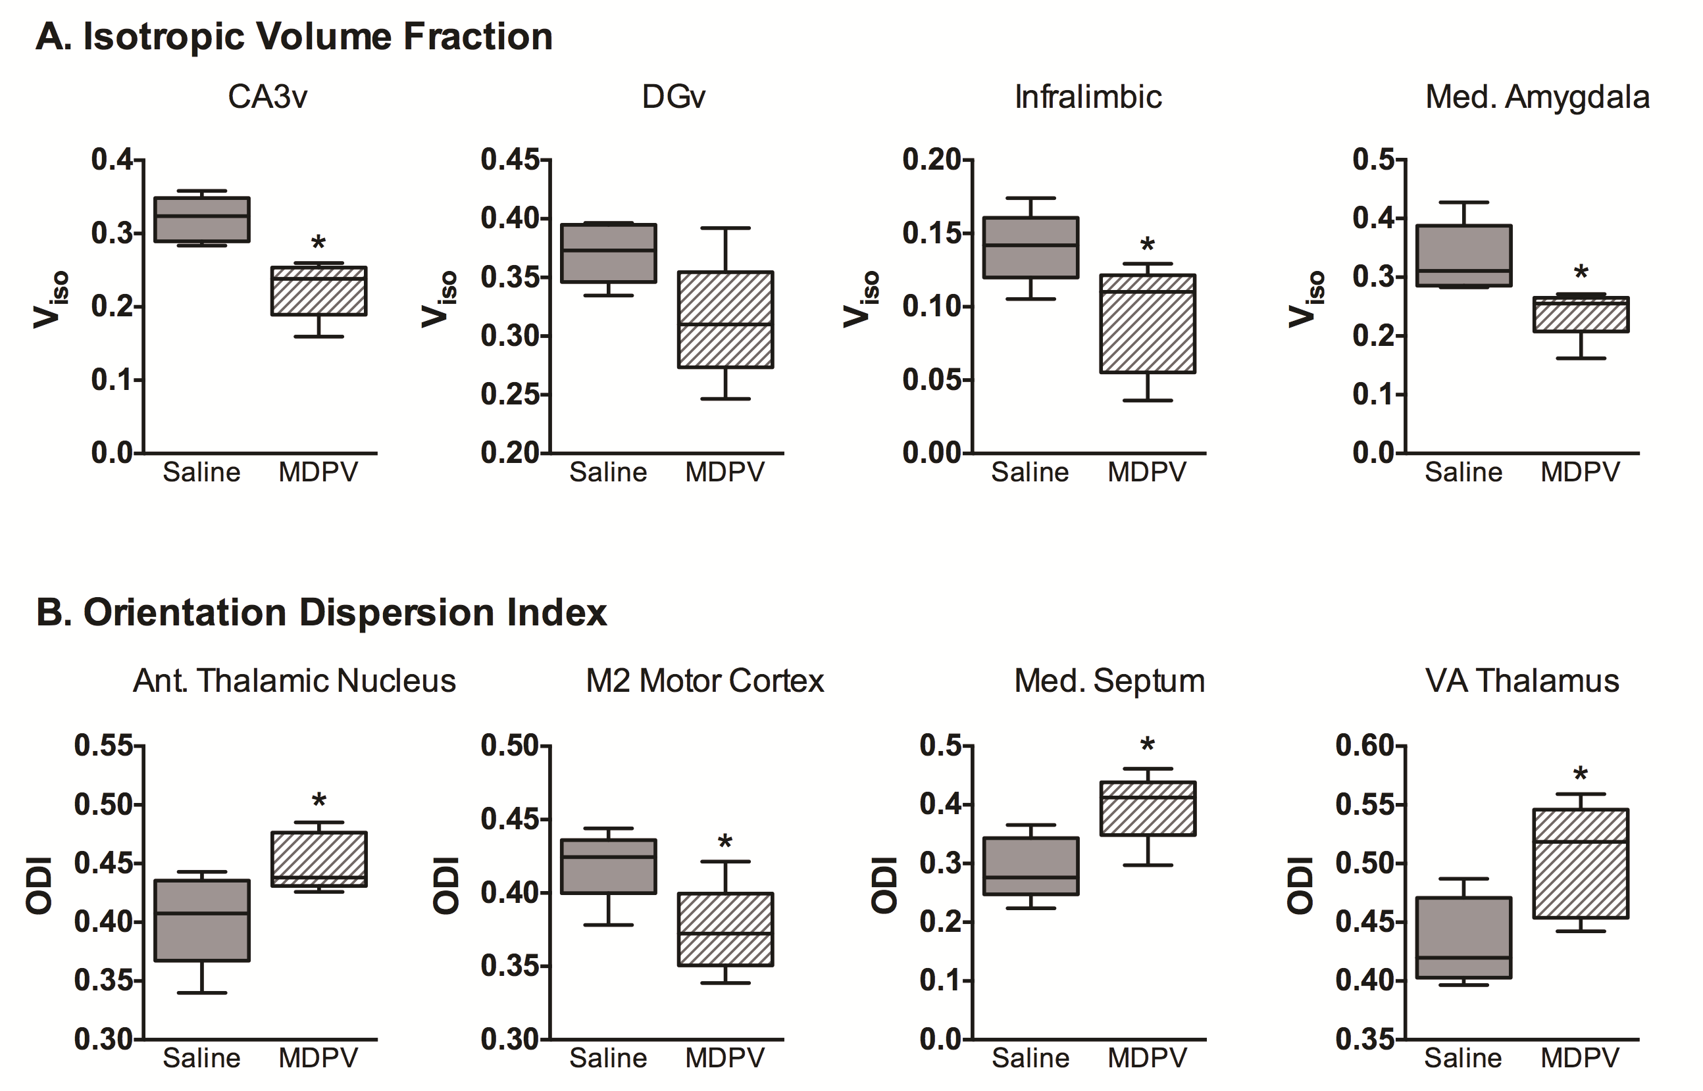

Figure 1. (Top) Representative subject scan showing various metrics for neurite (axon and dendrite) density and orientation dispersion and isotropic diffusion volume fraction. (Bottom) NODDI results for various regions of the rat brain.

Experimental: Male Long Evans rats (300-400g) were treated with repeated MDPV (1 mg/kg) or saline vehicle for consecutive 5 days. 24 hours after the last injection, diffusion weighted images (DWI) were acquired with an 8-shot spin echo echo-planar imaging (EPI) sequence (TR = 5.0 s and TE = 39 ms) with the following geometric parameters: 32.5 x 32.5mm² in plane, 12 slices at 1.5mm thickness per slice, data matrix = 128 x 128 (254 μm in-plane resolution). The diffusion scan consisted of two shells of diffusion weighting. A total of six diffusion direction scans were acquired with b = 500 s/mm² and thirty diffusion directions with b = 1200 s/mm² (Δ = 15.0 ms, and δ = 5.0 ms) and 2 images without diffusion weighting (b = 0), and 4 averages per DWI. Anatomical scans for image overlay and reference-to-atlas registration were collected using a fast spin echo sequence (TR = 2.0 s; TE = 45 ms; RARE factor = 8; number of averages = 10) with the following geometric parameters: 32.5 x 32.5mm² in plane, 12 slices at 1.5mm thickness per slice, data matrix = 256 x 256 in plane for a resolution of 127 μm.
Results and Discussion: Consistent with our postmortem analysis, we measured changes in various NODDI values that suggest profound changes associated with increased neuroinflammation (Figure 1). Isotropic volume fraction in hippocampus, prefrontal cortex and amygdala were reduced, an effect that might relate hindered diffusion in these regions (possibly associated with increased immune cell presence in these regions.
Conclusions: Our initial results show the feasibility of conducting NODDI in live rat. Furthermore, the results of this diffusion MRI analysis suggests microstructural changes in the brain as a result of MDPV exposure, which might be associated with inflammatory effects of this drug.
Acknowledgements: Funded by NIH/NIDA Grant DA038009. LCP is funded by a MBI postdoc fellowship and a UF MINDS travel fellowship. The authors also thank the Advanced Magnetic Resonance Imaging and Spectroscopy (AMRIS) facility for their support (National Science Foundation Cooperative Agreement No. DMR-1157490 and the State of Florida).
References: Zhang et al (2012) Neuroimage, 61(4): 1000-1016.

