DREADDs-induced functional connectivity in a rat model of trigeminal pain

Colon-Perez, L.M. (UF Psychiatry); Rohrs, E. (UF Dentistry); Levites, Y., Golde, T. (UF Neuroscience), Febo, M. (UF Psychiatry); Neubert, J.K. (UF Dentistry)

Introduction : Changes in large-scale neural connectivity could be potential useful markers for trigeminally-mediated orofacial pain. Unique disorders of the orofacial region, such as trigeminal neuralgia, suggest novel modulatory signaling within the neuraxis from the trigeminal nerve to central processing centers such as the nucleus caudalis, thalamus, and somatosensory cortex. Recent advances in designer receptors exclusively activated by designer drugs (DREADD) along with advances in functional MRI offer a unique opportunity to study this circuitry and topological changes that underlie large-scale network alterations due to facial pain. In this study, we determined how activating and inhibiting DREADDs, delivered via AAV, altered functional connectivity in rats following chronic nerve constriction of the infraorbital nerve.
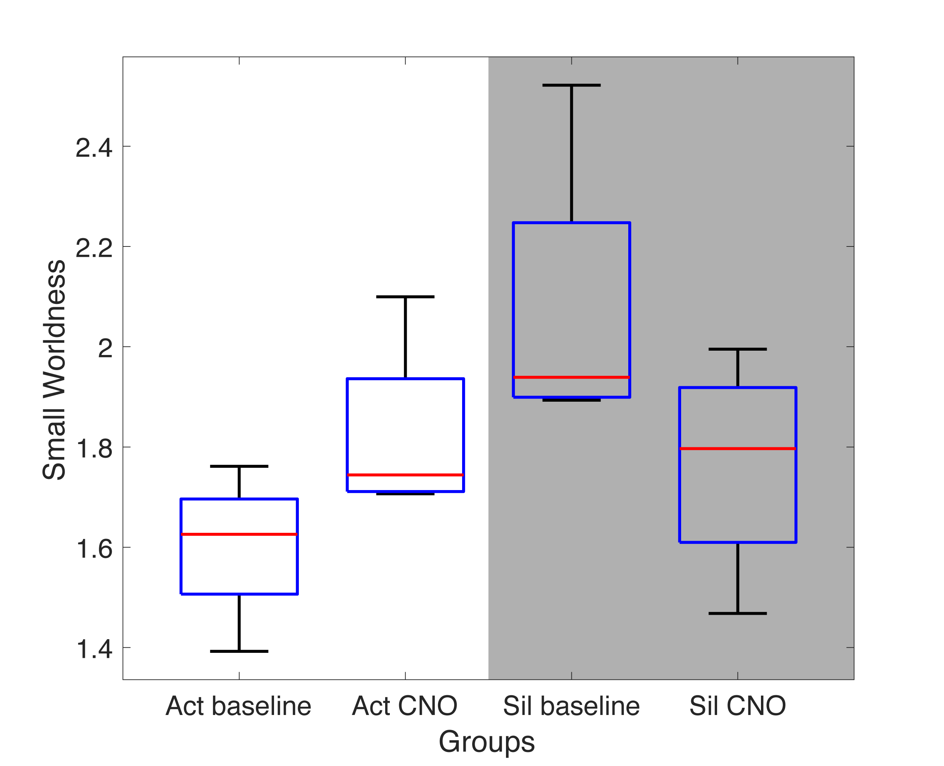
Figure 1. Small worldness results. Paired t tests did not find any statistical difference between baseline and after activating receptors (p_{act} = 0.17, p_{sil} = 0.31). No between-groups were performed.

Experimental: Hairless Sprague Dawley rats (female, 300g), were scanned in a 4.7 Tesla Agilent system. A resting state fMRI dataset was collected at baseline (injected with vehicle, DMSO) and a second scan after 45 minutes of injection of CNO (to activate receptors), in a cohort of rats with: activating DREADDs, and inhibiting DREADDs. A 2-shot spin echo EPI sequence was acquired with acquisition parameters for a total acquisition time of 10 mins (an image was acquired every 2s). Time series fMRI signals were extracted from each region of interest (ROI) based on the atlas-guided seed location (150 total areas). The correlation values of the graphs were thresholded for each subject to create matrices with equal densities (e.g the top 15% correlation values). Network matrices were normalized by the highest correlation value, such that all matrices had edge weight values ranging from 0 to 1. The networks were quantified with the following graph theory metrics: node strength (sum of edge weights), and small worldness (topological organization of high clustering among nodes and short number of edges between any node).
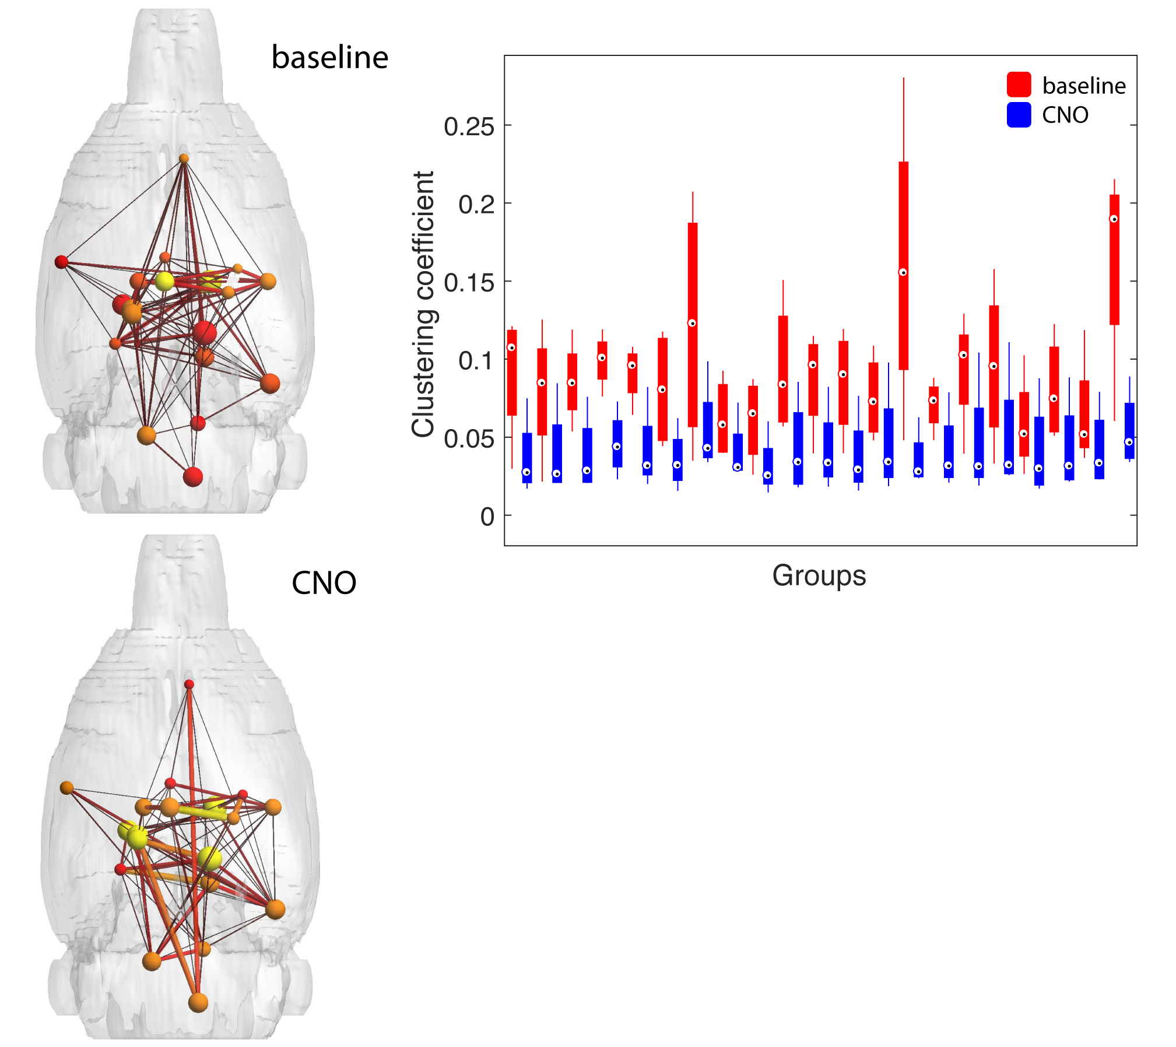
Figure 2. Largest differences in clustering coefficient (p < 0.1). After correction for multiple comparisons significance was lost, probably due to small sample size and complex pathway mechanisms of DMSO. No between-groups were performed.

Results and Discussion: Rats with activating DREADDs showed a decrease in the node strength compared to baseline while the inhibiting DREADDs showed an increase in node strength. Meanwhile, the small worldness had an opposite effect, activating DREADDs showed an increase in the small worldness index while inhibiting DREADDs showed a decrease in small worldness.
Conclusions: This seems to imply that facial pain induces reorganization changes in connectivity strength and topological organization. Inhibiting DREADDs favors increasing in connectivity at the expense of a more inefficient organization (i.e. reduced small worldness), while activating DREADDs favors the more efficient organization while also reducing brain connectivity.
Acknowledgements: A portion of this work was performed at the AMRIS Facility of the NHMFL, which is supported by NSF Cooperative Agreement No. DMR-1157490, the State of Florida. This work was supported by: Facial Pain Research Foundation, University of Florida McKnight Brain Institute
References:
[1] Filippi, et.al. Lancet Neuro (2013) doi: 10.1016/S1474-4422.
[2] Armbruster, et.al. PNAS (2007) doi: 10.1073/pnas.0700293104.
[3] Gomez, et.al. Science (2017) doi: 10.1126/science.aan2475

