Beyond Structural Biology to Functional Biology: Solid-State NMR Experiments and Strategies for Understanding the M2 Proton Channel Conductance

Qin, H. (FSU, Chemistry & Biochemistry); Miao, Y. and Cross, T.A. (FSU, Chemistry & Biochemistry, NHMFL) and Fu, R. (NHMFL)

Introduction
In terms of structural biology, solid-state NMR experiments and strategies have been well established for resonance assignments leading to the determination of three-dimensional structures of insoluble membrane proteins in their native-like environment. It is also known that NMR has the unique capabilities to characterize structure-function relationships of membrane-bound biological systems beyond structural biology. The question is how to extract the functional information beyond the structural information. Here, we report on solid-state NMR experiments and strategies for extracting functional activities on a sub-msec time scale. Specifically, we use the His37-labeled full length M2 (M2FL) protein of Influenza A virus embedded in synthetic lipid bilayers as an example to characterize the proton conduction mechanism and kinetics [1].
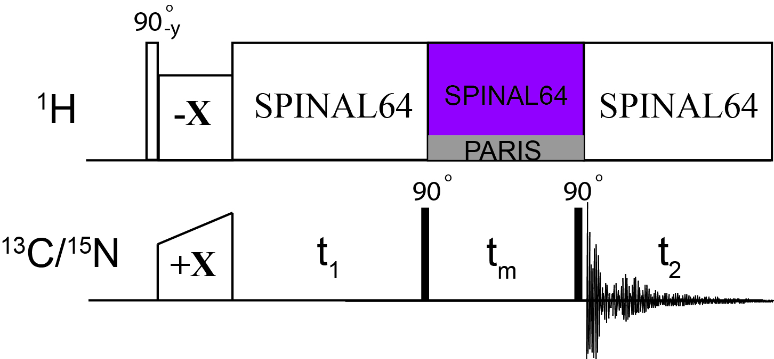
Fig. 1. Pulse sequence used for 2D homonuclear correlation experiments. During the mixing time t_{m}, three different irradiation methods are applied: PARIS (grey) and SPINAL64 (purple).
Experimental
High-resolution solid-state MAS NMR spectra were acquired on a 63 mm mid-bore 800 MHz magnet equipped with a Bruker Avance console using a NHMFL low-E double-resonance ¹H-¹⁵N biosolids MAS probe. The reverse labeled ¹³C,¹⁵N H37-labeled M2 mutant (H57,90Y) at pH 5.8 was reconstituted in liposomes. Slow chemical exchange and spin diffusion are two main mechanisms that result in cross-peaks in homonuclear chemical shift correlation experiments. Chemical exchange spectroscopy (EXSY) represents kinetic processes within molecules and can only be manipulated by temperature, not by any experimental techniques. On the other hand, spin diffusion primarily depends on through-space homo-nuclear dipolar interactions and can be manipulated by experimental techniques, as shown in Fig. 1.
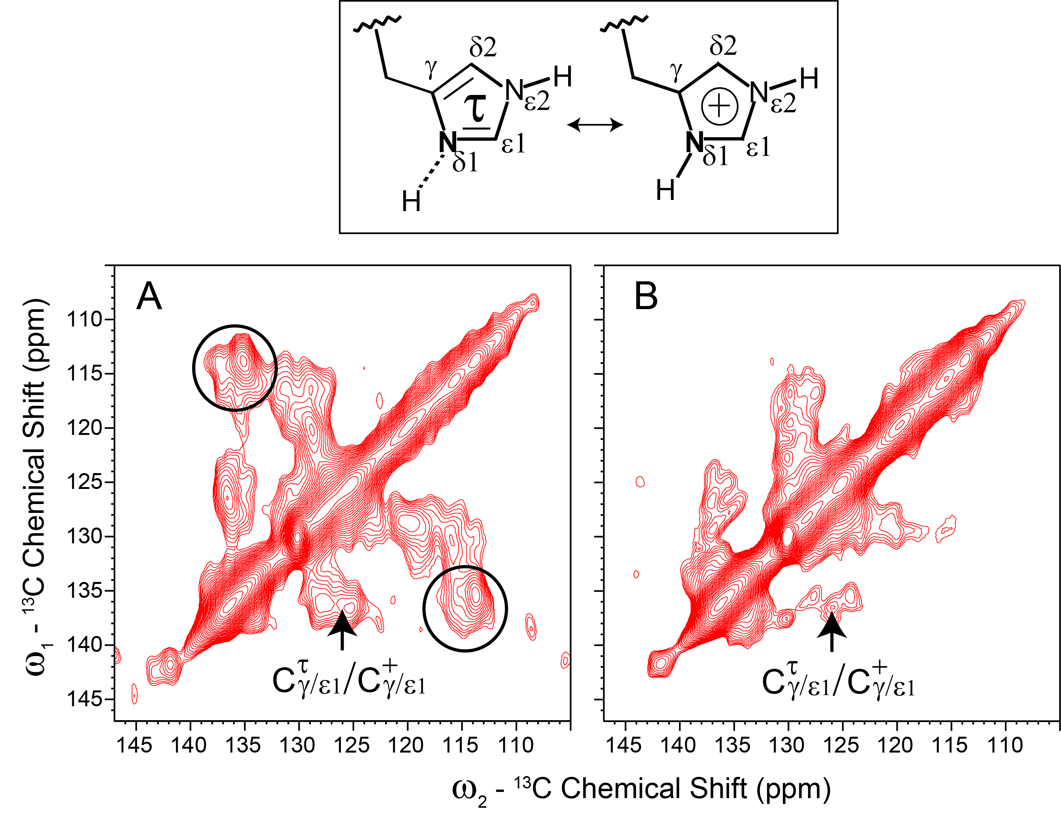
Fig. 2. (Top) Schematics for the τ and charged histidine sidechains. (Bottom) Aromatic/aromatic region of 2D ¹³C-¹³C correlation spectra of the His37-labeled M2FL (pH 5.8) in DOPC/DOPE liposomes with a mixing time of 20ms, during which the PARIS (A) and SPINAL64 (B) irradiation were applied on the ¹H channel. The circled regions indicate the cross peaks between Cγ/ε1(τ) and Cδ2(τ) from the His37(τ) residues.

Results and Discussion
Fig. 2 shows the aromatic/aromatic region of the 2D ¹³C-¹³C correlation spectra of the His37-labeled M2FL protein (pH 5.8) in DOPC/DOPE lipid bilayers with a mixing time of 20 ms. Since the ¹³C-¹³C spin diffusion is relatively efficient when mediated by abundant protons via the PARIS irradiation [2], the connectivity for all carbons in close vicinity may be established with a short mixing time (e.g. 20 ms) (c.f. Fig. 2A). However, when the protons are decoupled by the SPINAL64 irradiation, the proton mediation is effectively cut off such that the spin diffusion from one carbon to others become insufficient, thus the buried chemical exchanged peaks could be observed (c.f. Fig. 2B). Our results present convincing evidence for the formation of imidazolium-imidazole hydrogen-bonds in the His37 tetrad at low pH and that these hydrogen bonds have a low barrier that facilitates the proton conduction mechanism in the M2FL protein.

Acknowledgements
This work was supported by NIH AI119178 and AI023007. A portion of this work was performed at the NHMFL, which is supported by NSF Cooperative Agreement No. DMR-1157490 and the State of Florida.

References
[1] Qin, H., et al., J. Phys. Chem. B, 121, 4799-4809 (2017).
[2] Weingarth, M., et. al., Chem. Phys. Lett., 469, 342-348 (2009).

