Triple Quantum MR Signals From 9L Glioma Cells

Schepkin, V.D. (NHMFL); Levenson, C. (FSU, Biomedical Sciences); Neubauer, A. (Heidelberg U., Germany, Physics) and Gottwald, E. (Karlsruhe Institute of Technology, Germany, Institute for Biological Interfaces)

Introduction
MR signals from living cells can provide unique information about cell functioning. A variety of isolated cells can be investigated using a bioreactor that supports cellular functioning for a long time. It is a major advantage of bioreactors relative to in vivo experiments that the bioreactor allows a wide range of interventions. The main challenge in such experiments is the weak MR signals emitted from the cells. A bioreactor compatible with the 21.1T magnet is under construction now. Here we present the first attempt to detect sodium MR signals from tumor cells. The 9L glioma cells were chosen for our experiments which are used in many tumor model in vivo experiments. The selectivity of sodium MR signal from cells, relative to solution, was achieved using a triple quantum method [1].

Experimental
9L glioma cells were placed into a 15 mL vial containing HEPES-buffered complete DMEM media (approx. 1x10⁶). There was no perfusion; the media in vials was enough to support cells during our short experiments. MR experiments were performed using the 21.1 T magnet (Tallahassee) and the Na/H double tuned RF coil. The triple quantum experiments were performed using a time proportional phase increment (TQTPPI) Fig. 1. The duration of the 90^{ᵒ} RF pulses was 95 µs, time increment step was 0.2 ms, and the number of steps was 760. The number of accumulations was 4 and the total scan time was 28 min.

Results and Discussion
The TQTPPI spectrum (Fig. 2) reveal sodium bound to tumor cells. The TQ peak has a frequency exactly three times more than the single quantum peak (SQ) frequency. The SQ peak represents the total sodium signal from the media and cells, while the TQ signal represents sodium interacting with tumor cells. This signal is capable to detect changes of intracellular sodium in tumor cells [2].
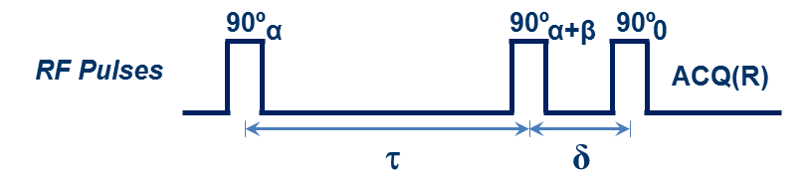
Fig.1 TQTPPI pulse sequence. Increment τ = ns*Δ, α = ns*45^{ᵒ}, β = ±90^{ᵒ}, R = 0^{ᵒ}, ns = 760.
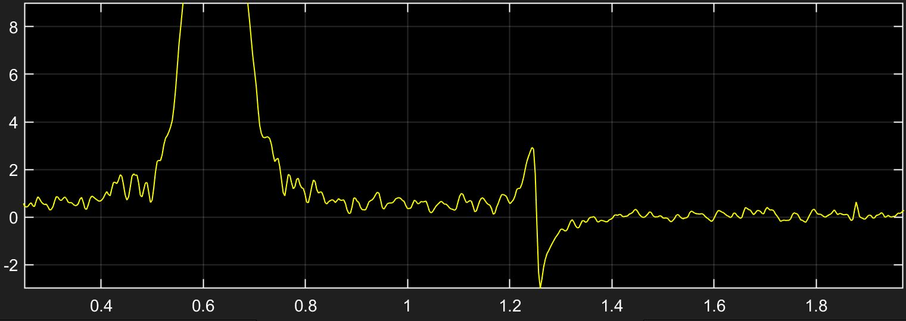
TQ
DQ
SQ

Fig.2 Sodium TQTPPI spectrum from 9L glioma cells.
Conclusions
Sodium TQ MR signal can be detected from a small amount of 9L cells. Further optimization will follow to optimize the TQ signal and the amount of cells to make it available as a new capability.

Acknowledgements
A portion of this work was performed at the NHMFL, which is supported by NSF DMR-1157490 and the State of Florida. In addition, this work was supported by the Heidelberg University to A.N.

References
[1] Schepkin, V.D., et al., J Magn Reson, 277, 162-168 (2017).
[2] Schepkin, V.D., et al., Magn Reson Med, 39, 557- 563 (1998).

