Optogenetic excitation of neurons in the prefrontal cortex that express oxytocin receptors eliminates preference for social novelty in male mice

Tan, Y., Hiller, H., Harden, S., Nguyen, D.-T. (UF Pharmacodynamics); Colon-Perez, L.M., Febo, M. (UF Psychiatry); Wang, L., Cahill, K. (UF Pharmacodynamics); de Kloet, A.D. (UF Physiology/Genomics); Frazier, C.J. and Krause, E.G. (UF Pharmacodynamics)

Introduction: Oxytocin is currently in clinical trials for a variety of neurodevelopmental disorders, including autism spectrum disorder and schizophrenia; however, the brain circuits underlying its therapeutic effects remain unknown. The prefrontal cortex (PFC) densely expresses oxytocin receptors (OTR) that may mediate the effects of oxytocin on social behavior. Here, we use the Cre-LoxP system in mice with anatomical, electrophysiological, functional imaging and optogenetic approaches to discern whether excitation of OTR-expressing neurons in the PFC influences social behavior.
Experimental: Male mice with expression of Cre recombinase driven by the promoter for the OTR gene (OTR-Cre mice) were delivered Cre-inducible adenoassociated virus producing channelrhodopsin-2 and enhanced yellow fluorescent protein (AAV-ChR2-eYFP) into the PFC. Viral delivery revealed that 45% and 27% of OTR-expressing neurons in the PFC were glutamatergic or GABAergic, respectively. Retrograde tract-tracing, in conjunction with in vitro optogenetics, found that OTR-expressing PFC neurons send glutamatergic projections to the nucleus accumbens, bed nucleus of the stria terminalis and basolateral amygdala (BLA). Functional magnetic resonance imaging confirmed that in vivo optogenetic stimulation of OTR-expressing neurons evoked stimulation-correlated BOLD signal increases in the PFC and subcortical nuclei including the BLA. To assess the function of OTR-expressing PFC neurons, OTR-Cre mice were administered AAV-ChR2-eYFP or control virus and chronically implanted with fiber optics targeting the PFC. Subsequently, mice were evaluated in the social interaction (SI) and social novelty paradigms, novel object recognition test (NOR), elevated plus maze (EPM) and open field (OF).
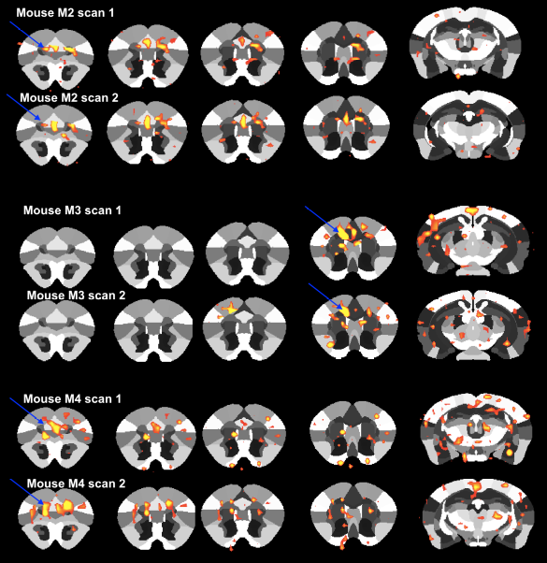
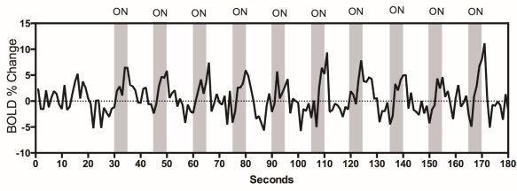
Figure 1. (top) In vivo optical stimulation of OTR expressing neurons in the PFC elicits changes in the BOLD signal. (bottom) BOLD signal changes occurred during light-stimulating stages.

Results and Discussion: In vivo optogenetic stimulation of OTR-expressing PFC neurons abolished preference for social novelty (n=6 per group; Control: P<0.01; ChR2: P=0.4). Intriguingly, this effect appears to be specific to a social stimulus because in vivo optogenetic stimulation of OTR-expressing PFC neurons had no effect on the NOR test or performance in the EPM, OF, or SI tests.
Conclusions: Collectively, our results suggest that OTR-expressing neurons in the PFC comprise a neuronal network that can be manipulated to modulate preference for social novelty.
Acknowledgements: National Institutes of Health HL122494(EGK), HL096830(EGK), MH104641(CJF), HL125805(ADK). LCP is funded by a MBI postdoc fellowship and a UF MINDS travel fellowship. The authors also thank the Advanced Magnetic Resonance Imaging and Spectroscopy (AMRIS) facility for their support (National Science Foundation Cooperative Agreement No. DMR-1157490 and the State of Florida).

References: Peris et al (2017) J Comp. Neurol. 525(5): 1094-1108.

