¹⁷O MRI of Rat Head at 21.1 T

Schepkin, V.D. (NHMFL); Levenson, C.W. (FSU, College of Medicine); Neubauer, A. (Heidelberg U., Germany, Physics); Schuch, C., Glaeser, T. and Kievel, M. (NUKEM GmbH, Germany, Trading Isotopes); Ranner, S., Brey, W.W. and Helsper, S. (NHMFL) and Schad, L. (Heidelberg U., Germany, Computer Assisted Clinical Medicine)

Introduction
The importance and potential of ultra-high magnetic field MRI for humans (up to 20 T) is under investigation across-the-board [1]. Detecting ¹⁷O is an attractive and promising goal of utilizing MRI at ultra-high magnetic fields and is expanding our capability to conduct non-invasive in vivo MR imaging. The power of the ultra-high magnetic field of 21.1 T is demonstrated below by performing 3D ¹⁷O MRI at natural abundance of oxygen (0.037%) in 25 min. Thus, a variety of labeled ¹⁷O substances can be monitored with high resolution 3D MR imaging.

Experimental
The MR experiments were performed using the 21.1 T magnet and Bruker MRI Avance III console. The in vivo RF probe has a double tuned ¹⁷O/¹H volume RF coil with an internal diameter of 33 mm, covering a rat head. The MR frequency for ¹⁷O was 121.65 MHz. 3D MR imaging of a rat head was accomplished using a modified Bruker UTE pulse sequence with radial sampling having a matrix size =80x112x56, using FOV=64x64x64 mm, TR = 15 ms, TE = 0.2 ms, NA= 16, Scan time = 25 min. The effect of labeled ¹⁷O-water was observed using an injection of PBS solution with a final ¹⁷O enrichment of 17%. All animal experiments were conducted according to the protocol approved by the Florida State University ACUC.

Results and Discussion
The ultra-short echo time MR images of rat head using ¹⁷O demonstrate many anatomical features and the background level of MR signal intensity, which can be successfully used for calibration of ¹⁷O MR signals (Fig. 1).
The ¹⁷O labeling expands our capability to perform in vivo research using non-invasive MR imaging.
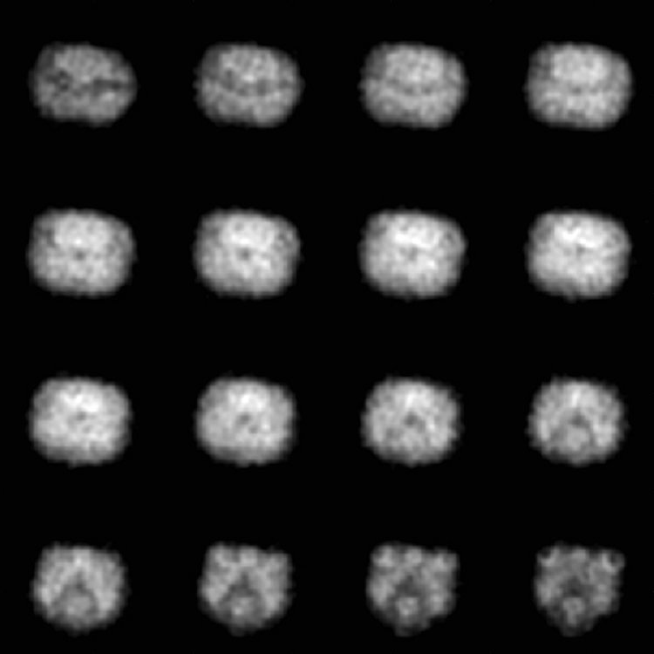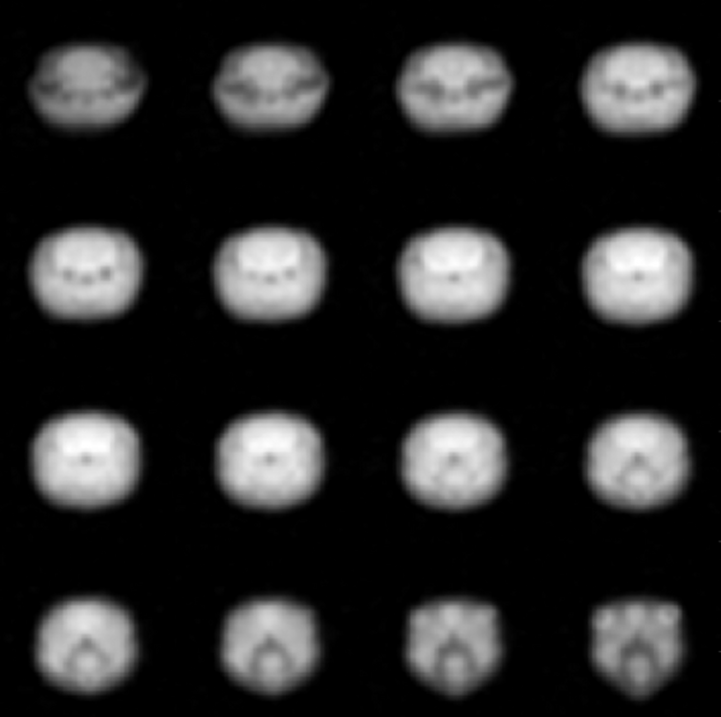

Fig.1 ¹⁷O 3D MRI of rat head (left, natural abundance) and 1.5 hours after 1 mL bolus injection of ¹⁷O-water (right). Scan time was 25 min in both cases and resolution of 1x1x1 mm.

Conclusions

The ¹⁷O MR 3D imaging with resolution of 1x1x1 mm is feasible in a rat head for natural abundance of oxygen and labeled ¹⁷O compounds. The higher voltage capability of the RF probe allowed for minimizing the loss of ¹⁷O MR signal during in vivo experiments by achieving a 90 º RF pulse of 120 µs for ¹⁷O.

Acknowledgements
A portion of this work was performed at the National High Magnetic Field Laboratory, which is supported by the National Science Foundation Cooperative Agreement No. DMR-1157490 and the State of Florida, as well as, funding from Heidelberg University. Many thanks to Jason Kitchen for his prompt help with RF coils during arcing.

References
[1] Budinger, T.F., et al., MAGMA, 29(3), 617-639 (2016), Review.

