Molecular and spectroscopic characterization of water extractable organic matter from thermally altered soils reveal insight into disinfection byproduct precursors

Cawley, K.M. (CU Boulder, NEON); Hohner, A.K. (CU Boulder); Podgorski, D.C. (Mag Lab); Cooper, W.T. (FSU); Korak, J. and Rosario-Ortiz, F.L. (CU Boulder)

Introduction
This study focused on the characterization of the quantity and quality of water extractable organic matter (WEOM) from laboratory leaching experiments of unheated and oven heated soils in order to determine how thermal alteration influences the spectroscopic properties, molecular characteristics and reactivity of WEOM. Three different temperatures (225, 350, and 500 °C) were used that correspond to minimal organic matter loss, moderate organic matter mass loss, and nearly complete organic matter loss under high temperatures. WEOM leachates of heated and unheated soils were analyzed for dissolved organic carbon (DOC) concentration, UV-Visible absorbance, fluorescence, molecular size distribution, disinfection byproduct (DBP) formation potential, and elemental composition by ultrahigh resolution mass spectrometry and compared to one another. This work is relevant to the study of the impact of wildfires on water quality.

Experimental
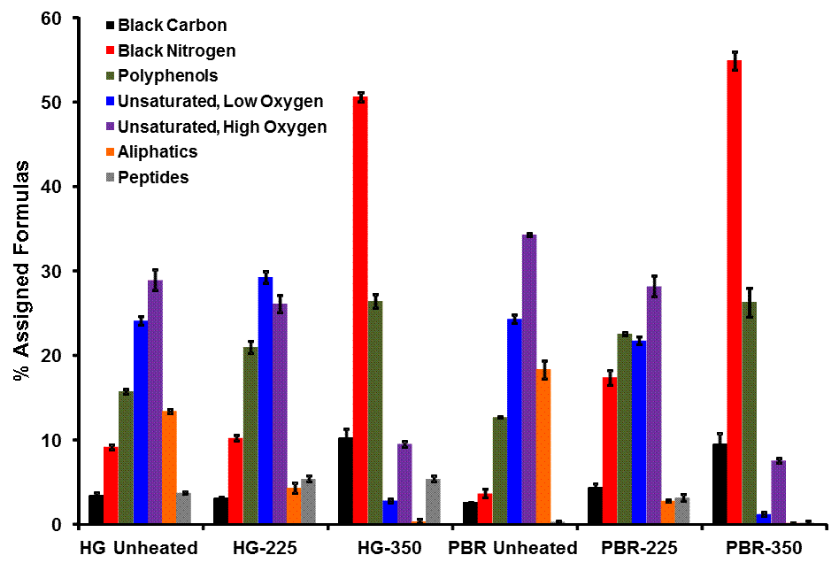
Soil samples were collected from two sites within the Cache la Poudre (CLP) Watershed in northern Colorado where the Hewlett Gulch and High Park Fires burned a portion of the watershed in 2012. Soil samples were placed in ceramic evaporating dishes in a pre-heated muffle furnace for 2 hours under oxic conditions at one of three temperatures; low (225 °C), moderate (350 °C) and high (500 °C), which have been shown to lead to low, moderate, and high (i.e., nearly complete) mass losses of organic matter, respectively. Leachates were acidified to pH ~2 and solid phase extracted with PPL Bond Elut (Agilent) resin cartridges, which were eluted in methanol. Each extract was diluted in methanol to a final concentration of 200 µg C/mL and analyzed in triplicate by direct infusion negative-ion electrospray ionization ((-) ESI) coupled to a custom-built Fourier transform ion cyclotron resonance (FT-ICR) mass spectrometer equipped with a 9.4 Tesla 220 mm room-temperature bore superconducting magnet (Oxford Instruments, Abingdon, U.K.).

Results and Discussion
The soils heated to 225 °C leached the greatest DOC and had the highest C- and N-DBP precursor reactivity per unit carbon compared to the unheated material or soils heated to higher temperatures. The molecular weight of the soluble compounds decreased with increasing heating temperature. There were clear differences in molecular assignments as shown in Fig. 1. Compared to the unheated soil, the haloacetonitrile yields (μg/g/DOC) were higher for leachates of the soils heated to 350 °C, whereas trihalomethane, haloacetic acid and chloropicrin yields (include units) were not. Soluble N-containing compounds comprised a high number of molecular formulas for leachates of heated soils, which may explain the higher yield of haloacetonitriles for heated soil leachates compared to unheated soil leachates. Overall, heating soils altered the quantity, quality, and reactivity of the WEOM pool. These results may be useful for inferring how thermal alteration of soil by wildfire can affect water quality.
Fig.1Bar graph of % assigned formulas of each class for the unheated, low (225 ˚C) and moderate temperature (350 ˚C) leachates.

Acknowledgements
A portion of this work was performed at the National High Magnetic Field Laboratory, which is supported by National Science Foundation Cooperative Agreement No. DMR-1157490 and the State of Florida. Funding for the project was also provided by grants from the Water Research Foundation to CU (WRF 4524) and Department of Energy to FSU (DE-SC0012272).

References
[1] Cawley, et al., Environmental Science and Technology, 51, 771-779 (2017).

