Climate driven carbon and microbial signatures through the last ice age

D’Andrilli, J., Smith, H.J., Dieser, M. and Foreman, C.M. (MSU)

Introduction
Here we present organic matter (OM) molecular composition and microbial community structure from the Byrd Station (Byrd) and West Antarctic Ice Sheet Divide deviation #3 (WD_3) ice core sections from the Last Glacial Maximum (LGM) and last deglaciation (LD) periods. Stringent next generation sequencing protocols and Fourier transform ion cyclotron resonance mass spectrometry (FT-ICR MS) were applied in concert with bulk characterization metrics to link deep ice core OM molecular composition and microbial assemblages to different climate periods.

Experimental
Ice cores were decontaminated, melted, and aliquoted for a suite of biological and chemical analyses including: major ion and organic matter concentrations, bacterial cell abundances, next generation sequencing (DNA extraction and PCR amplification), fluorescent OM spectroscopy, and OM molecular composition analysis by Fourier transform ion cyclotron resonance mass spectrometry (9.4 T FT-ICR MS, ICR Facility at the NHMFL).

Results and Discussion
Microbial assemblages and organic matter (OM) composition from Byrd and WD_3 ice cores may serve as palaeoecological markers from the Last Glacial Maximum (LGM; section ~20.5 ka BP) and last deglaciation periods (LD; section ~14.5 ka BP), reflecting environmental changes. Fluorescent analyses determined OM from both cores to have similar amino acid-like signatures; however, more comprehensive molecular characterization showed only 12 % overlap in molecular formulae, with Byrd OM being more chemically labile. Microbial diversity in both cores was low, and together with predicted metabolic capabilities, differed significantly between communities. Variation in OM composition and microbial diversity reflects changes in environmental sources and deposition patterns onto the Antarctic Ice Sheet during distinct climate periods (Fig. 1), with OM composition potentially shaping microbial communities post-deposition.

Conclusions
Distinct chemical and biological signatures were detected in the Byrd and WD_3 ice cores, unique to each climate period. Major ion concentrations were consistent with values reported for Antarctic ice. Dissimilarities in cell and phylogenetic abundances, and OM concentrations collectively support our view of different deposition patterns onto the Antarctic Ice Sheet during distinct climate periods. Changes in the OM composition between the LGM and LD may further reflect changes in environmental sources. Therefore, similar to other palaeo-ecological materials, OM composition and microbial assemblages in ice preserves past environmental conditions.

Acknowledgements
A portion of this work was performed at the National High Magnetic Field Laboratory, which is supported by National Science Foundation Cooperative Agreement No. DMR-1157490 and the State of Florida. This work was also supported by the NSF through ANT-1141936 and DGE-0654336.

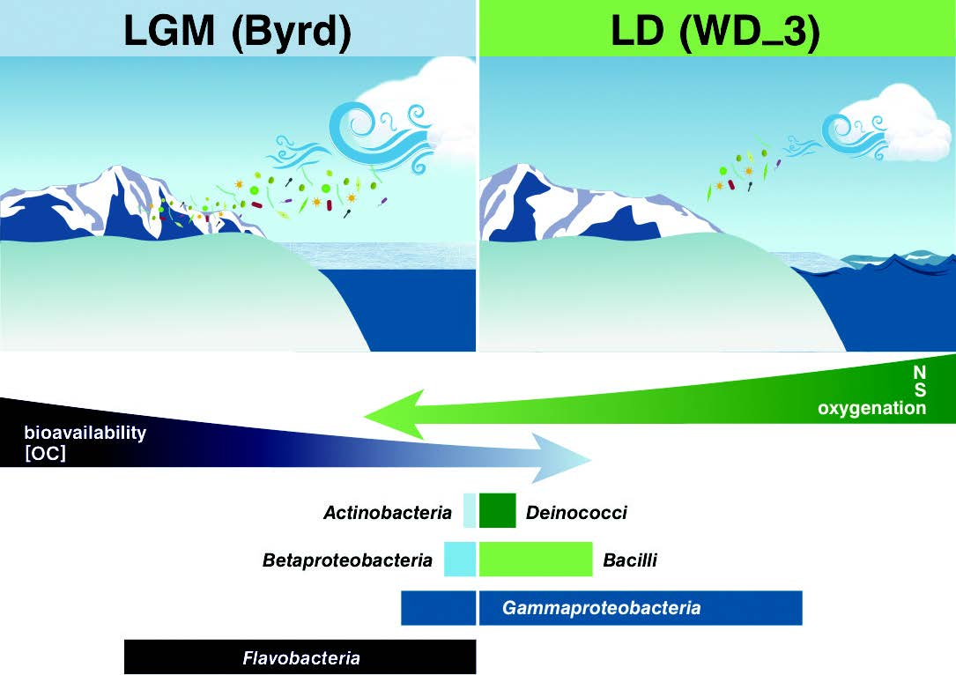

Fig. 1 Antarctic palaeoecological markers of organic matter
and microbial community structure from the LGM and LD.

