New multisensitive materials based on the organic-inorganic hybrid perovskites [TPrA][Mn(dca)₃] and [TPrA][Fe(dca)₃]

Bermúdez-García, J.M., Señarís-Rodríguez, M.A., Sánchez-Andújar, M. (Universidade da Coruña -UDC-, Spain), Yáñez-Vilar, S., Mira, J. (Universidade de Santiago de Compostela -USC-, Spain), Ding, X., Singleton, J.and Zapf, V. (NHMFL-PFF)

Introduction
Dicyanamide-perovskites with general formular [TPrA][M(dca)₃] (M = Mn²⁺, Fe²⁺, Co ²⁺, Ni²⁺) have recently emerged as a new multifunctional family of organic-inorganic hybrids, which show multiple structural and dielectric transitions and pressure-induced responsiveness.^{1,2} In the granted magnet time of 4 days (out of the 14 days requested) we searched for magnetic and magnetoelectric coupling in the Mn compound.

Experimental
Single crystals were grown by a slow evaporation solution technique at UDC. Magnetization (∆M) and electric polarization (∆P) changes were measured as a function of magnetic field (H) at the NHMFL-PFF to 65 Tesla in short pulse magnets. M was measured by the usual method of integrating the voltage induced in a triply-compensated coil during sample in and sample out shots.³ In addition, magnetic susceptibility was measured as a function of temperature (T) at the NHMFL-PFF 14 T physical properties measurement system (PPMS).

Results and Discussion
The ∆M(H) of a [TPrA][Mn(dca)₃] single crystal was measured with the magnetic field oriented parallel and perpendicular to the crystal longer axis. The magnetization was found to be similar in both orientations, and to show an anomaly at T_{t} between 1.25 and 2.1 K. Fig. 1a shows the critical field versus temperature graphic for both orientations of the single crystal, where it can be seen that T_{t} is shifted to lower temperatures upon the application of stronger fields. On the other hand, χ_{molar}T vs T measurements at ZFC on cooling and heating and under the application of μ₀H of 1 T and 5 T parallel to the long axis of the single crystal revealed another magnetic anomaly at T´_{t} related to the structural transition this compound experiences above room temperature, Fig. 1b. Such T´_{t} depends on the measuring conditions and according to preliminary results might also be affected by the strength of the magnetic field, Fig. 1b. Finally, ∆P(H) measurements were performed along different orientations of the crystal axis and the magnetic and electric fields and at different temperatures. Unluckily in these first experiments, no magnetically-induced polarization signal could be detected.
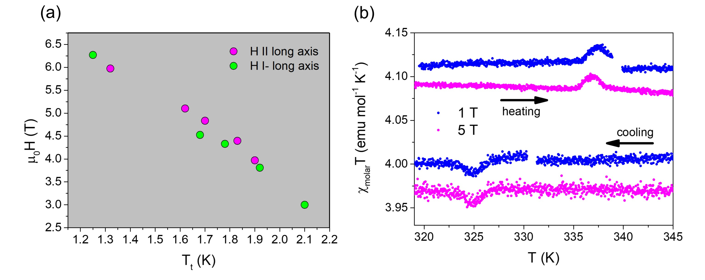
Fig. 1a. μ₀H vs T_{t} phase diagram of the Mn compound measured in both orientations of the crystal. 1b. χ_{molar}T vs T for a single crystal of the Mn compound on cooling and heating at 2 K min⁻¹and under the application of two different magnetic fields (1 T and 5 T) applied parallel to the crystal long axis.
Conclusions
In conclusion, we have started the study of the magnetic properties of the [TPrA][M(dca)₃] family, with the M = Mn²⁺member. We have found magnetic anomalies at low temperatures (below 2.1 K) and near room temperature (~330 K), which encourage further magnetic studies on this new family of hybrid perovskites.

Acknowledgements
A portion of this work was performed at the National High Magnetic Field Laboratory, which is supported by National Science Foundation Cooperative Agreement No. DMR-1157490 and the State of Florida. MINECO and EU-FEDER (ENE2014-56237-C4-4-R) and Xunta de Galicia (GRC2014/042) also supported this work.

References
[1] Bermúdez-García, J. M., et al., Inorganic Chemistry 54, 11680-11687 (2015).
[2] Bermúdez-García, J. M., et al., Journal of Materials Chemistry C 4, 4889 (2016).
[3] J. A. Detwiler, et al, Phys. Rev. B 61, 402 (2000).

