¹⁵N Solid-State NMR Investigations of Heteroanionic Oxynitrides

Haile, S. (Northwestern U., Materials, Science & Education); Marks, T. (Northwestern U., Materials, Science & Education, Chemistry); Tang, M. and Hu, Y.-Y. (FSU, Chemistry & Biochemistry, NHMFL)

Introduction
Materials with multiple anionic species, i.e., heteroanionic materials (HetMs), have shifted traditional structure-property paradigms.¹ New structure types emerge when anions adopt ordered arrangements: local crystalline structure can be systematically tuned, bond iconicity and carrier concentration can be varied, and band and defect structures can be manipulated. Essential to this investigation is the use of advanced tools and techniques that distinguish and differentiate anionic species including F, O, S, and N.² Solid-state ¹⁵N NMR provides critical insight into short-range structural environments of the substituents and reveal structural defects induced by substitution in N-containing HetMs. In this work, ¹⁵N NMR is employed to probe how N substitutes for O in metal oxides to form metal oxynitrides (M_{a}O_{b}N_{c}) and how disruptive structures correlate with technologically important properties.

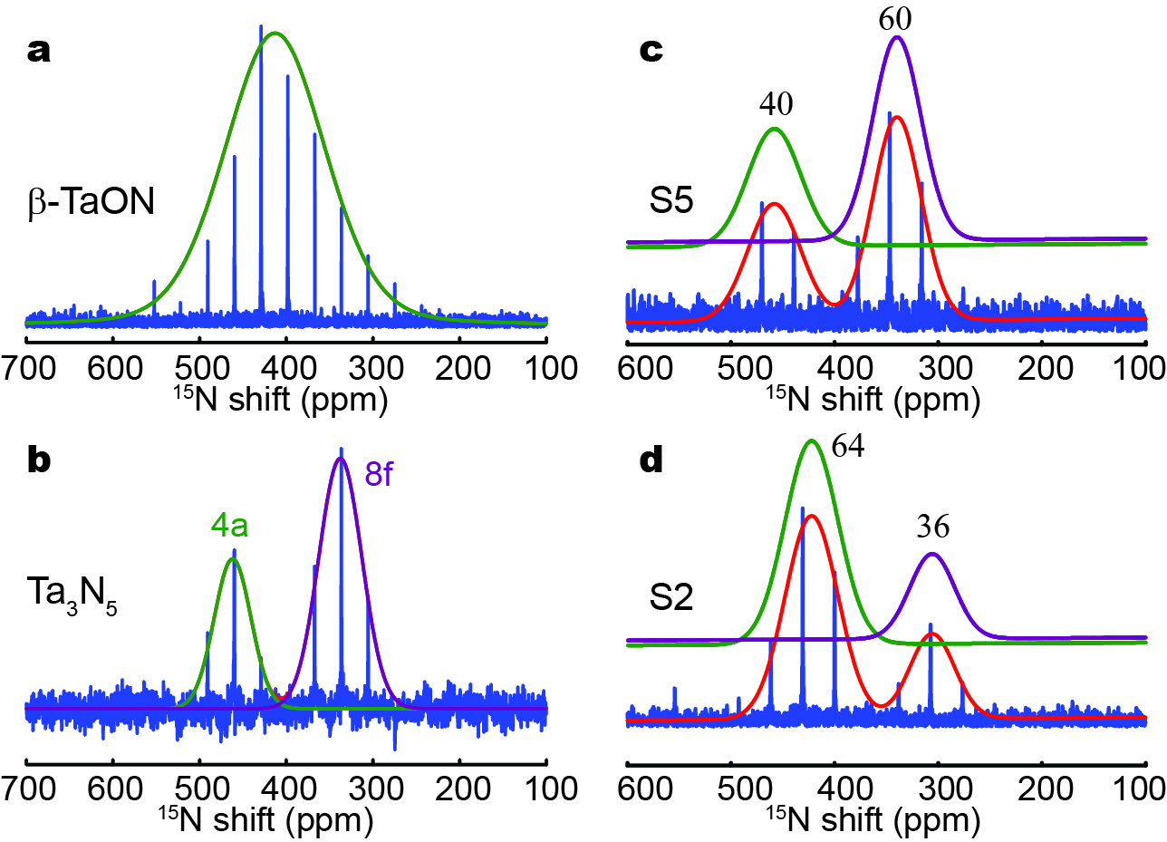
Experimental
Fig. 1. qCPMG ¹⁵N spectra and the corresponding simulations for different oxynitrides.
All oxynitrides were synthesized at 850 ºC with tuned contents of TaON and Ta₃N₅: S2 contains 53.5% β-TaON, 5.7% δ-TaON and 40.8% γ-TaON; S5 contains 11.5% β-TaON and 88.5% Ta₃N₅. ¹⁵N NMR acquisitions were performed on a Bruker Avance III spectrometer in an 18.8 T magnetic field with a ¹⁵N Larmor frequency of 81.1 MHz. The ¹⁵N spectra were obtained using a quadrupolar Carr-Purcell-Meiboom-Gill (qCPMG) sequence was employed for sensitivity enhancement, with a 90° pulse length of 5.0 µs. The MAS rate was 10 kHz. 512 transitions were accumulated for each spectrum with a recycle delay of 50 s. Spectra were analyzed by using Topspin (version 3.5) and the DMFit software.

Results and Discussion
Experimentally obtained ¹⁵N qCPMG NMR spectra of pure β-TaON and Ta₃N₅ with the corresponding simulations are shown in Fig.1a and b. One isotropic signal at 413 ppm is found for β-TaON. Two ¹⁵N resonances at 462 and 338 ppm with respective signal area integrals of 34% and 66% were observed for the Ta₃N₅ sample. This is in good agreement with the crystal structure determined by XRD: 1N at 4a site and 2N at 8f site. ¹⁵N NMR spectra of S₅ and S₂ are shown in Fig. 1c and 1d. In the ¹⁵N NMR spectrum of S₅, the increase in the intensity of the resonance on the left (compared to Fig. 1b) comes from β-TaON. The center of resonance is shifted to higher field (462 to 458 ppm) again due to the co-existence of β-TaON and Ta₃N₅. In Fig. 1d, narrowed peaks with higher resolution compared to that for pure β-TaON (Fig. 1a) indicates that sample S2 is more crystalline than β-TaON. The signal at 305 ppm is assigned to γ-TaON. The results prove that ¹⁵N NMR is useful to distinguish different local structural environments, including different arrangements, atomic connections, and defects.

Conclusions
Fast MAS, high magnetic field, in conjunction with NMR pulse sequence for sensitivity enhancement are employed for probing local structural futures of N-containing HetMs with natural-abundance ¹⁵N. It proves to be a reliable diagnostic tool to reveal the local assembling and connection of heteroanionic materials. The insights extracted from N substitutes for O in metal oxides will guide novel material design and synthesis for technological applications.

Acknowledgements
This work was supported by the NSF MRSEC DMR-1702139. Work was performed at the NHMFL, supported by NSF DMR-1157490 and the State of Florida.

References
[1] Yu, X., et al., Nat. Mater., 15, 383 (2016).
[2] Marvel, M.R., et al., J. Am. Chem. Soc., 129, 13963–13969 (2007).

