Brain-targeted image-guided drug delivery for HIV treatment

Tomitaka, A. (FIU, Department of Immunology); Colon-Perez, L.M., Febo, M. (UF, McKnight Brain Institute),
__________________________________________________________________________________________
Introduction
Antiretroviral therapies (ART) for human immunodeficiency virus (HIV) can reduce viral load significantly in plasma and other bodily fluids. However, the ultimate goal of eradicating HIV has not been attained due to limited accessibility of antiretroviral drugs to some locations and the existence of reservoirs. The brain is one of those sanctuary sites, and antiretroviral drugs show low effectiveness in central nervous system (CNS) penetration, primarily because of the Blood‒Brain Barrier (BBB) [1]. Nanoparticle based-drug delivery systems have shown to improve the efficiency of brain delivery by active targeting, which includes magnetic targeting and cell-specific targeting through selective ligands. Among various nanoparticles, inorganic nanoparticles show promising properties for image-guided drug delivery, which enables efficient and accurate treatment by combining drug delivery and non-invasive imaging by a selective nanoformulation. In this project, we will develop near infrared (NIR)-responsive magneto-plasmonic nanostars (MPNS) bound with antiretroviral drug for image-guided drug delivery to the brain and on demand controlled release of antiretroviral drug using NIR. MPNS possess magnetic and plasmonic properties in a single nano-structure. This integration gives great potential for MR-guided drug delivery with enhanced BBB transmigration and NIR controlled drug release.

Experimental
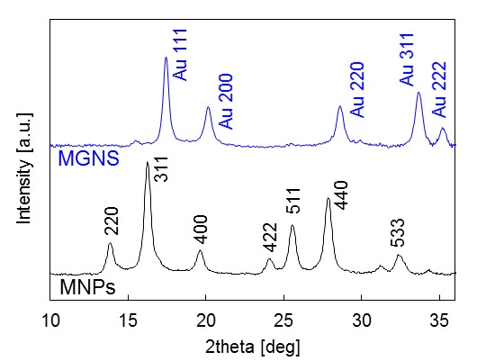
NIR-responsive MPNS with magnetic nanoparticle-core and gold-shell were synthesized by a two-step process. First, magnetic nanoparticles (MNPs) were synthesized by co-precipitation of Fe²⁺ and Fe³⁺ in an alkaline solution, followed by gold coating of MNPs by citrate reduction. MNPs and sodium citrate were used as seeds and a reducing agent for Au³⁺ ions, respectively. In the second step, the morphology of the nanoparticles was modified to star shape achieved by reduction process using spherical nanoparticles as seeds, ascorbic acid as a reducing agent for Au³⁺ ions, and silver nitrate as a catalyst. X-ray powder diffraction (XRD) pattern of MNPs and MPNS was recorded with Bruker GADD/D8 X-Ray system with Mo anode (wavelength: 0.708 A). MR property of MPNS was evaluated by using 4.7T MRI system (Agilent 4.7T) at AMRIS. An aqueous solution of MPNS (100 μl) was placed into a polymerization chain reaction (PCR) tube and fixed with 1wt% agar. The transverse relaxation time T₂-weighted images were obtained for MPNS with the concentration varied from 5 to 100 µg/ml.
Fig.1 XRD patters of MNPs and MGNS.

Results and Discussion
After the synthesis of MPNS, the existence of the gold shell on MNPs were confirmed from X-ray diffraction (XRD) pattern (Fig.1). The XRD pattern of MPNS showed sharp peaks from gold shell which can be indexed to the (1 1 1), (2 0 0), (2 2 0), (3 1 1), and (2 2 2) planes. MPNS showed concentration dependent contrast in T₂-weighted MR images (Fig.2). Stronger negative contrast was observed by increasing the concentration of MPNS. The transverse relaxivity of MPNS decreased with respect to MPNS concentration.

Conclusions
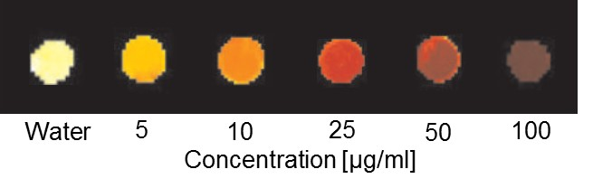
Successful synthesis of MPNS with magnetic nanoparticle-core and gold shell was confirmed by XRD. The synthesized MPNS showed concentration dependent negative contrasts in T₂-weighted MRI. These results indicate the capability of MPNS as imaging probe for image-guided drug delivery.
Fig.2 T₂-weighted MR images of MGNS.
Acknowledgements
A portion of this work was performed at the National High Magnetic Field Laboratory, which is supported by National Science Foundation Cooperative Agreement No. DMR-1157490 and the State of Florida. We would like to acknowledge Center for Study of Matter at Extreme Conditions (CeSMEC) at FIU for XRD.

References
[1] Varatharajan et al, Antiviral. Res. 82, 99–109 (2009).

