Role of screening and charge transfer for a Mott transition in a Hydrogen lattice
Quito, V.L. (MagnetLab, FSU); Tanaskovic, D. (Institute of Physics Belgrade, Pregrevica, Serbia); Sen, S., Ku, W. (Shanghai Jiao Tong University, Shanghai, China); Miranda, E. (University of Campinas, Campinas, Brazil); Dobrosavljevic, V. (MagnetLab, FSU)

Introduction
A lattice of hydrogenic atoms may be regarded as a prototypical model system displaying a Mott metal-insulator transition as the density is varied at zero temperature. According to early ideas of Mott, however, this transition may be accompanied by appreciable charge transfer from the hydrogenic impurity band to the conduction band, giving rise to a significant screening of the ionic binding potential, possibly leading to a first order Mott transition at T = 0. In the single-band model description of the Mott transition, however, relevant screening effects are ignored. In this work, we investigate the appropriate (two band) charge-transfer model, supplemented by an inter-band Coulomb interaction, which is solved using a slave-boson (Gutzwiller) method.
Results and Discussion
The Hamiltonian of the model we study consists of the following terms

H= ∑_{i, j, σ}t_{ij}(c_{iσ}†c_{jσ} + h.c.) + ϵ_{f}∑_{i, σ}n_{iσ}^{f} + U_{ff}∑_{i}n_{i↑}^{f}n_{i↓}^{f} + V∑_{i, σ}(f_{i, σ}†c_{i, σ} + c_{i, σ}†f_{i, σ}) + U_{fc}∑_{i} n_{i}^{f}n_{i}^{c} [1]

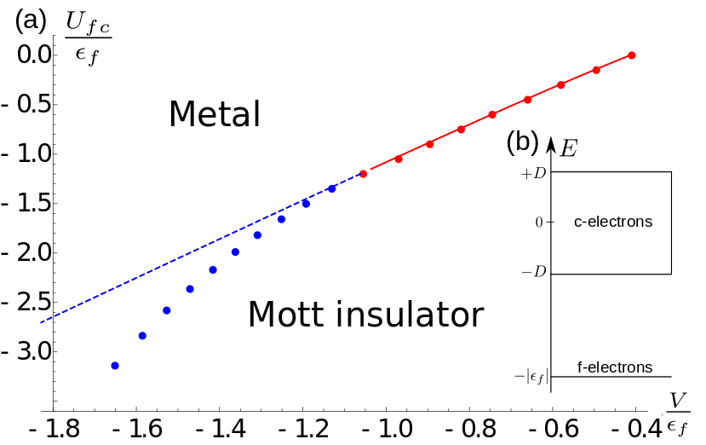where c†_{i, σ} and f†_{i, σ} are operators that create fermions with spin projection σ at site i. We assume that the bandwidth of the c-electrons is W = 2D, with an uniform density of states, while the f electrons have no dispersion. We also assume that |ϵ_{f}| > D, and ϵ_{f} < 0. This non-interacting band structure is represented at Fig. 1(b). The filling condition is ⟨n_{i}^{c}⟩ + ⟨n_{i}^{f}⟩ = 1, which implies that when U_{ff} = U_{fc} = 0, the lower band is half-filled and the phase is metallic for any V or ϵ_{f}. In the hydrogen lattice, the ratio (|ϵ_{f}|/V)/(/V) is small [1] and the lower band remains narrow, with a bandwidth D_{f} ~ ((V/)/(/|ϵ_{f}|) ²D≪D. If modest U_{ff} is included, the f band is split into a upper and the lower Hubbard band, while the other bands, here represented by the c electrons, are well separated in energy. A Mott-Hubbard transition is then found as U_{ff} is tuned, with its critical value U_{c} of order of the bandwidth D_{f}. In the opposite limit, U_{ff}≫|ϵ_{f}|, the Zaanen-Sawatzky-Allen charge-transfer limit is reached [3], where the energy of the upper Hubbard band is much higher than the conduction band. There is then no qualitative difference when one takes U_{ff} → ∞, which is a limit that facilitates some of the calculations. On top of the large U_{ff} condition, we include an interaction term between the c and f electrons, U_{fc}, and find that the phase transition becomes first order when U_{fc} ~ V. In Fig. 1(a), we show the phase diagram, obtained at mean-field level, using the Read-Newns-Coleman [2] representation of the slave bosons. The dots correspond to the phase boundary. In blue, the first-order transition region. The lines are predictions of the of the Landau-Ginzburg theory, and the discrepancy between the blue line and blue dots is proportional to the jump of the order parameter at the critical point.
Fig.1 (a) Phase diagram of the charge-transfer model in the presence of interaction U_{fc} between the c and f electrons, when the interaction between f electrons U_{ff} is very large, found at mean-field level using a slave boson approach. In red, the transition is second order, while in blue the transition is first order. (b) Non-interacting bands and their density of sates, with the narrow f-band at energy − |ϵ_{f}|, below the c band, assumed to have a width 2D and a uniform density of states.
Conclusions
We have investigated the two-band charge-transfer model, supplemented by an inter-band Coulomb interaction using a slave-boson (Gutzwiller) method. We find that the introduction of a U_{fc} can lead to a first-order phase transition, in agreement with the early ideas of Mott. The results should have strong relevance for the long-lasting puzzle of the metal-insulator transition in doped semiconductors, such as Si:P.
Acknowledgments
A portion of this work was performed at the National High Magnetic Field Laboratory, which is supported by National Science Foundation Cooperative Agreement No. DMR-1157490 and the State of Florida.
References
[1] Sen, S. , et al., (2017, unpublished).
[2] Read, ., et al., Journal of Physics C: Solid State Physics, 16, (1983)
[3] Zaanen et al Phys. Rev. Lett., 55, (1985).

