Phase diagram of Ba₂NaOsO₆, a Mott insulator with strong spin orbit interactions

Liu, W., Cong, R., Garcia, E. (Brown U.,Physics); Reyes, A. P. (NHMFL); Lee, H.O., Fisher, I.R. (Stanford U., Applied Physics); Mitrovic, V.F. (Brown U. Physics)

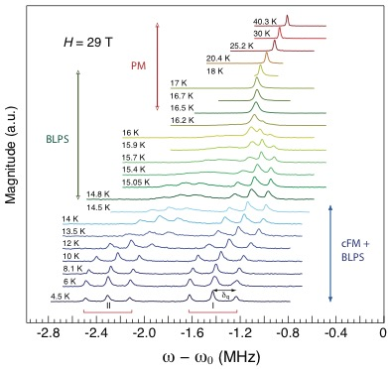
Introduction Strong spin-orbit coupling (SOC) in Mott insulators, in which the insulating behavior is driven by electronic correlations, can give rise to a variety of exotic quantum phases, such as spin liquid, Weyl semi-metal, topological insulator, etc. [1]. A representative Mott insulator with strong SOC is the d¹ double perovskites with cubic symmetry Ba₂NaOsO₆, in which Na and Os ions inhabit alternate cation B sites. In light of the uncommon ferromagnetic state in Ba₂NaOsO₆, quantum models with multipolar magnetic interactions have been proposed. Based on our earlier work [2], a canted ferromagnetic phase preceded by local point symmetry breaking is found at low temperatures, in line with theoretical predictions. To provide further test of the quantum models, we extend our NMR measurement to a high magnetic field of 29T. We find that the broken local point symmetry phase extends to a larger temperature range as magnetic field increases.

Experimental The temperature dependence of ²³Na NMR spectra were measured from 4.5K to 40.3K at an applied magnetic field of 29T. The measurements were done using a high homogeneity superconducting magnet at SCM1 at the NHMFL in Tallahassee FL. A ⁴He variable temperature insert provided the temperature control. The NMR spectrum was obtained from the sum of the Fourier transforms of the standard solid echo sequence ($π$/2-$τ$-$π$), using a homemade NMR spectrometer. The high quality single crystal sample of Ba₂NaOsO₆ was mounted with the applied field parallel to [001] crystalline axis.

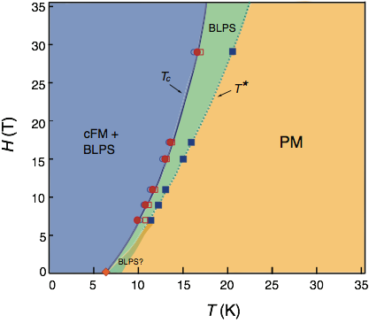
Results and Discussion Figure 1 shows the temperature evolution of ²³Na NMR spectra at 29T. Above 16.6K, the narrow single peak spectrum characterizes a paramagnetic (PM) state with cubic symmetry. At intermediate temperatures, NMR line broadening and triplet splitting indicate the development of a non-zero electric field gradient, marking a broken local point symmetry (BLPS) phase. Entering into low temperatures, the emergence of two sets of triplets signify two distinct magnetic sites. This originates from a two-sublattice canted ferromagnetic (cFM) phase which is verified by detailed analysis in [2]. The phase diagram up to 29T is shown in Figure 2. The solid line, marked by T_{c}, denotes the phase transition from PM state into a cFM state. The dashed line, marked by T*, indicates the crossover of the BLPS phase with the PM state. The determination of T_{c} and T* are explained in detail in [3].
Fig. 1 Temperature evolution of ²³Na spectra at 29T.

Conclusions We measured the ²³Na NMR spectra of a single crystal sample of Ba₂NaOsO₆ with an applied magnetic field of 29T. A long range ordered magnetic phase preceded by local point symmetry breaking is identified at low temperatures in Ba₂NaOsO₆. We extended the corresponding phase diagram to higher fields and found that the BLPS phase occupies a larger temperature range as magnetic field increases.
Fig. 2 Phase diagram based on NMR measurement results presented here and on [3].

Acknowledgements The study was supported in part by the National Science Foundation DMR-1608760. The study at the NHMFL was supported by the National Science Foundation under Cooperative Agreement no. DMR95-27035, the state of Florida and Brown University.

References
[1] Witczak-Krempa, W., et al., Ann.Rev.Condens.Matter Phys. 5,57-82 (2014).
[2] Lu, L., et al., Nat. Commun., 8,14407 (2017)
[3] Liu, W. et al., Physica B: Condens. Matter (2017)

