High Field Magneto-Optical Studies of Liquid Crystals and Complex Fluids

Gleeson, J.T., Sprunt, S.N., Jákli, A. (Kent State University)

Introduction
High magnetic fields are a particularly powerful technique for the study of ordered, fluid materials, such as liquid crystals. This technique can give insight into the propensity of these materials to spontaneously break their symmetry. Furthermore, high fields give the experimenter a powerful tool to control the principal axes within inherently anisotropic fluid materials. During 2015, we examined the magneto-optical response of two new classes of liquid crystal materials, the twist-bend nematic phase, and the twist-bend cholesteric phase.

Experimental
Using the unique capabilities of the split-helix magnet, we measured the magnetic field induced birefringence of these materials in two geometries: Faraday, in which the direction of light propagation is parallel to the field, and Voigt, in which it is perpendicular. For both cases we have devised specialized temperature-controlled magnet inserts and beam recovery optics with appropriate optical access. Additionally, we performed, for the first time, angularly resolved photon-correlation spectroscopy in the split helix, taking advantage of both directions of angular access (horizontal and vertical).

Results and Discussion
We ran for one week in late 2017. In addition to studying the phase transition temperatures (as a function of magnetic field in a series of thermotropic liquid crystals having tailored architecture, we also investigated mixtures of new liquid crystal compounds with chiral (i.e. handed species). The results are still being analyzed, but it appears likely that in tetrameric systems, there is a never before observed threshold for field dependence of transition temperature shift (see below).

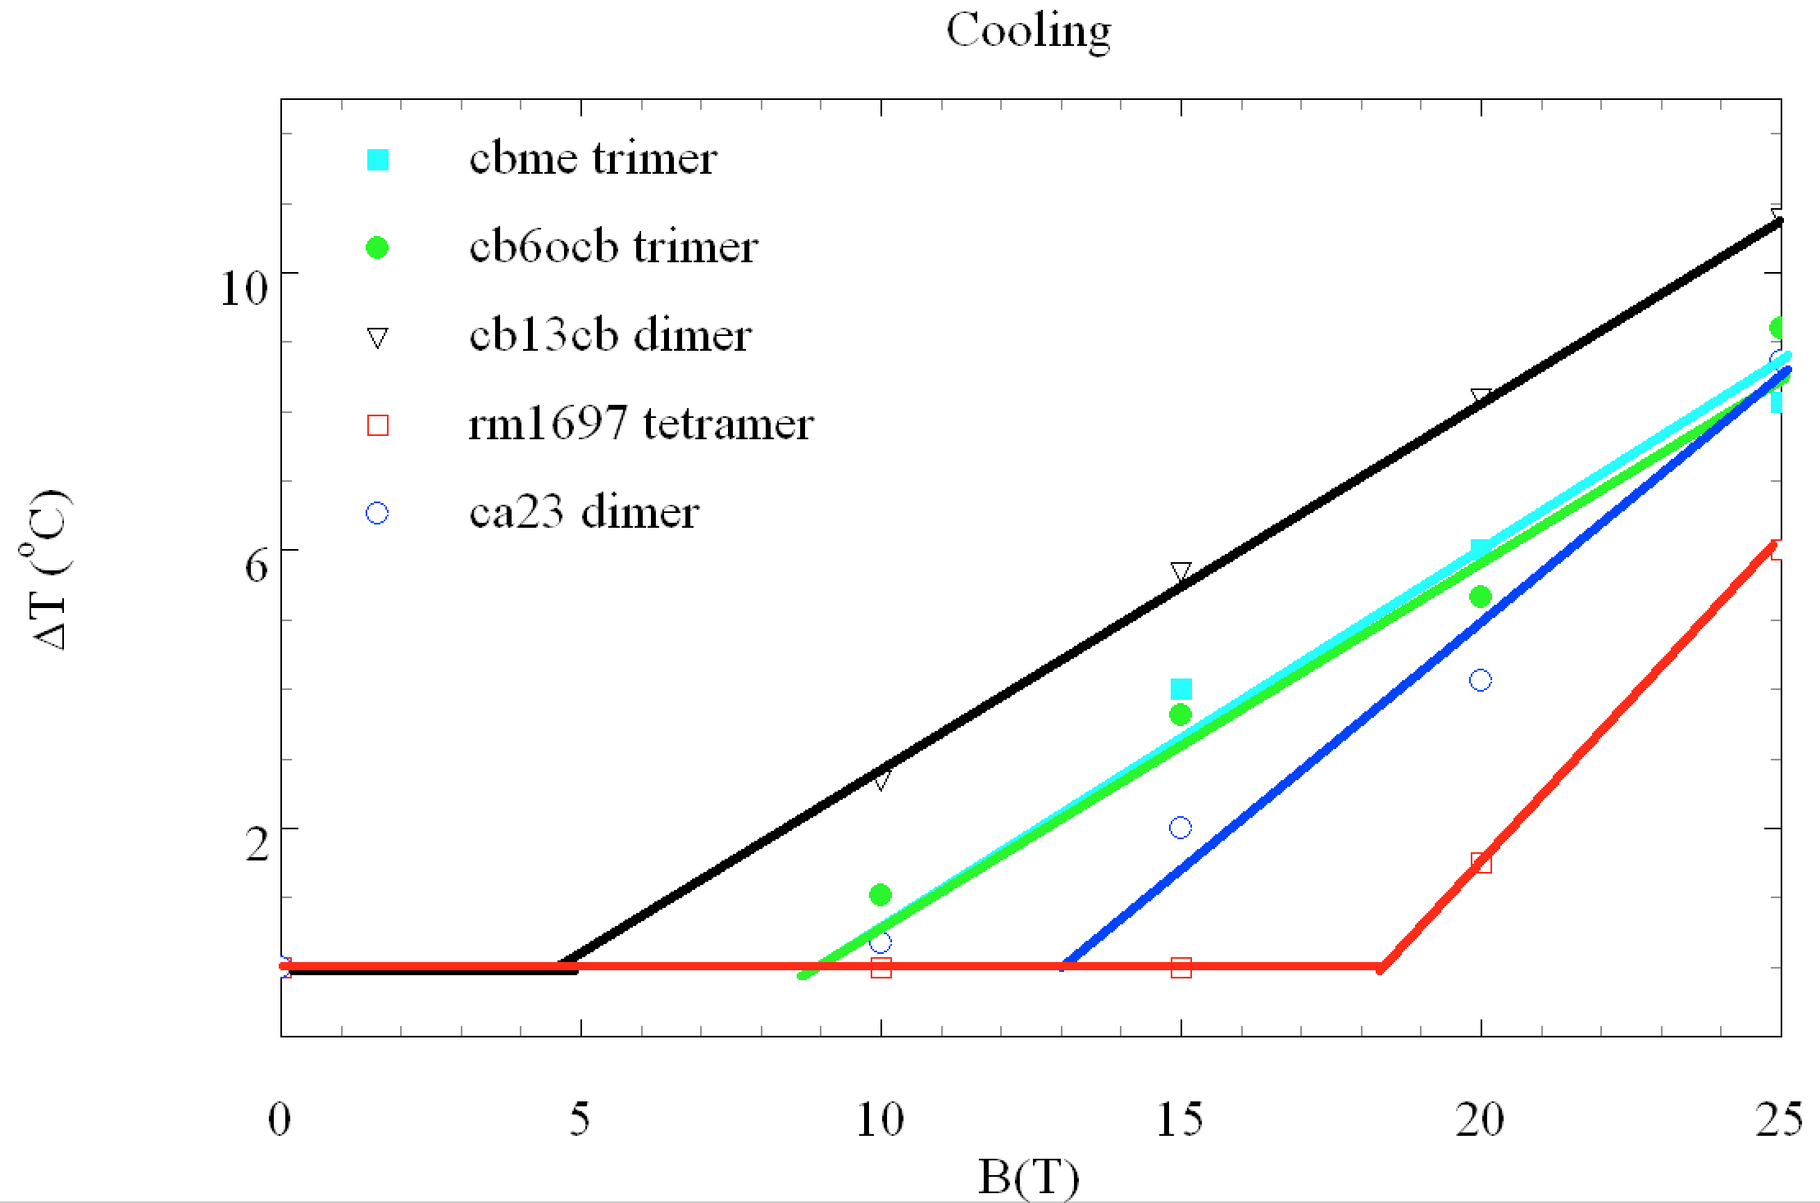

Acknowledgements
This work was funded by the National Science Foundation (DMR 1307674). A portion of this work was performed at the National High Magnetic Field Laboratory, which is supported by National Science Foundation Cooperative Agreement No. DMR-1157490, the State of Florida, and the U.S. Department of Energy.

