Search for the Rapid Oscillations and Field-Induced Spin-Density-Waves in (TMTTF)₂Br

Kang, W. (Ewha Womans U., Physics); Nakamura, T. (Inst. Mat. Res.)

Introduction
(TMTTF)₂Br is the first superconductor in the TMTTF family of which the metallic state is studied by measuring angle dependent magnetoresistance oscillations (AMRO). It can be considered as the simplest and ideal quasi-one-dimensional (Q1D) electron system because of its monoatomic anion. Observations of intriguing properties of Q1D organic conductors, namely, rapid oscillations and the quantized Hall effect, are crucial to understand the unconventional superconductivity of the whole Q1D materials. A magnetic field stronger than 20 T is necessary for the cascade of quantum Hall transitions and 45 T for the observation of rapid oscillations.

Experimental
An indenter type pressure cell generating more than 25 kbar was developed to stabilize metallic state of the title compound. Electrical contacts were made with carbon paste along the side of the samples. Longitudinal resistance and transverse resistance were measured simultaneously. Symmetrization was necessary to extract small Hall components from dominant magnetoresistance. Experiments were performed in the 45 T hybrid magnet to maximize a chance to observe the proposed results.

Results and Discussion
Fig. 1 shows longitudinal magnetoresistance and transverse magnetoresistance, respectively. Threshold magnetic field is about 15 T at 0.3 K. Abrupt increase of longitudinal resistance was observed around 27 T, which may be regarded as a signature for the entrance into the N=0 state. However, quantized Hall plateaus are not observed and rapid oscillations are absent until 45 T. The current observations betray our belief that the title compound must have the simplest physical properties with its symmetric ions. They might be related with the previous observations showing that AMRO of (TMTTF)₂Br is closer to those of (TMTSF)₂ReO₄ than to those of (TMTSF)₂PF₆. Smeared quantized Hall plateaus may also indicate existence of disorder.

Conclusions
Although a cascade of transition, reminiscent to those from FISDW formation, is observed, Hall plateaus are only partially quantized and there were not any rapid oscillations until 45 T at 0.3 K. The nature of disorder should be addressed in the future experiments.

Acknowledgements
A portion of this work was performed at the National High Magnetic Field Laboratory, which is supported by National Science Foundation Cooperative Agreement No. DMR-1157490 and the State of Florida. This work was supported by an NRF grand funded by the Korea Government (Grant No. 2015-001948)

References
[1] Balicas, L., et al., J. Phys. I (France), 4, 1539-1549 (1994).
[2] Behnia, K., et al., Europhys. Lett., 32, 73-77 (1995).
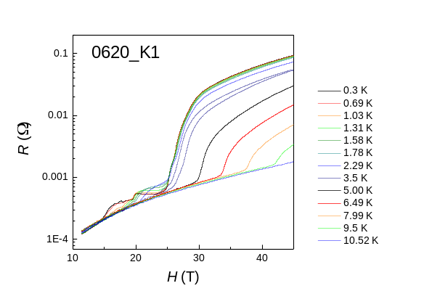
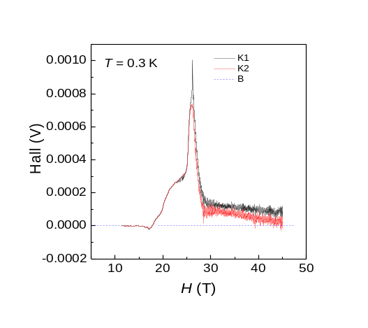
Fig.1 Longitudinal and transverse magnetoresistance of (TMTTF)₂Br. Possible cascade of transitions are visible both in R_{xx} and R_{yx}. However, quantization of Hall plateaus is far from being completed. Rapid oscillations are not observed till 45 T at a temperature as low as 0.3 K.

