Development of the new technique for the magnetostriction measurement in
pulsed magnetic fields

Ding, X., Zapf, V.S., Jaime, M., Balakirev, F.F. (NHMFL-PFF); Cheong. S.-W. (Rutgers); Chai, Y.-S. and Sun, Y. (IOP, China)

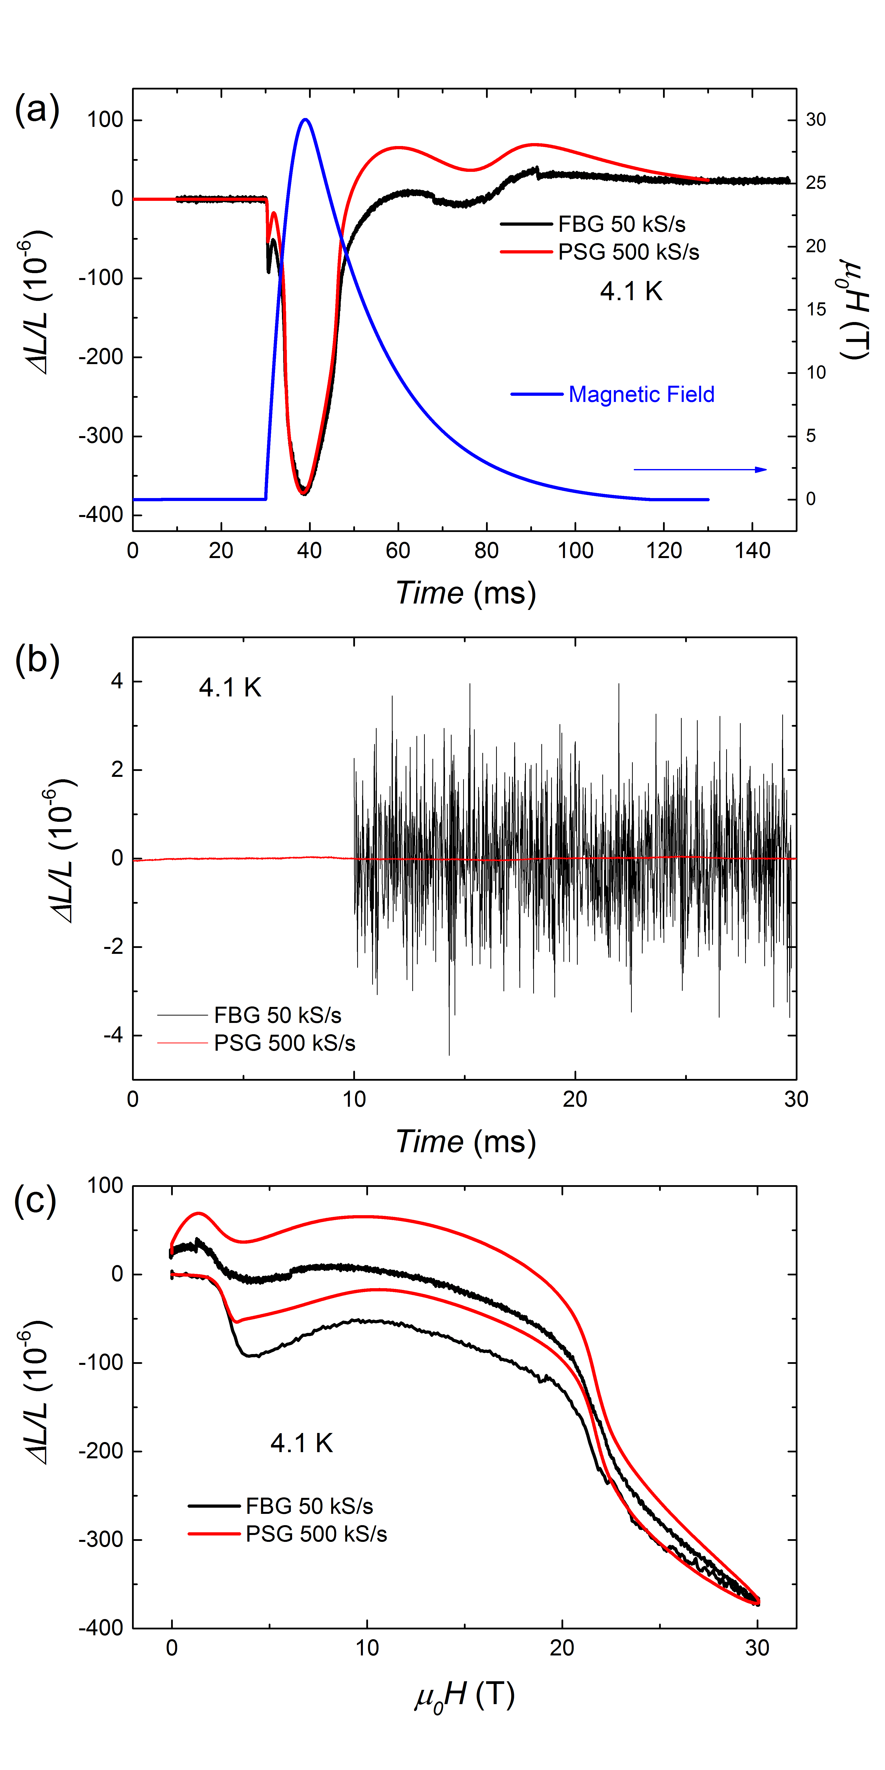
Introduction
Magnetostriction is a change in lattice dimensions in response to a magnetic field (H) that lowers the electronic and magnetic energy. We developed a new technique that may be more sensitive, though it is not absolute or sensitive to a single crystalline axis. It may be particularly useful for small signals or quantum oscillations. We attach the sample to a piezoelectric material which is known as the piezoelectric strain gauge (PSG). Levitin et al. published a version of this method, though it was not widely disseminated and limited by then-available materials. [1] We have demonstrated its effectiveness with modern piezoelectrics by measuring the angle-dependent magnetostriction of a Ca₃Co_{1.03}Mn_{0.97}O₆ (CCMO) single crystal in pulsed magnetic fields. In this report, we focus on improving the resolution of this new technique.

Experimental
We measured the field dependence of ΔL/L of CCMO single crystal by FBG and PSG simultaneously in pulsed magnets at 4.1 K. The magnetic field direction is along the c-axis of the CCMO single crystal.

Results and Discussion
Fig.1(a) shows time profile of the 30 T pulse and the time dependence of ΔL/L measured by two techniques with H || c. The value of PSG was calibrated by the FBG data. Fig. 1(b) shows the magnetostriction signal drift over time in zero field for PSG and FBG, respectively. In this case, the resolution of FBG is 5.8x10⁻⁹/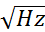, the resolution of PSG reaches 2.91x10⁻¹¹/. Fig. 1(c) shows the field dependence of ΔL/L for these two different techniques, which shows similar behavior.

Conclusions
Figure 1 (a) When exposed to magnetic field, the relative length change ΔL/L of CCMO as a function of time. The signal of PSG is calibrated by the data of FBG. (b) Magnetostriction signal drift with time in zero field. (c) ΔL/L of CCMO as a function of magnetic field for the two techniques.
We improved the resolution of PSG to 2.91x10⁻¹¹/. The phase transitions are observed in both measurements, with slight differences in magnitude attributable to the one axis vs. two axis sensitivity of the measurements. Both of these two techniques are very important and complement each other.
Techniques | Pros | Cons
Piezoelectric strain gauge | Highest resolution 10⁻¹¹/  Fast sampling rate 60 MS/s  Passive sensing  Easily rotated  Small footprint  Low cost | Senses two crystalline axes  Needs to be calibrated  More strain on sample
Fiber Bragg gratings | No eddy current heating  Intrinsically calibrated  Single-axis measurements  Less strain on sample | Slow sampling rate 50 kS/s  Can’t be rotated  Lower resolution 10⁻⁹/ [2]
Acknowledgements
A portion of this work was performed at the National High Magnetic Field Laboratory, which is supported by National Science Foundation Cooperative Agreement No. DMR-1157490, the U.S. D.O.E. and the State of Florida. This scientific work was supported by LANL’s LDRD program.

References
[1] R. Z. Levitin, V. N. Milov, Yu. F. Popov and V. V. Snegirev, Physica B 177, 59-62 (1992).
[2] M. Jaime et al, PNAS 109, 12404 (2012); R. Daou et al, Rev. Sci Inst. 81, 033909 (2010).

