Emergent Bloch Excitations in Bloch Matter

Lanatà, N., Lee, T.H. (FSU, NHMFL & Physics); Yao, Y.X. (Ames Laboratory, ISU) and Dobrosavljević, V. (FSU, NHMFL & Physics)

Abstract
We developed [1] a unified theoretical picture for excitations in Mott systems, portraying both the heavy quasiparticle excitations and the Hubbard bands as features of an emergent Fermi liquid state formed in an extended Hilbert space, which is nonperturbatively connected to the physical system. This observation sheds light on the fact that even the incoherent excitations in strongly correlated matter often display a well-defined Bloch character, with pronounced momentum dispersion. Furthermore, it indicates that the Mott point can be viewed as a topological transition, where the number of distinct dispersing bands displays a sudden change at the critical point. Our results, obtained from an appropriate variational principle [1-3], display also remarkable quantitative accuracy. This opens an exciting avenue for fast realistic modeling of strongly correlated materials.

Acknowledgements
N.L., T.-H.L. and V.D. were partially supported by the NSF grant DMR-1410132 and the National High Magnetic Field Laboratory. Y.Y. was supported by the U.S. Department of energy, Office of Science, Basic Energy Sciences, as a part of the Computational Materials Science Program.

References
[1] Lanatà, N., et al., Phys. Rev. B 96, 195126 (2017).
[2] M. C. Gutzwiller, Phys. Rev. 137, A1726 (1965).
[3] Lanatà, N., et al., Phys. Rev. X 5, 011008 (2015).
[4] Lanatà, N., et al., Phys. Rev. Lett. 118, 126401 (2017).

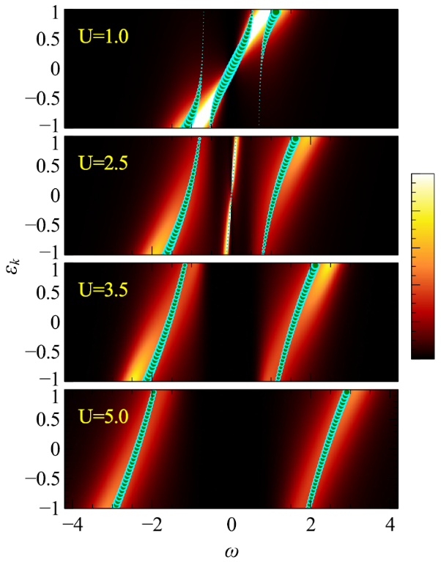

Fig 1 Poles of the ghost-GA energy-resolved Green’s function (bullets) in comparison with DMFT+NRG. The size of the bullets indicates the spectral weights of the corresponding poles. Metallic solution for U = 1, 2.5 and Mott solution for U = 3.5, 5.

