High magnetic field study of the first order transition antiferromagnet U₂Rh₃Si₅

Süllow, S. (TU Braunschweig, Physics, Germany); Jaime, M., Weickert, F., Harrison, N. (NHMFL, LANL); Amitsuka, H. (Hokkaido University, Japan); Valiska, M., Sechovsky, V. (Charles University, Czech Republic)

Introduction
The intermetallic U₂Rh₃Si₅ is a prime example of a 5f material exhibiting a first order magnetic phase transition [1-3]. This monoclinic system undergoes a structural transition without changing the crystallographic symmetry at T_{N} = 25.6K. It is accompanied by one into a canted antiferromagnetically ordered state with large magnetic moments (μ_{ord} ~2.4μ_{B}), together with modifications to the Fermi surface. Conceptually, this combined structural/magnetic transition has been interpreted as a “boots-trapping” effect, as it has been predicted to occur in crystal field singlet ground state systems [4]. Here, one approach to gain further insight is to use high magnetic fields for investigation of the field dependence of various physical properties. Initial studies have been carried out, but only up to fields of 30T and in a limited temperature range [2,5]. These limitations have hindered a better understanding of the microscopic mechanism of the phase transition in U₂Rh₃Si₅. Therefore, we have performed high field (65T) magnetization and magnetostriction experiments along the three crystallographic directions of U₂Rh₃Si₅, this way producing the experimental basis to unravel the interplay of crystal field states, magnetostructural response and magnetic order in this compound.

Experimental
We have carried out magnetostriction (using optical FBG dilatometry) and magnetization experiments at temperatures 1.3 to 30K in the 65T Multi-Shot pulsed magnet. During the experiments, the field has been applied along the three crystallographic directions of the lattice of U₂Rh₃Si₅.

Results and Discussion
The magnetostriction experiments along the crystallographic b axis clearly define a two-step metamagnetic transition (at 14T at low T; not shown). Along the other crystallographic directions, the magnetic torque exerted by the samples was too large and dislodged them from the holder. However, magnetization has been measured successfully along all three directions (see Fig. 1 with an overview for B||a axis). Combining the findings from magnetization and magnetostriction, we have derived the magnetic phase diagram (Fig. 2).

Conclusions
We have established the magnetic phase diagram of U₂Rh₃Si₅ for the main crystallographic axes. Remarkably, we find an anisotropy of critical fields by a factor of 5 or larger, and which attests to the relevance of crystal field effects in this 5f-electron compound.

Acknowledgements
A portion of this work was performed at the National High Magnetic Field Laboratory, which is supported by National Science Foundation Cooperative Agreement No. DMR-1157490 and the State of Florida. Moreover, this research was supported by the Visiting Scientist program of the NHMFL under VSP #268.
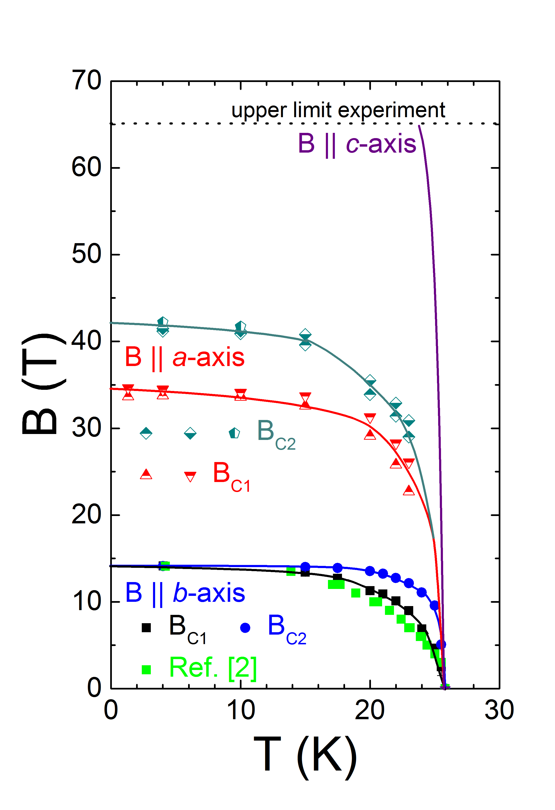
Fig. 2 Magnetic phase diagram of U₂Rh₃Si₅ for the three crystal axes; for details see text.
References
[1] B. Becker, et al., Phys. Rev. Lett. 78 (1997) 1347.
[2] T. Takeuchi, et al., Phys. Rev. B 56 (1997) 10778.
[3] R. Feyerherm, et al., Phys. Rev. B 56 (1997) 13693.
[4] Y.L. Wang, B.R. Cooper, Phys. Rev. 172 (1968) 539.
[5] B. Becker et al., Physica B 259-261 (1999) 250.
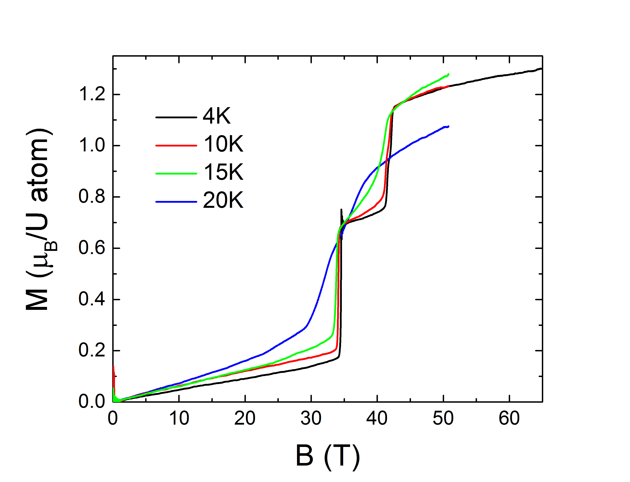
Fig.1 High field magnetization of U₂Rh₃Si₅ for B||a axis; for details see text

