Angle-dependent phase diagram of URu_{2-x}Fe_{x}Si₂ around the hidden order

Pouse, N., Ran, S., Maple, M.B. (UCSD, Physics); Baumbach, R. (FSU, NHMFL); Balakirev, F. and Singleton, J. (LANL, NHMFL)

Introduction
The heavy fermion system URu₂Si₂ has long been a topic of great interest in condensed matter physics, as the nature of its so-called “hidden order” phase (HO) has remained a mystery for decades. Many attempts at novel characterizations for this compound have been made in order to uncover the underlying physics manifested as the HO.

Experimental
We performed experiments on single crystals of URu_{2-x}Fe_{x}Si₂ at the NHMFL in LANL, in order to probe the nature of the HO and large-moment antiferromagnetic (LMAFM) phases in this compound. Our measurements at LANL used a pulsed magnet up to fields of 65 T where we measured the magnetoresistance at multiple temperatures for concentrations, x = 0, 0.2, covering the HO and LMAFM sides of the T vs. x phase diagram previously mapped to high fields by Ran et al.,^{[1]} with magnetic field H applied at various angles θ between the c-axis and the ab-plane from -90 to +90 degrees. At fixed T, we swept H through the HO and LMAFM transitions for the x = 0 and 0.2 samples, respectively, with H at several fixed θ, in order to characterize the behavior of the field-induced phase transitions as a function of angle.
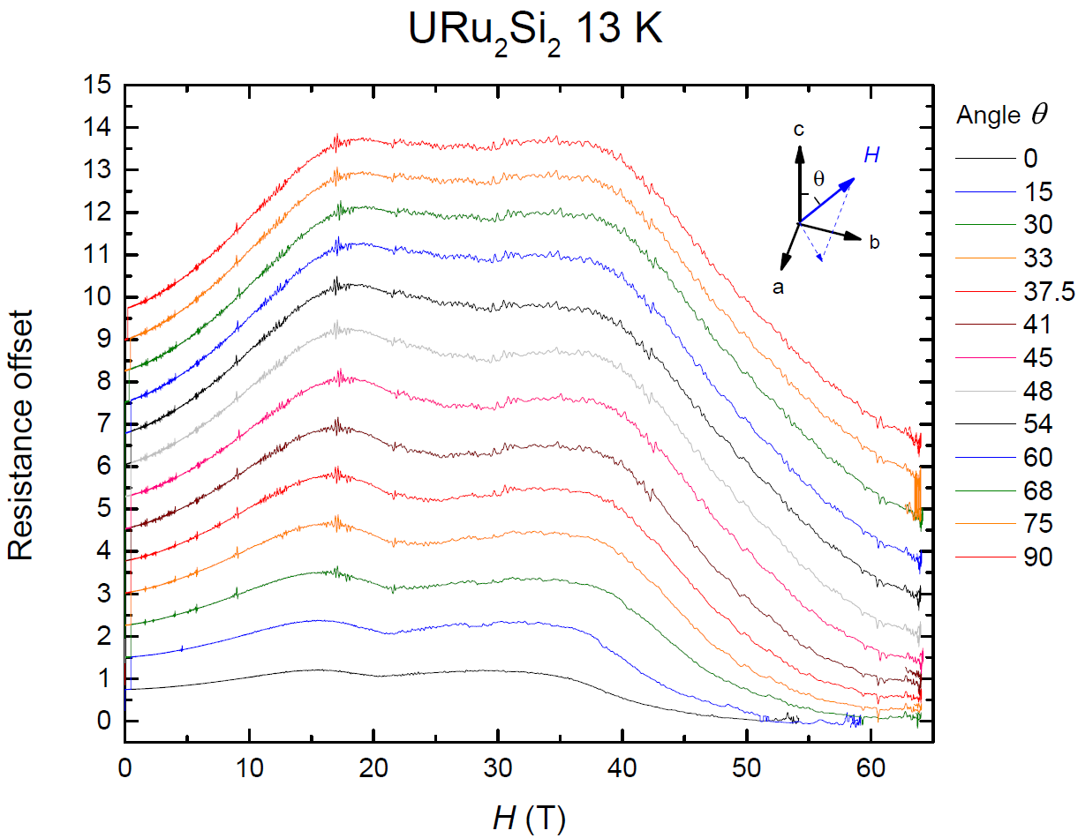
Fig. 1 - Magnetoresistance vs. H for multiple angles θ

Results and Discussion
From the pulsed field measurements, we can observe the relationship between T_{HO} and θ to help characterize the anisotropic HO. Figure 1 is a representative plot of magnetoresistance vs H at various θ which demonstrates how the T vs. H phase diagram varies with angle for URu₂Si₂ and related compounds.

Acknowledgements
Research at UCSD was supported by the NNSA through the U.S. DOE under Grant No. DE-NA0002909, by the DOE under Grant No. DEFG02-04-ER46105, and by the NSF under Grant No. DMR 1206553. A portion of this work was performed at the National High Magnetic Field Laboratory, which is supported by National Science Foundation Cooperative Agreement No. DMR-1157490 and the State of Florida.

References
[1] Ran, S., et al., to appear in Proceedings of the National Academy of Sciences (2017).

