Ce₃Bi₄Pt₃ and Ce₃Bi₄Pd₃ in Pulsed Fields

Zocco, D.A., Dzsaber, S., Bühler-Paschen, S. (TU Vienna); McDonald, R., Weickert, D., Harrison, N. (LANL-NHMFL)

Introduction
We performed magnetization (P15985-E002) and torque magnetometry (P15985-E005) experiments for Ce₃Bi₄Pt₃ and Ce₃Bi₄Pd₃ single crystals in pulsed fields. The main goal of these experiments is to tune with field the hybridization gap of these Kondo systems, and to map their Fermi surfaces from bulk experiments via quantum oscillations (QOs) that could reveal important new insight into topological phases in correlated materials.

Experimental
The experiments were carried out in the 65 T multi shot (25 ms) magnets at NHMFL-LANL, and in temperatures as low as 0.4 K. For Ce₃Bi₄Pt₃, magnetization was measured using a sample-in/sample-out technique for background subtraction; additional search for QOs via de Haas–van Alphen (dHvA) effect experiments was done using a compensated coil system specifically designed for this purpose. Magnetic torque was measured for Ce₃Bi₄Pt₃ and Ce₃Bi₄Pd₃ single crystals using sensitive piezo cantilevers and a sample rotator. Due to the small size of the samples, magnetic fields were not oriented to any specific crystallographic axis.

Results and Discussion
The magnetization (Fig.1) of Ce₃Bi₄Pt₃ displays a deviation from linear behavior near 30 T, coinciding with the expected magnetic field necessary for closing the Kondo hybridization gap [1]. This transition became more pronounced as temperature was reduced during the torque measurements (Fig.2). For Ce₃Bi₄Pd₃, the abrupt change in torque signal occurs at lower fields (Fig.3), consistent with the much lower Kondo energy scale previously discussed [2]. In both compounds, the torque signal oscillates for some field orientations (Figs.2-3), i.e. the magnetization does not simply saturate. This effect will be further investigated.
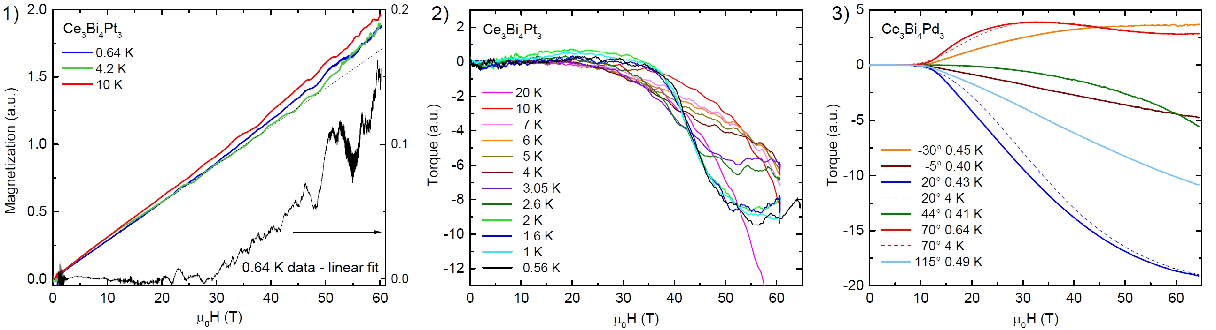 Fig.1-2 Magnetization and magnetic torque of Ce₃Bi₄Pt₃. Fig.3 Magnetic torque of Ce₃Bi₄Pd₃.

Conclusions
We observed for both Ce₃Bi₄Pt₃ and Ce₃Bi₄Pd₃ clear features in magnetization and torque consistent with the onset of hybridization gap closure with magnetic field. In the metallic state, non-monotonic behavior of the torque signal requires further investigation at higher magnetic fields. The dHvA effect experiments performed in the Ce₃Bi₄Pt₃ sample using the compensated coils system did not show any clear indications of quantum oscillations (not shown) within the noise level and vibrations background of the experiments, and within the measured field and temperature range.

Acknowledgements
A portion of this work was performed at the National High Magnetic Field Laboratory, which is supported by National Science Foundation Cooperative Agreement No. DMR-1157490 and the State of Florida. D.Z. and S.B.-P. acknowledge the financial support by the Austrian Science Fund (FWF I2535-N27) and U.S. Army Research Office (Grant W011NF-14-1-0497).

References
[1] Jaime, M., et al., Nature 405, 160 (2000).
[2] Dzsaber, S., et al., Phys. Rev. Lett. 118, 246601 (2017).

