A Study of Metamagnetism in UPt₃ through High Field Magnetization
Shivaram, B.S. (University of Virginia, Physics); Singleton, J. (Los Alamos National Labs.), Birnbaum, S. (org not provided)

Introduction
The prototypical heavy fermion system UPt₃.is an anisotropic metamagnet with the characteristic sharp upturn in the magnetization seen only for fields parallel to the basal plane. Associated with this sharp upturn are dramatic changes in longitudinal ultrasound velocity. No magnetic anomalies are detected when the field is in the perpendicular direction i.e. along the c-axis. Thus, it was surprising to see two dips in the sound velocity at 10 T and 29 T in UPt₃ for B||c-axis in experiments performed at Tallahassee in a resistive magnet to 33T. Associated with the 29 T feature new quantum oscillations in the sound velocity were also discovered. Motivated by these findings in ultrasound measurements high sensitivity magnetization measurements were carried out for the first time in UPt₃ for B||c-axis in fields upto 60T.

Experimental
Both the extraction method and the tunnel diode based magnetometry (TDO) were employed during the course of the present experiments. A high quality oriented single crystal synthesized at Argonne National Labs was used and measurements were carried out over the temperature range 0.5 K to 1 K. Due to the small moment of the sample and the weak field dependent signatures the lowest temperatures attainable in the 60 T magnet system at Los Alamos were required.

Results and Discussion
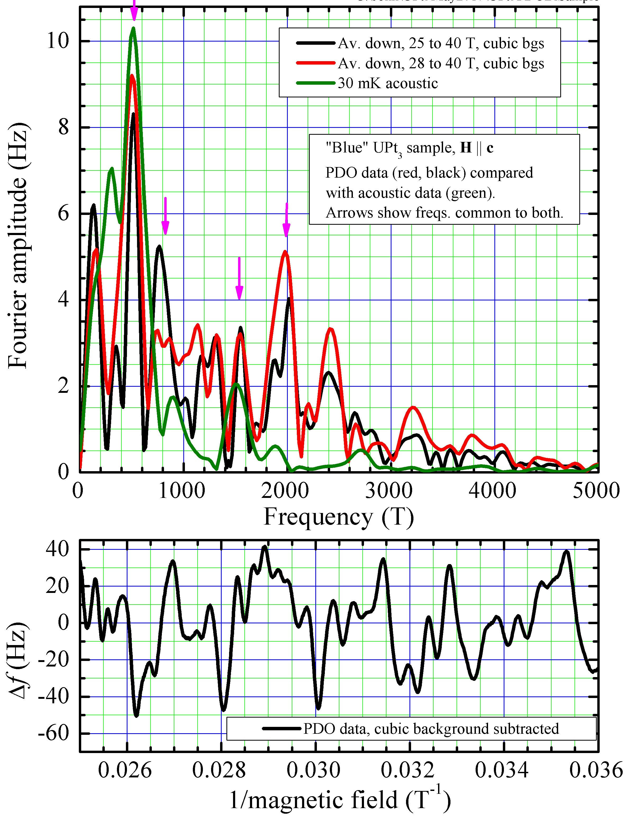
The extraction method showed that the magnetization response was fairly linear for B||c-axis all the way upto 60 T with very little indication of approach to saturation. Tiny anomalies in the neighborhood of 29 T could be seen but were not conclusive. In contrast the TDO method yielded a rich structure in the quantum oscillations. The oscillations corresponding to the original orbit detected through ultrasound velocity (green line in fig.1) were reproduced in the magnetization measurements also (red line). In addition, at least two additional unknown orbits were established. The temperature dependence of the oscillations showed that the smaller orbit had a significantly lower mass than the higher frequency ones.

Conclusions
While the anticipated signatures in absolute magnetization in the 29 T region were too small to be detected the TDO method revealed a rich structure in the quantum oscillations for B||c-axis. These are the first measurements in this high field region in UPt₃ and further detailed studies exploring the off-axis quantum oscillations are required to complete the understanding of the electronic structure and magnetism in this fascinating heavy fermion system.

Acknowledgements
This work was performed at the National High Magnetic Field Laboratory, pulsed field facility at Los Alamos which is supported by National Science Foundation Cooperative Agreement No. DMR-1157490 and the State of Florida.
Fig.1 Shows the quantum oscillations in the magnetization in UPt3 for B||c-axis (bottom panel) as detected through changes in the TDO frequency. The top panel shows the fourier transform
.
References
"Longitudinal Ultrasound in the Anisotropic Metamagnet UPt₃ - The Perpendicular Case, Vern Ulrich, B.S. Shivaram and M.Jaime, to be published.

