Magnetoelastic signatures for a bulk gap in Ce₃Bi₄Pt₃ Kondo insulator

Rosa, P.F.S.; Roning F., Thompson J.D.; (MPA-CMMS, LANL); Jaime, M.(NHMFL)

Introduction
Previous experimental studies have suggested that the Kondo gap in highly correlated compounds such as Ce₃Bi₄Pt₃ [1], YbB₁₂ [2], and SmB₆ [3] can be closed and bulk metallic behavior recovered at high magnetic fields. Similar behavior was therefore expected for Kondo insulators theoretically predicted to be topological insulators. The results of specific heat and transport measurements carried out at high magnetic fields, however, are still subject to debate. Although in the case of Ce₃Bi₄Pt₃ an increase in the Sommerfeld coefficient at 35-40T has been identified as likely due to the closing of the charge gap, surprisingly no signature of such closure has been observed in the magnetization M(H). Here we tackle the issue with magnetostriction measured to 60T in a Ce₃Bi₄Pt₃ crystal.

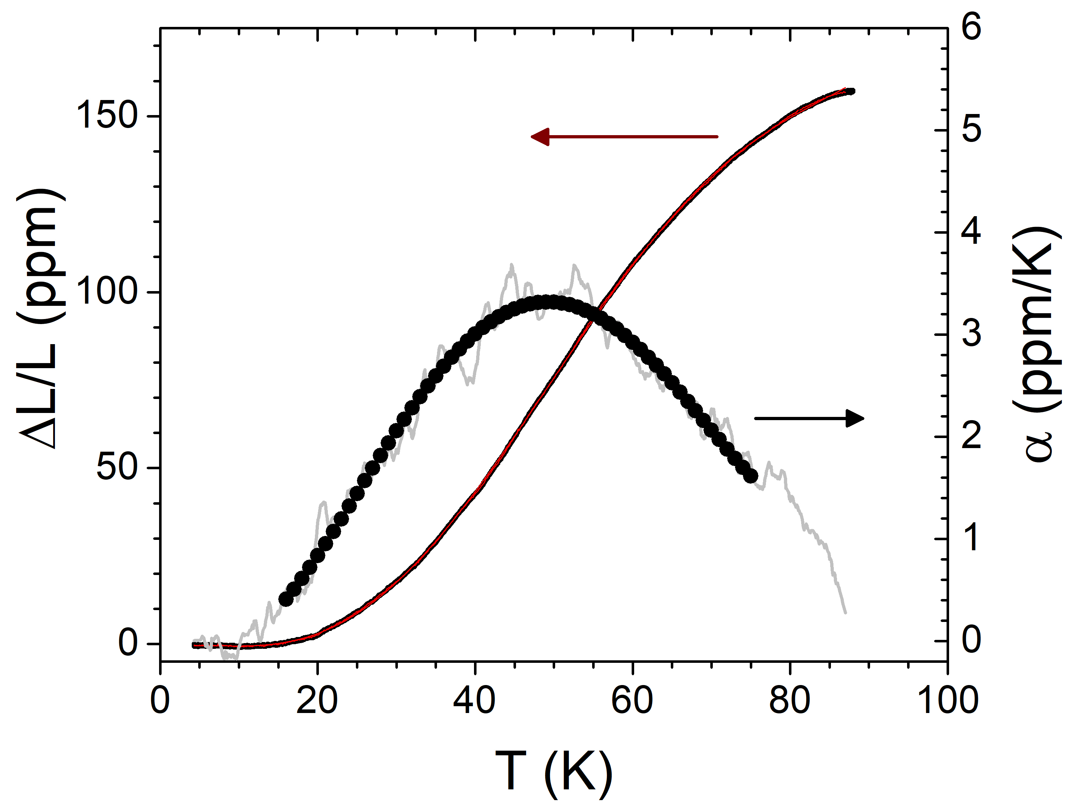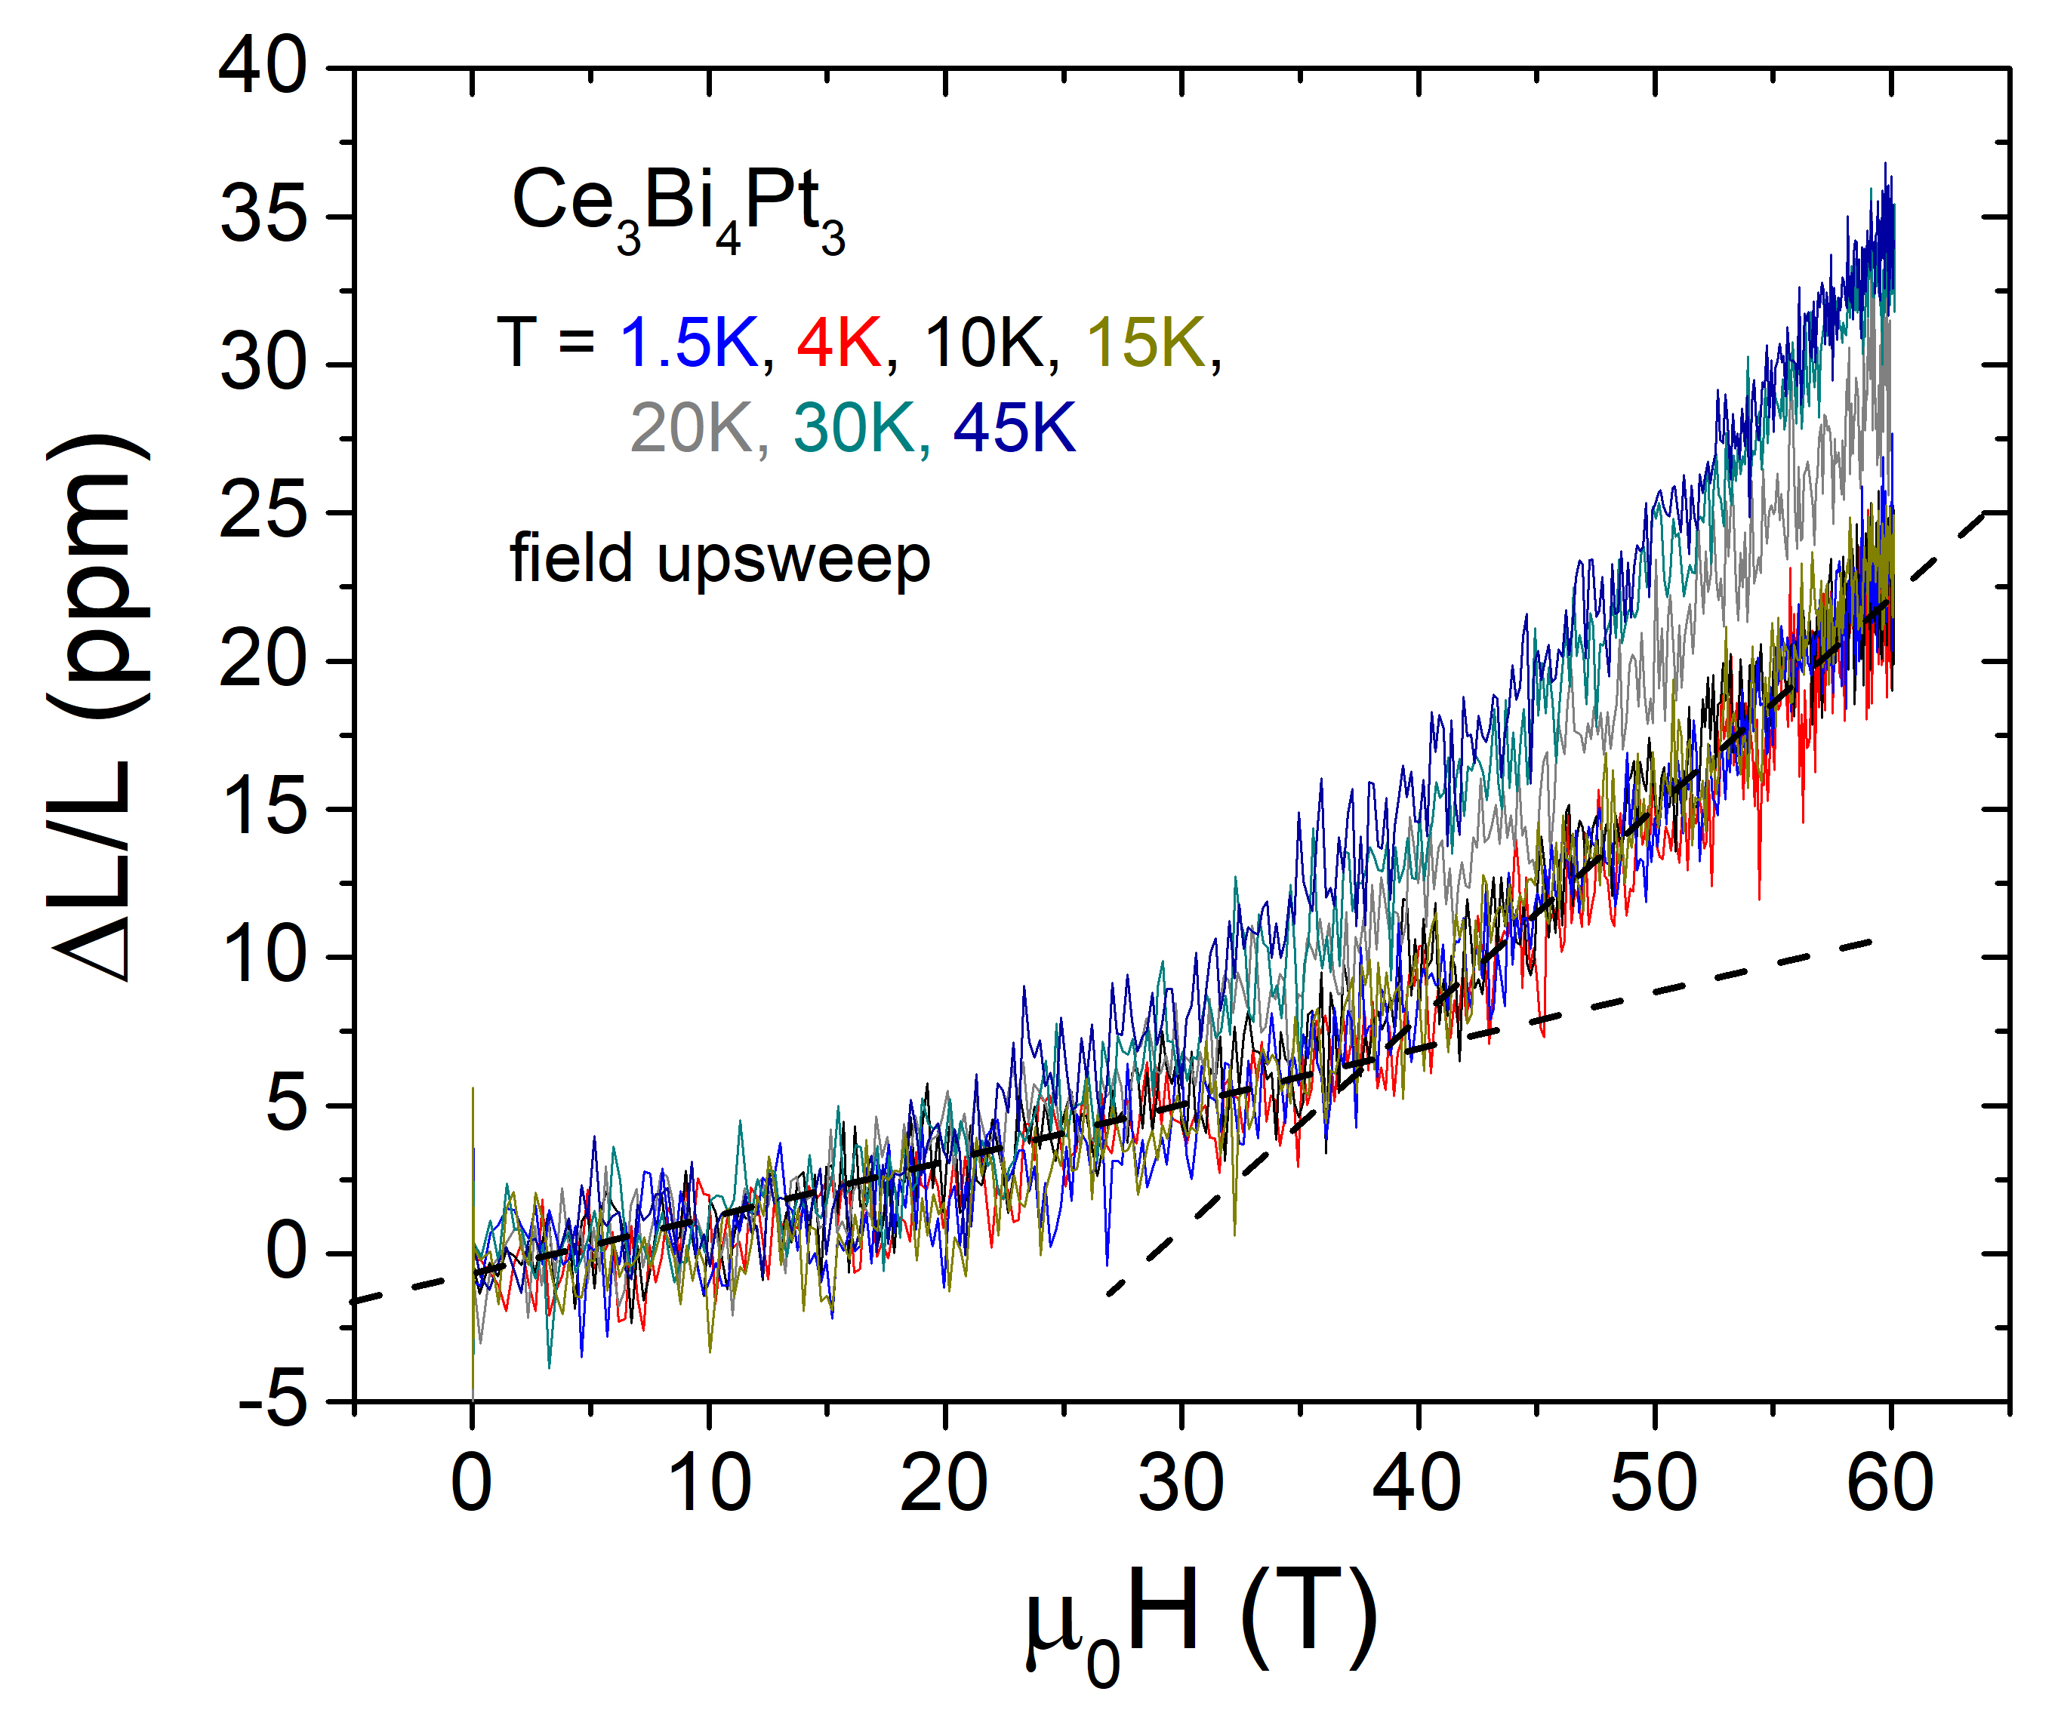
Figure 1 (left panel) The thermal expansion ΔL/L vs. T and the coefficient of thermal expansion α(T) for Ce₃Bi₄Pt₃ in zero magnetic field. (right panel) The magnetostriction ΔL/L vs H measured at various constant temperatures indicated in the label. The curves taken at the lowest temperatures T = 1.5K, 4.0K and 10K show an apparent kink at H_{K} ≈ 37K. Only field upsweep is shown, as the feature is washed out and less clear in the downsweep.

Experimental
Magnetostriction measurements in pulsed magnetic fields up to 60 T were carried out using an optical FBG technique running at 50 kHz. [4]

Results and Discussion
Figure 1 (left) shows the thermal expansion of the sample at cryogenic temperatures. The coefficient of thermal expansion displays a broad maximum at 45K, in agreement with specific heat C/T(T) measurements [1]. The magnetostriction curves obtained at temperatures 1.5K ≤ T ≤ 45K show a moderate expansion of the sample, as expected for the closure of the spin gap, and an abrupt change of slope at H_{K} ≈ 37K that agrees well with the fields at which a change in the Sommerfeld coefficient was previously reported [1]. In summary, our preliminary results are consistent with a bulk Kondo gap that can be closed with an applied magnetic field between 30T and 40T. Additional dilatometry experiments in DC magnetic fields are required to confirm our findings.

Acknowledgements
A portion of this work was performed at the National High Magnetic Field Laboratory, which is supported by National Science Foundation Cooperative Agreement No. DMR-1157490 and the State of Florida. MJ acknowledges support form DOE-BES project “Science at 100T”.

References
[1] M. Jaime, et al., Nature 45, 160 (2001).
[2] K. Sugiyama, et al., J. Phys. Soc. Jpn 57, 3946 (1988).
[3] N. Wakeham, et al., Phys. Rev. B 94 035127 (2016).
[4] M. Jaime et al., Sensors 17, 2572 (2017).

