Magnetostriction in SmB₆

Jaime, M. (Los Alamos National Laboratory); Liu, H., Hartstein, M., Davies, A.J., Sebastian, S.E. (Department of Physics, U. of Cambridge); Ciomaga Hatnean, M., Balakrishnan, G. (Department of Physics, U. of Warwick).

Introduction

The observation of quantum oscillations in the magnetization unaccompanied by oscillations in the electrical resistance of SmB₆ was reported in refs [1], [2], and [3]. Here we study accompanying effects in the crystal lattice [4] using magnetostriction measurements.

Experimental

High-purity single-crystal SmB₆ samples were grown by floating zone method and screened with Laue x-ray diffraction and inverse electrical resistivity residual ratios. The optical fibre technique was used to measure magnetostriction over a range of temperatures using the 45T hybrid magnet and a 65T pulsed magnet.

Results and Discussion

We have measured magnetostriction using facilities at the NHMFL up to 45T and at the LANL up to 60T. Fig. 1 shows the magnetostriction measured in pulsed fields on samples with a smooth surface to avoid shear lag. The data shown in Fig. 1 are seen to be dominated by mechanical vibrations (Fig. 1).

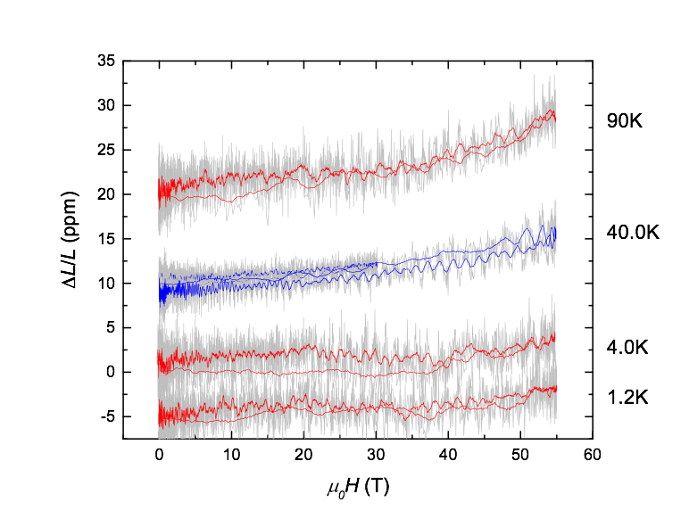
Acknowledgements

Fig. 1. Measured magnetostriction in a single crystal of SmB₆ with a 65T pulsed magnet. The data are dominated by mechanical vibrations, which are evident from the difference between the upsweeps and downsweeps.

A portion of this work was performed at the National High Magnetic Field Laboratory, which is supported by National Science Foundation Cooperative Agreement No. DMR-1157490, the State of Florida, and the Department of Energy. We also acknowledge support from the Royal Society, the Winton Programme for the Physics of Sustainability, EPSRC UK (studentship and grant number EP/P024947/1 and EP/M028771/1), and the European Research Council under the European Unions Seventh Framework Programme (grant number FP/2007-2013)/ERC Grant Agreement number 337425.

References

[1] Li, G., et al., Science, 346, 1208-1212 (2014).

[2] Tan, B., et al., Science, 349, 287-290 (2015).

[3] Hartstein, M., et al., Nat. Phys., advanced online publication (2017).DOI: 10.1038/nphys4295.

[4] Chandrasekhar, B. S., et al, Phys. Lett. 6, 27-28 (1963).

