Aging effect of Zylon
Niu, R., Han, K. and Walsh, R.P.(NHMFL)

Introduction
Zylon is used for structural reinforcement of high field pulsed magnet coils due to its high strength and high moudulus. However, Zylon exhibited an unusual sensitivity to degradation by ultraviolet light. Considering the application circumstance, we investigated the influence of laboratory lighting over prolonged time on both single and strand Zylon fiber, by comparing the mechanical strength of Zylon kept in dark bag and exposed to laboratory light.

Experimental
For the evaluation of the aging effects, some Zylon fibers were stored in black plastic bags while others were put in transparent plastic bags and left under lab lighting. These are referred to as in-dark, and light-aged Zylon, respectively. Spool #1, #2, #3 and #4 are is 8-, 6-, 4-, and 1-year old to test date, respectively.

Results and Discussion
Fig. 1(a) shows the retained strength of light-aged Zylon stands and fibers. The strand lost approximately 37% of its strength in six months and approximately 44 % in seven months. For the single fibre test, the initial strength loss is same as the strand. After 80 days, however, the strength degradation became more rapid that that of the strand. The fiber lost about 75% of its strength in three months.
In contrast, the in-dark strength of both strands and single fibers changed <9% over eight years, as shown in Fig. 1 (b). This variance in strength value is insignificant because it is within the variation (6.2%~9.1%) which is commonly observed in the same spool and spool to spool data .
Fig. 2(a) and (b) exhibit the scanning electron microcopy (SEM) observation on the surface morphology of Zylon stored with and without exposure to light. Fig. 2(a) shows clearly the fibrils in fiber, and most of the fibrils are well aligned along the fiber axis. Fig. 2(b) shows lots of scratch-like defects and debris on the light-aged Zylon. The defects width is less than 1 µm. The light-aged fiber was as well protected as the in-dark Zylon. External damage factors can be excluded. The formation of defects or debris may affect the continuity of fibrils, act as crack initiation location and accelerate crack propagation under tension.

Conclusion
Zylon remains stable and strong after aging without exposure to light for 8 years. Prolonged exposure to laboratory lighting rapidly resulted in strength degradation. Light-aging induces the surface defects. Therefore, it is necessary to protect Zylon from long-term light exposure.

Acknowledgements
This research was undertaken in National High Magnetic Field Laboratory, which is supported by US NSF DMR-1157490 and State of Florida.

References
[1] Niu, R., et al. IEEE Transactions on Applied Superconductivity. Accepted.

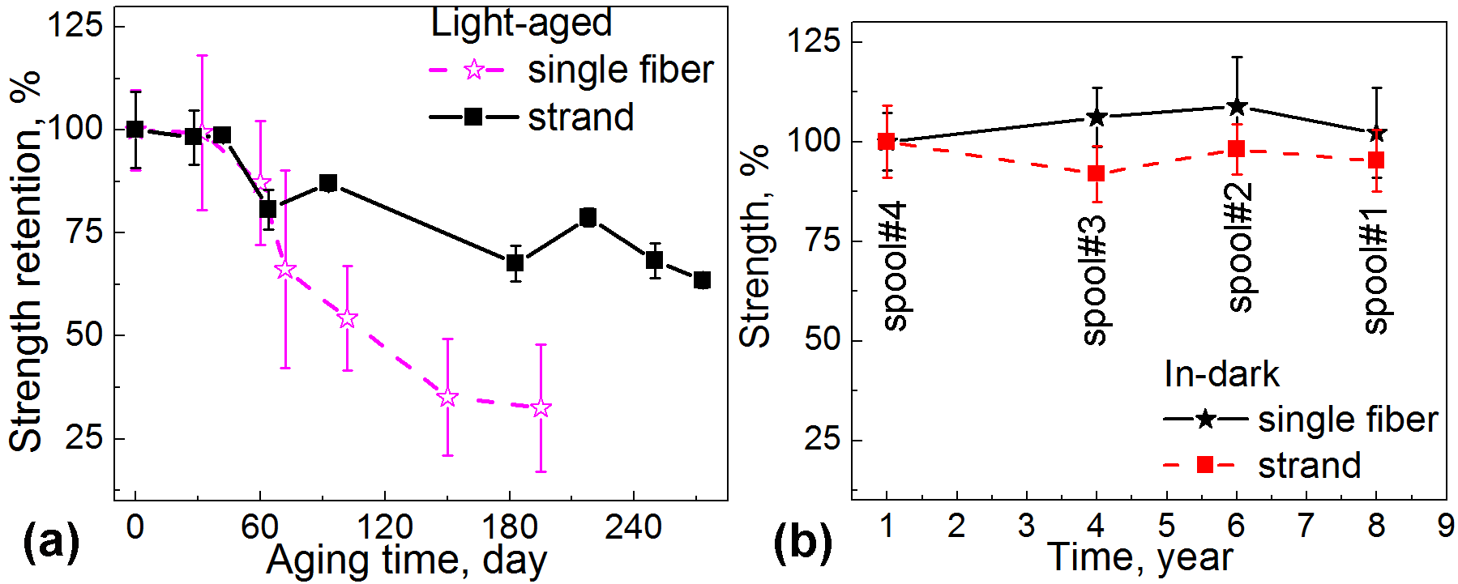 | . 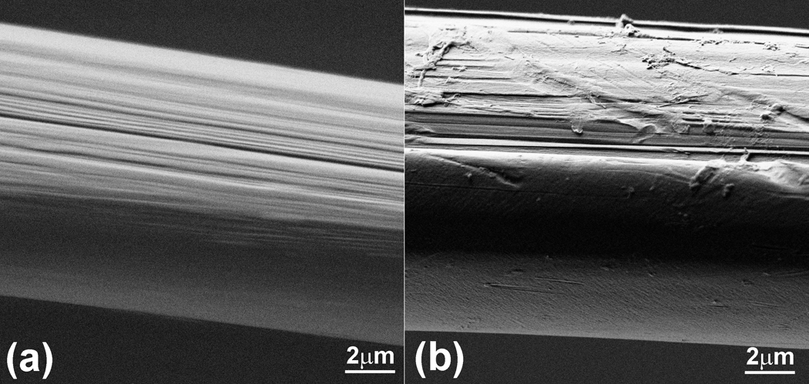
Fig.1 (a) light aging effect on the fracture strength of Zylon strands and single fiber. (b) Strength evolution of In-dark Zylon strand and single fiber. | Fig. 2. SEM (scanning electron microscopy) observation of Zylon aged in dark (a) and aged under light (b).

