NMR Structural Analysis of Sarcoplasmic Reticulum Proteins in Membranes

Veglia, G. (U. of Minnesota, Chemistry/BMBB); Gopinath, T. (U. of Minnesota, BMBB/MNMR) and Nelson, S.E.D. (U. of Minnestoa, BMBB)

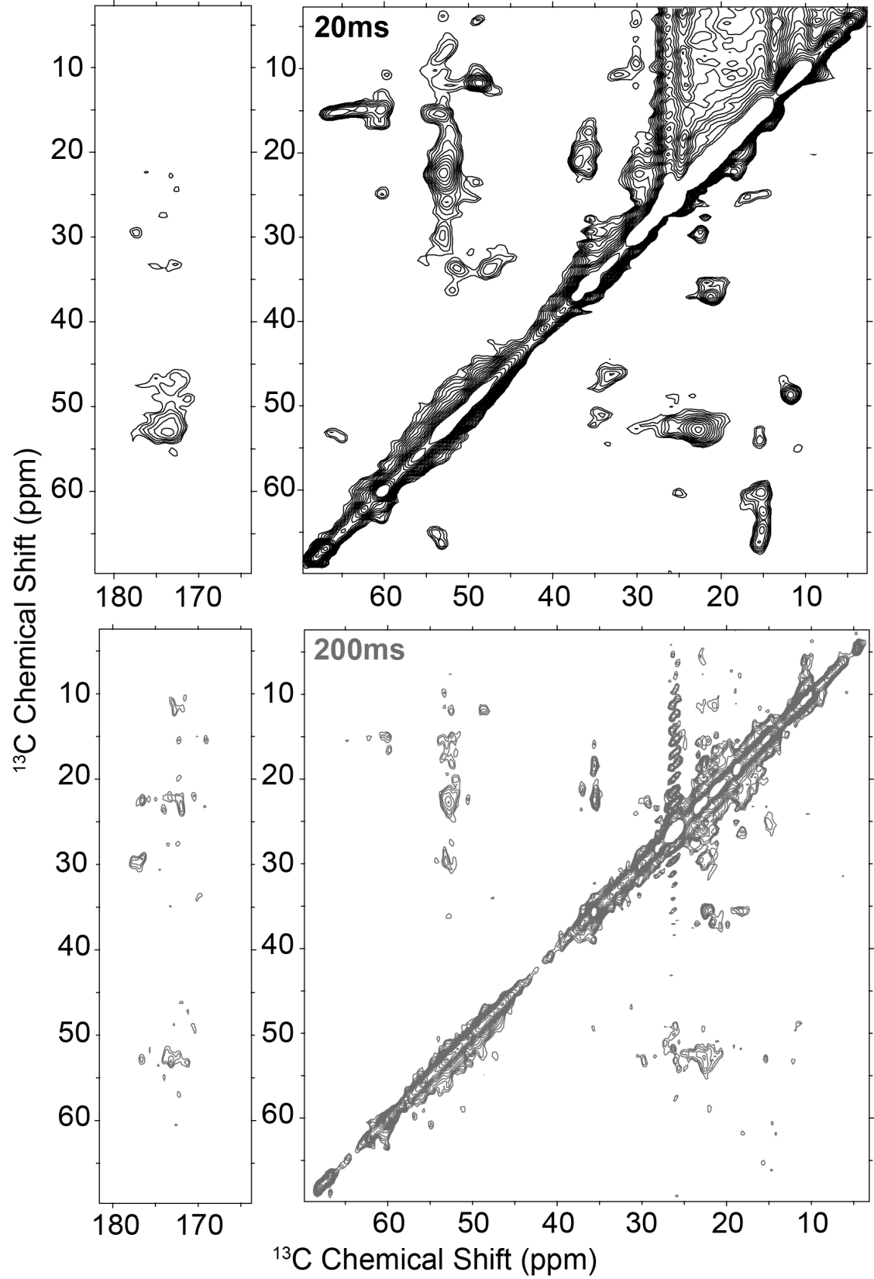
Figure 1: [¹³C, ¹³C] DARR of CaM bound to the RyR. Top, 20 ms mixing time. Bottom, 200 ms mixing time. Spectra were acquired using the 900 MHz NMR spectrometer at the NHMFL facility in Tallahassee, FL.
Introduction
We are applying NMR to map the binding interface between the calcium sensing regulatory protein, calmodulin (CaM), and the SR Ca²⁺ release channel, ryanodine receptor (RyR). Recently multiple mutations in CaM were identified in cardiac arrhythmias, and mapping the CaM-RyR binding interaction will provide valuable insights into how these mutations disrupt Ca²⁺ transport and lead to arrhythmia. MAS NMR is an ideal method to investigate the CaM-RyR complex due to the variety of available experiments in a biologically relevant lipid environment.

Experimental
CaM-RyR samples were prepared in SR tissue extracts. [¹H, ¹⁵N] INEPT and [¹³C, ¹³C] DARR spectra were acquired using both uniformly and selectively labeled CaM samples. All experiments acquired at NHMFL in Tallahassee, FL used the 800 and 900 MHz solid-state spectrometers.

Results and Discussion
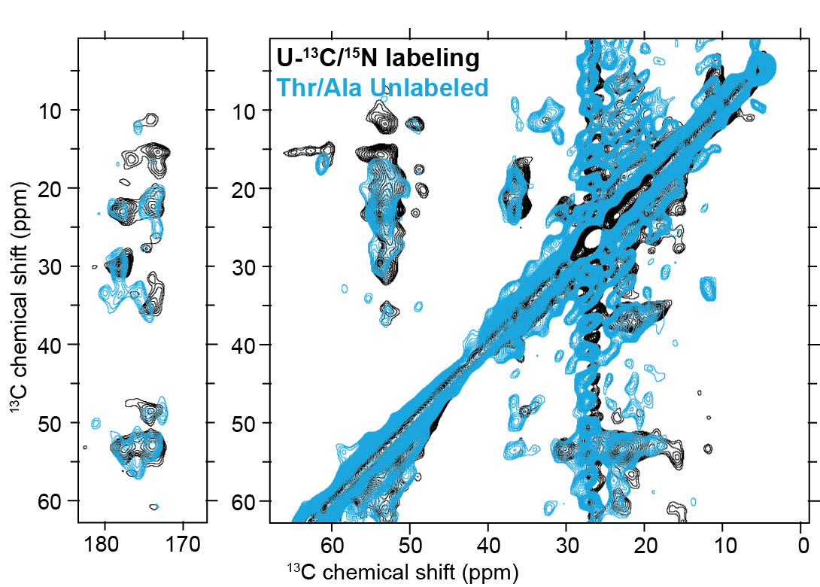
The sensitivity of the 900 MHz 105 mm solid-state spectrometer allowed for the acquisition of well resolved [¹³C, ¹³C] DARR spectra of CaM in complex with the RyR at a variety of mixing times (Fig. 1). These spectra indicate that certain regions of CaM sample different dynamic regimes, an observation we have confirmed through acquisition of INEPT-based experiments. To aid in resonance and domain assignment we acquired [¹³C, ¹³C] DARR spectra on samples of reverse unlabeled CaM (Fig. 2) and selectively labeled CaM in complex with the RyR. Our selective labeling strategies focused on key residues in CaM’s binding interaction identified via peptide and mutation studies, and have provided a strong foundation for building a residue-specific model of CaM binding to the RyR [1,2]. In particular, the [¹H, ¹⁵N] INEPT spectra have proved extremely valuable as they provide a direct comparison to solution NMR spectra of unbound CaM. In addition, the increased sensitivity provided by the 900 MHz spectrometer at the NHMFL has allowed us to detect the multiple dynamic states CaM populates during its binding interaction with the RyR. Identification of these states, coupled with our studies on the membrane-bound SERCA-PLN complex, also prompted our laboratory to develop new pulse sequences that utilize ¹H detection to enhance sensitivity [3, 4].

Acknowledgements
The spectra shown were acquired at the National High Magnetic Field Laboratory, which is supported by National Science Foundation Cooperative Agreement No. DMR-1157490 and the State of Florida. Research funding for was provided by NIH grant GM64742 and AHA Pre-doctoral Fellowship 16PRE27770056.

References
Figure 2: Selective unlabeling resolved residue type. Overlay of uniformly ¹³C/¹⁵N labeled (black) and Ala/Thr reverse unlabeled (blue) [¹³C, ¹³C] DARR spectra for CaM bound to the RyR. Spectra were acquired on the 900 MHz spectrometer at the NHMFL facility in Tallahassee, FL with a mixing time of 300 ms at 25ºC.
[1] Nelson, S.E.D., et al., Angew Chem., in prep.
[2] Nelson, S.E.D. Thesis.
[3] Gopinath, T., et al., J Magn Reson, 285, 101-107 (2017).
[4] Gopinath, T., et al., J Phys Chem B, 121(17), 4456-4465 (2017).

