Spin-Echo Based Diagonal Peak Suppression in Solid-State MAS NMR Homonuclear Chemical Shift Correlation Spectra

Wang, K. (NHMFL and Xiamen U., Electronic Science); Zhang, Z. (Weizman Institute of Science, Chemical Physics ); Ding, X. and Tian, F. (Pennsylvania State U., Biochemistry & Molecular Biology); Huang, Y. and Chen, Z. (Xiamen U., Electronic Science) and Fu, R. (NHMFL)

Introduction
So far, suppression of diagonal peaks in solid-state correlation experiments has not yet been reported in the literature. Here, we demonstrate the feasibility of extending the spin-echo based method in solution NMR [1, 2] to suppress diagonal peaks in solid-state MAS NMR homonuclear chemical shift correlation experiments. A complete phase cycling is designed and a data processing procedure is further introduced to reconstruct this acquired spectrum into a conventional two-dimensional homonuclear chemical shift correlation spectrum.

Experimental
Two uniformly ¹³C, ¹⁵N labeled samples, Fmoc-valine and LR11 TM (sorLA) in native E. coli membrane vesicles have been used to illustrate the capability of the proposed method in comparison with standard ¹³C-¹³C chemical shift correlation experiments. All NMR experiments were carried out on a Bruker Avance 600 MHz NMR spectrometer operating at the resonance frequency of 600.13 MHz for ¹H and 150.82 MHz for ¹³C using a NHMFL 3.2 mm low-E double-resonance biosolids MAS probe [3]. The spinning rate for Fmoc-valine is 14 kHz ± 3 Hz.
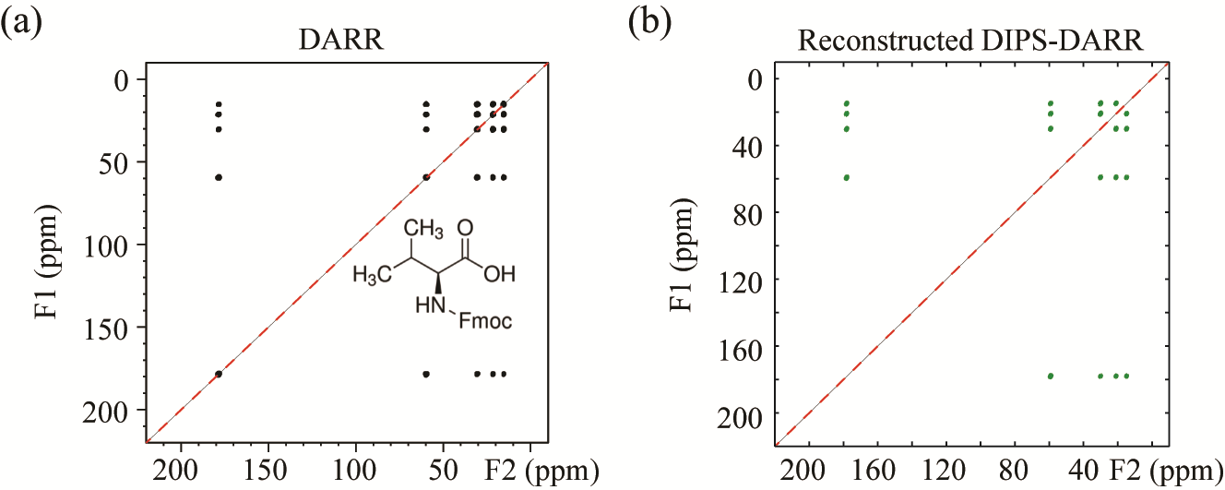
Results and Discussion
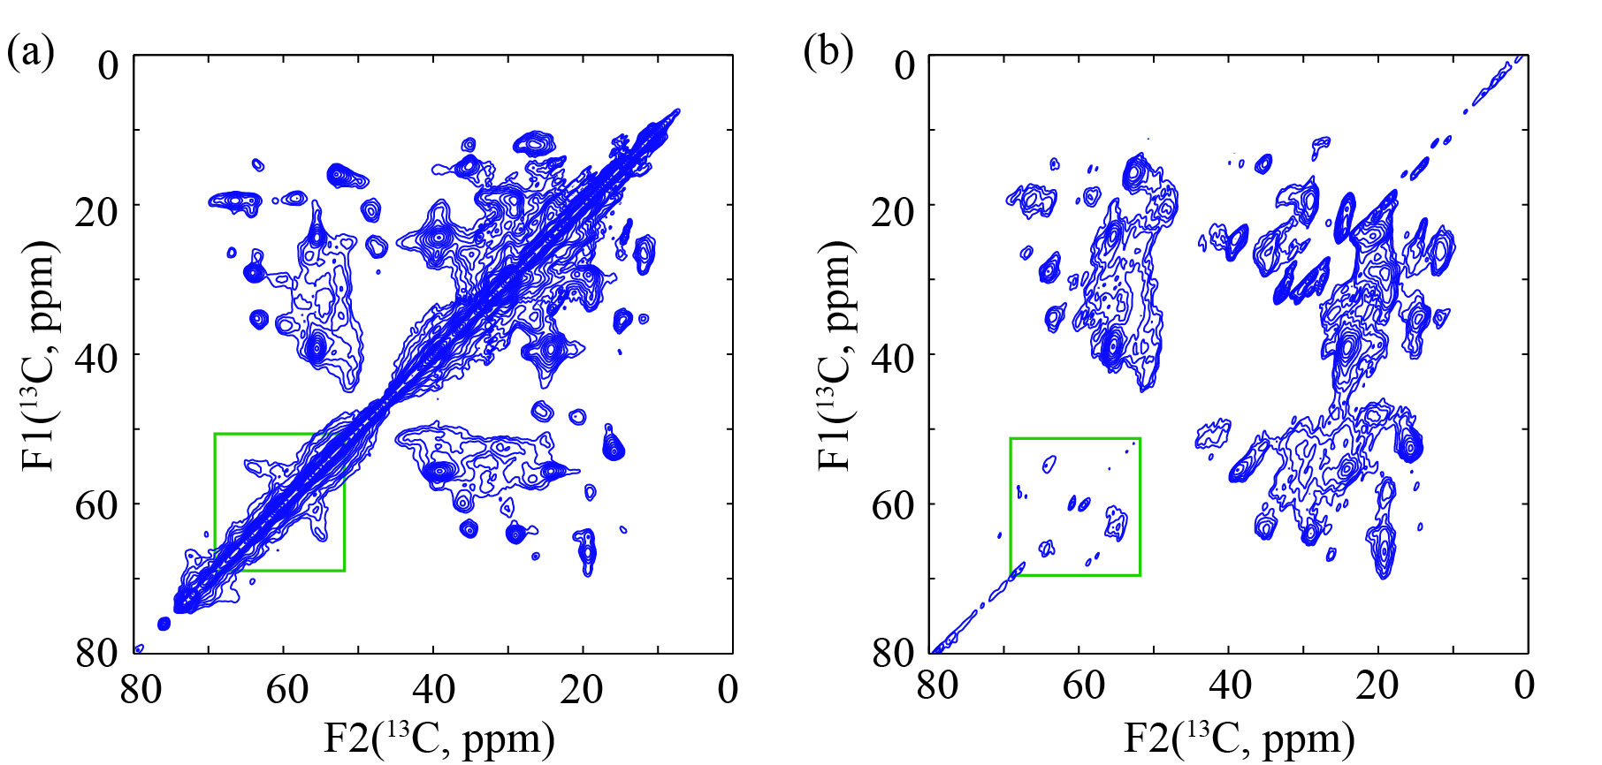
By using the spectra of the uniformly labeled Fmoc-valine sample in Fig. 1 for quantification, we discover that 99% of the diagonal peak intensities could be suppressed, while at least 50% of the cross peak intensities remain in the reconstructed spectrum. In comparison with the standard DARR spectrum of the protein in Fig. 2(a), the reconstructed DIPS-DARR spectrum with greatly reduced diagonal signal in Fig. 2b shows that some cross peaks nearby the diagonal axis can be easily identified such as those in the green boxed region as well as in the region of 20-30 ppm .
Fig.1 Experimental results of Fmoc-valine sample. (a) The standard DARR spectrum. (b) Reconstructed DIPS-DARR spectrum.

Conclusions
The spin-echo based diagonal peak suppression method, originated from solution NMR experiments, is adapted for the first time in solid-state MAS NMR to eliminate the diagonal signals. It is anticipated that this efficient diagonal peak suppression method will be beneficial for resonance assignments and protein structural characterizations.

Acknowledgements
Fig.2 Experimental results of ¹³C, ¹⁵N-labeled LR11 TM in native E. coli inner membrane vesicles. (a) The standard DARR spectrum. (b) The reconstructed DIPS-DARR. The spectra were recorded at 280 K on a Bruker Avance 600 MHz NMR spectrometer. The sample spinning rate was 12 kHz ± 3 Hz. spectrum.
All NMR experiments were carried out at the NHMFL, supported by NSF DMR-1157490 and the State of Florida. This work is also in part supported by National Natural Science Foundation of China No. U1632274.

References
[1] Glanzer, S.E., et al., J. Magn. Reson., 232, 1-6 (2013).
[2] Harbison, G.S., et al., J. Am. Chem. Soc., 107, 5567-5569 (1985).
[3] Gor’kov, P.L., et al., J. Magn. Reson., 185, 77-93 (2007).

