Augmented Tune/Match Circuits for
High Performance Dual Nuclear Transmission Line Resonators

Erickson, M.G. (UF, Division of Infectious Diseases and Global Medicine)

Introduction
This year saw definitive testing of the fundamental design change mentioned in last year’s report. Suffice it to say, all expectations were met or exceeded. In addition to some experimental work, much time and effort was devoted to the filing of a preliminary patent application, and to presenting the work at the 2017 Experimental NMR Conference in Asilomar, California.

Experimental
The single loop coil surface coil fabricated on copper clad Rexolite 1422 was configured as before with both hybrid termination stubs and hybrid notch filters. A slight difference was made in the adjustment procedure. After getting a “rough cut” setting with the grid dip oscillator, fine adjustments to the two notch filters were made using an Agilent network analyzer set for S₂₁ measurements. By using this method, significant improvements in both carbon/proton and proton/carbon port to port isolation were made.
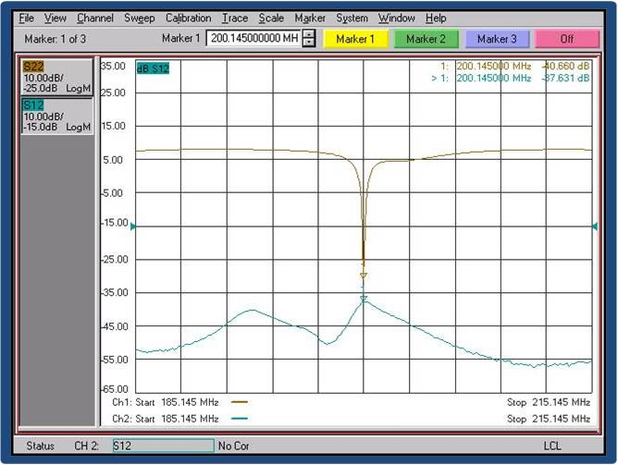
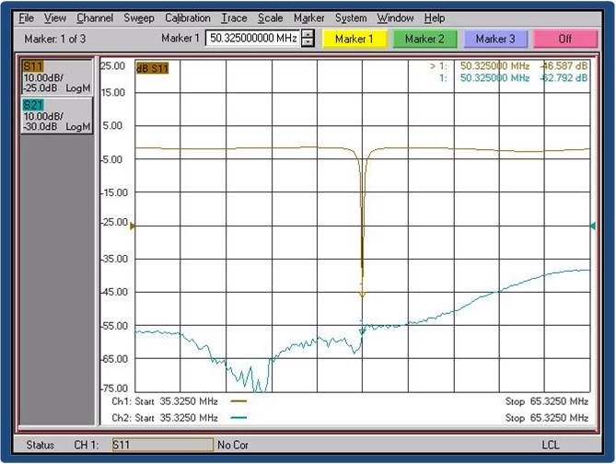
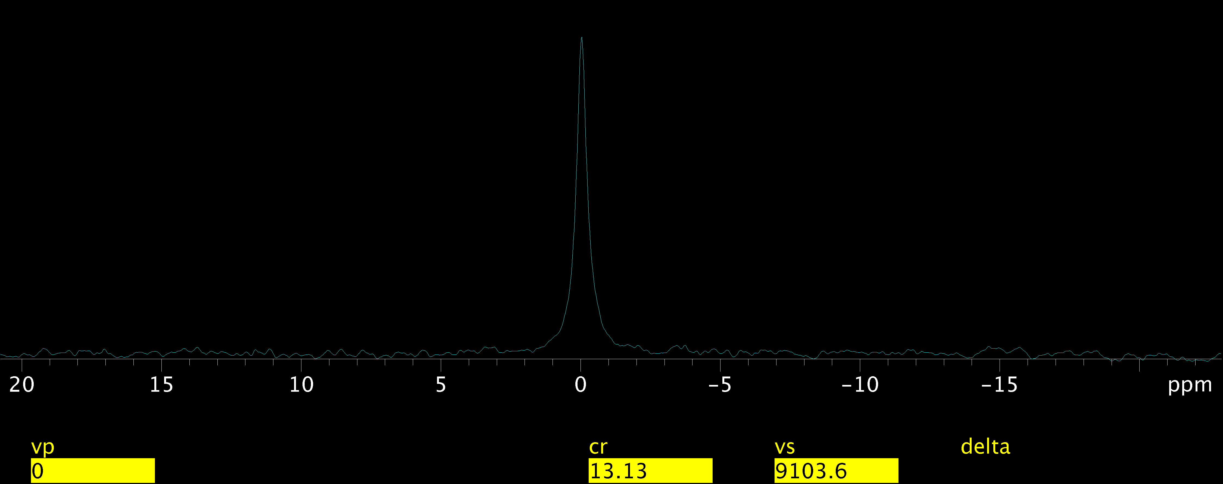
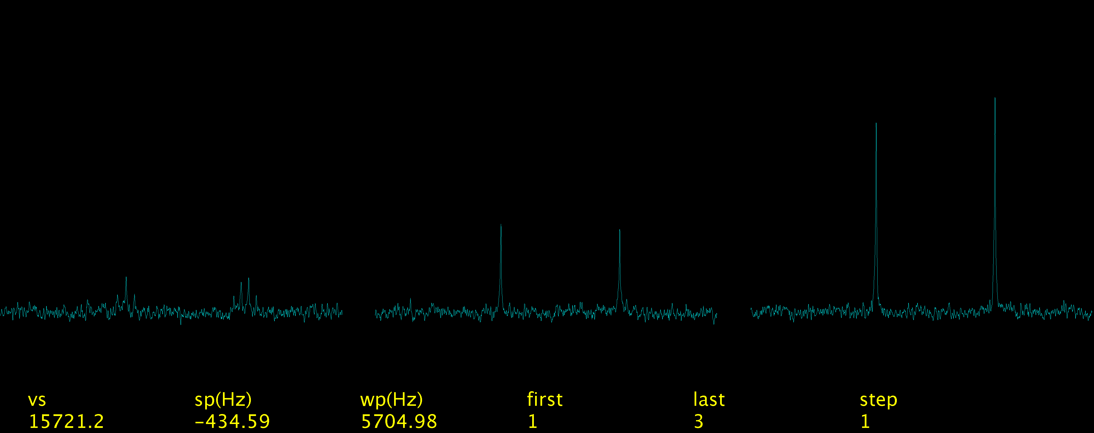
New magnet tests were made as well. A ¹³C urea phantom produced the ¹³C peak shown after shimming on ¹H. No retuning or repositioning of the coil was required; each nucleus was called up sequentially on the console. Finally, some proton decoupling experiments were performed using natural abundance ethanol. As before, ¹³C spectra were obtained after shimming on 1H with no tuning or readjustment. Both standard ¹H decoupled spectra and NOE enhanced spectra were easily obtained without retuning, cable swapping, or physical manipulation. In all situations, tuning of each resonance was smooth and easy, with no observable cross talk between ¹H and ¹³C.
Figure 1: S12 measurement of ¹H isolation from ¹³C port.
Figure 3: ¹³C spectrum of urea phantom with no retuning of coil.
Figure 4: ¹³C spectra at natural abundance of ethanol. Left to right: No ¹H decoupling, ¹H decoupling, ¹H decoupling with NOE enhancement.
Figure 2: S21 measurement of ¹³C isolation from ¹H port.
Results and Discussion
Port to port isolation was superb, as shown in Figures 1 and 2. Since the time of these measurements, ¹H isolation from the ¹³C port has been improved to better than -45dB, and the ¹³C isolation from the ¹H port exceeds -65 dB. Unloaded Q’s for the ¹H resonator and the ¹³C resonator were measured to be 250 and 200, respectively. The ¹³C spectrum of the urea phantom is shown in Figure 3, and the ¹³C proton decoupled spectra of natural abundance ethanol are shown in Figure 4.

Conclusions
The dual nuclear transmission line resonator design has been perfected and experimentally verified. The design shows much promise, as it can be extended to virtually all 1H/X pairs. The final step in this saga will be the construction of several “production coils” built around Rexolite 1422 stripline circuits. Both surface coils and volume coils are planned. This approach will make for compact and sturdy embodiments of the design. We also anticipate significant enhancements in unloaded Q over the prototype reported here. The Gainesville RF lab now has a computer controlled router suitable stripline work.

Acknowledgements
Much of this work was performed at the National High Magnetic Field Laboratory, which is supported by National Science Foundation Cooperative Agreement No. DMR-1157490 and the State of Florida.

