Time-dependent changes in magnetic resonance electrical impedance tomography phase-sensitive images resulting from magnetic field instability

Kasinadhuni, A.K. (UF, Biomed. Eng); Indahlastari, A., Chauhan, M. (ASU, Biomed. Eng.); Schär, M. (JHU, Radiology); Sadleir, R.J. (ASU, Biomed. Eng.), and Mareci, T.H. (UF, Biochem.)

Introduction
In phase-sensitive MR imaging, background spatial variations in magnetic fields (e.g. inhomogeneity) must be minimized, and the static and dynamic (i.e. RF) magnetic fields must be stable during the measurement; particularly for the measurement of phase shifts produced by nano-Tesla fields induced by electric current distribution in the brain during transcranial electric stimulation (tES). To measure tES induced phase changes using MR electric impedance tomography (MREIT) [1], spatial variations in the background magnetic fields is effectively removed by a complex division of two images acquired with opposite polarity of the electric current simulation. However, temporal instability in the imaging magnetic fields can obscure the current-induced phase from tES, so we developed a MREIT acquisition scheme to reduce the effect of temporal instability.
Experimental
Data were measured using in a Philips Achieva scanner using a 3 T magnet with passive iron shims. MREIT acquisitions using a multiple gradient echo protocol, modified to produce a TTL-logic pulse after each MR excitation pulse [2]. For MREIT with tES, this TTL pulse triggers a MR-safe battery-operated constant current source. To evaluate the effect of temporal magnetic-field instabilities, we acquired ‘no current’ MREIT images of an agarose phantom using two MREIT acquisition schemes. For both schemes, MREIT scans were performed for each slice sequentially, and comprised 100 phase encode (PE) steps for each slice. For each PE step, ten echoes were acquired during 32 msecs (when a current would be injected) within a TR of 50 msecs. This sequence was repeated 12 times to improve the signal-to-noise ratio. Therefore, the total acquisition time for a ‘no current’ MREIT image was 3 minutes. In the first scheme, the first image (equivalent to acquiring with one polarity) was divided by a second image (equivalent to acquiring with opposite polarity) to determine the phase variation due to temporal magnetic field stability. The second scheme is identical to the first except the measurements from adjacent intervals is divided before the image is reconstructed (equivalent to alternating the polarity of every other current pulses).
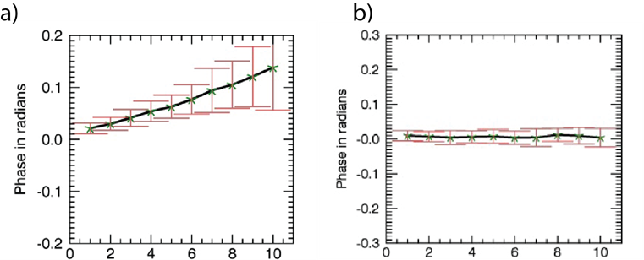
Results and Discussion
The variation of the mean phase in a 20 x 20 voxel region-of-interest drawn in the center of the phantom image is shown here. The horizontal axis in each plot represents the echo number. In a), phase is calculated by complex dividing two images measured sequential with a temporal separation of about 3 minutes, which represents the acquisition time a MREIT image with one polarity. In b), phase is obtained by complex dividing data after each PE step (equivalent to current polarity reversal with each PE). From the results in a), the calculated rate of phase change is -0.573 Hz/hour (-0.0045 ppm/hour at @ 128 MHz). An exceptional persistent superconductive magnet has a decay rate of -0.004 ppm/hour caused by the resistance of the superconductive joints [3]. This implies that the observed phase change results from main-field drift.
Conclusions
Careful consideration of pulse sequence timing allows the measurement of subtle magnetic field changes (e.g. induced by the electric current stimulated in the brain) in the presence of a downfield drift of main magnetic field. In practice, this allowed the use of MREIT to measure current density in the human brain in vivo [2].
Acknowledgements
A portion of this work was performed at the National High Magnetic Field Laboratory, which is supported by National Science Foundation Cooperative Agreement No. DMR-1157490 and the State of Florida, and grant R21NS081646 from the National Institutes of Health.
References
[1] E. J. Woo and J. K. Seo, Physiological measurement 29 (10), R1-26 (2008).
[2] A. K. Kasinadhuni, et al., Brain Stimul 10 (4), 764-772 (2017).
[3] G. D. Brittles, et al., Supercond Sci Tech 28 (9) (2015).

