Overhauser Effect in Solutions: Electron Spin Characterization

Akindeferin, A. (FSU, Physics); van Tol, J., Dubroca, T. (NHMFL); Hill, S. (NHMFL and FSU Physics) and Frydman, L. (Weizmann Institute of Science, Rehovot, Israel and NHMFL)

Introduction
The governing polarization mechanisms for Dynamic Nuclear Polarization (DNP) are Overhauser Effect (OE), Solid Effect (SE), Cross Effect (CE) and Thermal Mixing (TM). The Overhauser Effect has been observed historically in metals because of the presence of mobile electrons, but it is also the main mechanism in solution state DNP. The gain in sensitivity offered by DNP could be of great value for high resolution solution state NMR. We aim to implement this ¹³C and ¹H NMR for relatively large samples in a variety of systems. The DNP efficiency is dependent on various parameters like viscosity, temperature, molecule size, rotational correlation times, radical concentration etc. We have used high field electron paramagnetic resonance (HFEPR) at 120-336 GHz to characterize the various radical systems used for the development of solution-state DNP at 395 GHz, as a function of the temperature, concentration, and solvent.

Experimental
High field EPR spectra at 120, 240, and 336 GHz were recorded on the home-built multi-frequency quasi-optical spectrometer at the NHMFL based on a 12.5 T SC magnet. The samples were solutions of radicals in various non-polar organic solvents. The typical sample volume is 30 µl, and concentration range from 0.1 mM to 100 mM.

Results and Discussion
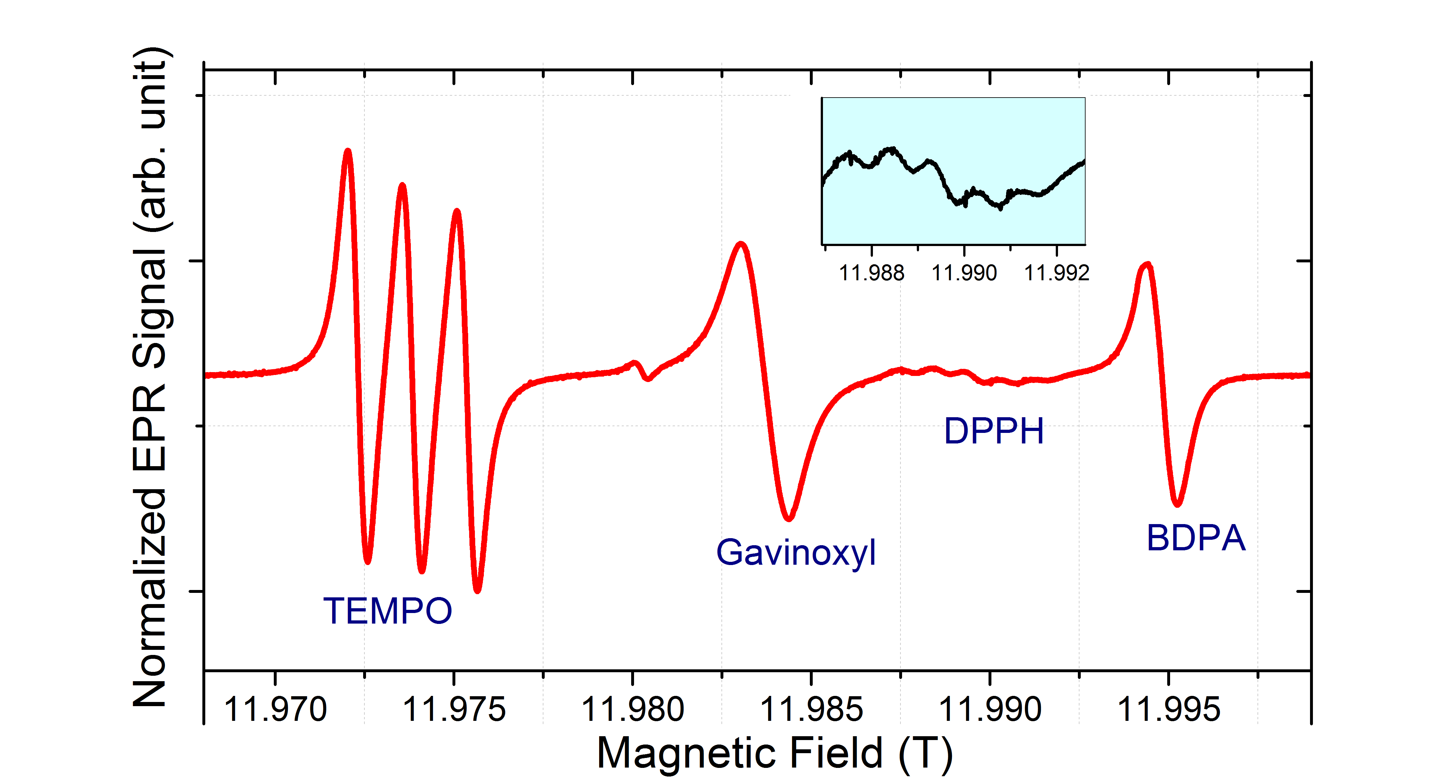
Accurate g-values were obtained for the different radicals used for DNP, and it was observed that in the temperature and concentration regime for liquid state DNP, the EPR lineshape depends strongly on temperature, radical concentration, and viscosity of the solvent solution, especially for the nitrogen containing radicals TEMPO and DPPH due to spin exchange processes. These and further measurements in conjunction with DNP measurements will help to optimize the radical systems for DNP-enhanced liquid state NMR at 14 T.
Fig.1 Room temperature CW-EPR Spectra for a solution of benzene and 10mM each of TEMPO, Gavinoxyl, DPPH and BDPA radical at 336GHz.

Acknowledgements
This work was funded by the National Science Foundation through the MRI grant CHE-1229170 and partially supported by the NHMFL User Collaboration Grant Program. This work was performed at the National High Magnetic Field Laboratory, which is supported by National Science Foundation Cooperative Agreement No. DMR-1157490 and the State of Florida.

References
[1] Dubroca, T., et al., J. Magn. Reson., under review (2018).

