Pulsed EPR at 395 GHz of Impurities in MgO

van Tol, J., Dubroca, T. (FSU, Physics and NHMFL); Jurado, G. and Akindeferin, A. (FSU, Physics)

Introduction
Commercial pulsed EPR instruments are limited to 263 GHz and carry a high price tag. In order to measure pulsed EPR at 395 GHz to characterize relaxation of spin systems used at these frequencies for Dynamic Nuclear Polarization (DNP) at our laboratory and elsewhere, we have built a 395 GHz spectrometer and performed initial experiments [1].
The main purpose of the 395 GHz equipment is to incorporate it into the existing DNP set-up for in-situ cw EPR in the MAS-DNP and the Overhauser DNP setups. This will allow a precise determination of the EPR spectra of the ‘DNP-juice’ and can be used to monitor sample quality/degradation. It will be available to users in the near future.

Experimental
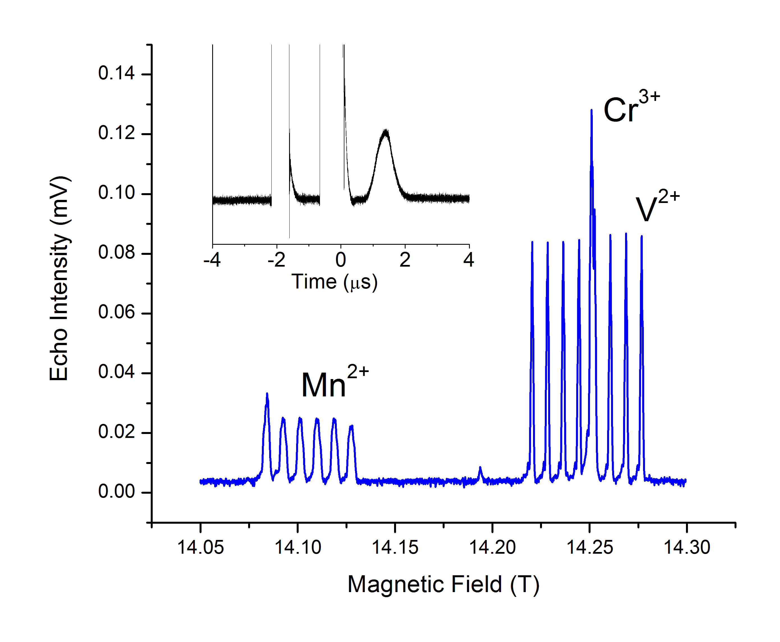
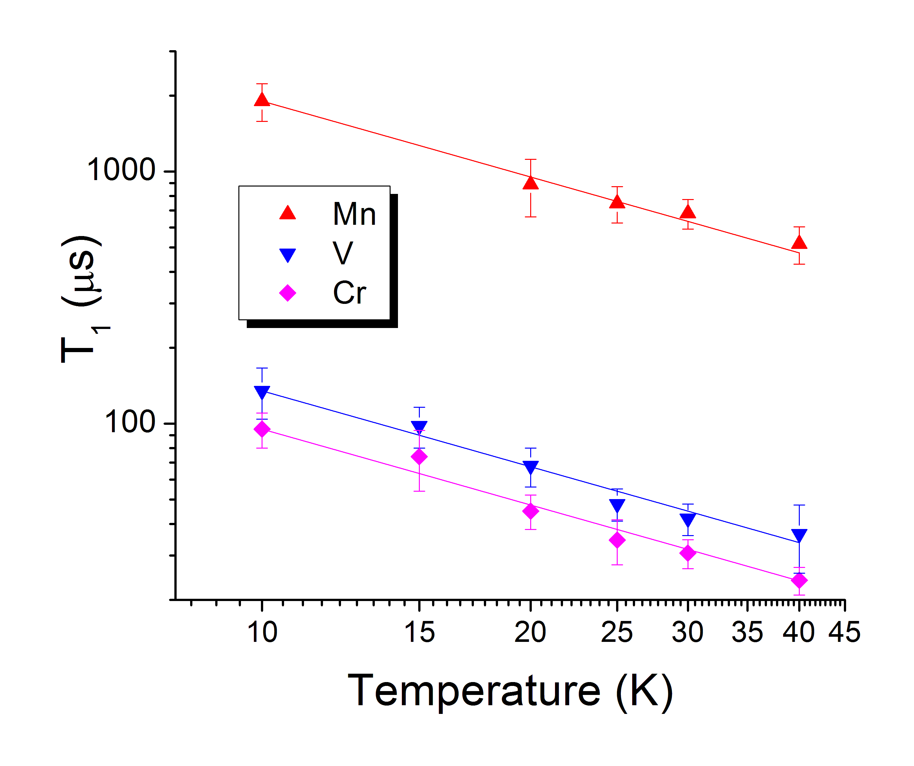
The spectrometer source is a solid state multiplication chain delivering 20 mW over a 390-400 GHz band, with the phase sensitive detection system having as its primary element a 2nd harmonic mixer with its 195 GHz local oscillator (LO) generated by a similar multiplication chain (both Virginia Diodes Inc.). A quasi-optical (QO) bridge provides for attenuation, isolation, and polarization control. The linearly polarized millimeter-wave pulses excite the electron spins in the sample, currently without resonator. The signal is detected in the perpendicular polarization. The test sample is an MgO single crystal substrate containing Mn²⁺, V²⁺, and Cr³⁺ impurities.
Fig.1 Echo-detected EPR spectrum of impurities in MgO at 395 GHz and 5 K. The inset shows the time domain response.
Fig.2 Spin Lattice relaxation times (T₁) of impurities in MgO at 395 GHz. Lines represent a linear dependence of (1/T₁) versus Temperature.

Results and Discussion
We successfully tested pulsed EPR at 395 GHz on impurities in MgO at low temperature and an organic radical at room temperature. The spin lattice relaxation rate of impurities in MgO at 395 GHz is linear with temperature between 10 and 40 K indicating a dominant direct process that is about 8 times faster at 14.1 T compared to 4.3 T.

Conclusion
We have successfully tested a new setup for pulsed and CW EPR at 395 GHz. It will be available to outside users for in-situ EPR in the liquid and solid state DNP-NMR spectrometers.

Acknowledgements
This work was supported by the NHMFL User Collaboration Grant Program, and was performed at the National High Magnetic Field Laboratory, which is supported by National Science Foundation Cooperative Agreement No. DMR-1157490 and the State of Florida.

References
[1] Dubroca, T., et al., 2017 IEEE MTT-S International Microwave Symposium (IMS), 1400-1403, (2017).

