Overhauser Dynamic Nuclear Polarization in Liquids at 14.1 T

Dubroca, T., McKay, J., Trociewitz, B., Mentink, F., Wi, S., van Tol, J., Brey, W. (NHMFL); Frydman, L. (NHMFL and Weizmann Institute); Long, J.R. (NHMFL and UF, Biochemistry and Molecular Biology); Hill, S. (NHMFL and FSU, Physics)

Introduction
Nuclear magnetic resonance (NMR) is an intrinsically insensitive technique, with a Boltzmann distribution of nuclear spin states often no greater than one in a million. In order to overcome this limitation dynamic nuclear polarization (DNP) is used to gain up to two orders of magnitude in signal enhancement, which can decrease experimental time by up to four orders of magnitude. In DNP experiments NMR signal enhancements are obtained by transferring the larger electron polarization to NMR active nuclei via microwave irradiation. The DNP mechanisms, cross, solid or Overhauser effect, have a complex dependence on the experimental conditions but in short, improving the signal to noise ratio, or polarization enhancement, gets more challenging with increasing magnetic field. We present here the development of liquid DNP at high field (hardware and results).

Experimental
We use a 395 GHz gyrotron microwave source to perform Overhauser DNP on a 14.1 T (1H 600 MHz) spectrometer for solution state NMR (Fig.1 left). Our gyrotron is shared between two DNP spectrometers (the Overhauser instrument presented here and a Bruker Magic Angle Spinning DNP system). The microwave beam system has been designed and built such that it can be used to adjust the beam power and polarization state going to the sample in the Overhauser DNP spectrometer. A custom probe was design and built for this spectrometer. Note: this instrument will become part of the user facility once its development is finalized.

Results
Fig.1 (center) displays the Overhauser DNP enhancement for 31P, at room temperature and 14.1 T. An enhancement factor of 160 is observed. These results were obtained for triphenylphosphine with BDPA radical in deuterated benzene solvent. Finally, Fig.1 (right) displays the enhancement as function of the magnetic field.

Acknowledgements
A portion of this work was performed at the National High Magnetic Field Laboratory, which is supported by National Science Foundation Cooperative Agreement No. DMR-1157490 and the State of Florida. This work was also supported by the National Science Foundation award No. CHE-1229170.

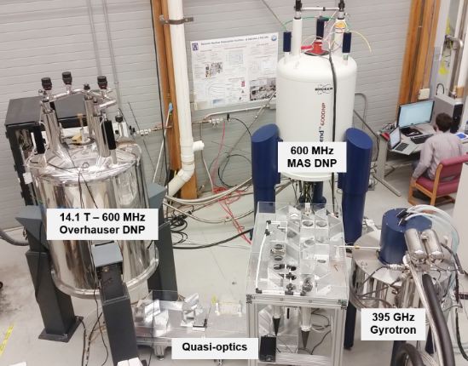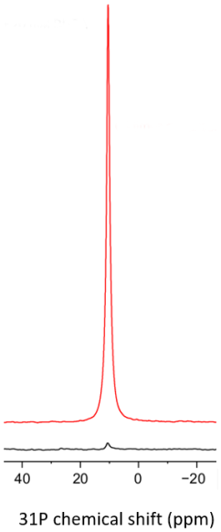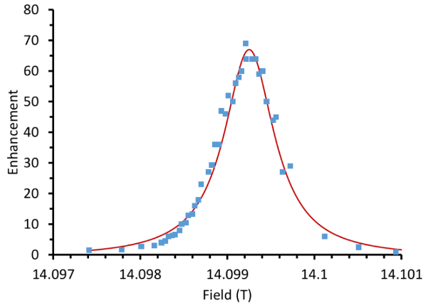
Fig.1 Left: Dual DNP instrument (Overhauser and Magic Angle Spinning) both operating at 600 MHz using a common source of microwaves, a 395 GHz gyrotron. The microwave beam is split in two by a quasi-optics table. The microwave beams are controlled (power, polarization) separately for each system. Center: NMR spectra of 650 mM triphenylphosphine with 20 mM BDPA radical in d8-toluene at room temperature, with and without microwaves showing an enhancement of 160x. Right: same sample, enhancement as function of the magnetic field.

