Out of Equilibrium Effects in a Quantum Magnet

Reeder, T.R. (Colorado State U.); Zhou, H. (U. of Tennessee), and Ross, K.A. (Colorado State U.)

Introduction
We studied the ac magnetic susceptibility of CoNb₂O₆ under an applied dc field. This material is an example of the “transverse field Ising model”, hosting a field-tuned quantum critical point (QCP) at 5.5 T between an ordered antiferromagnetic state and a polarized paramagnet [1]. We aimed to measure the effect of varying the quench rate across the QCP (i.e., varying dB/dt) on the generation of topological defects in the ordered state of CoNb₂O₆. The c-axis ac susceptibility has previously been suggested as measure of the domain wall density [2]. We used a 35T magnet to achieve a wide range of quench rates which are not possible with conventional superconducting magnets. The experiment did not yield the expected results (power law scaling of defect density with quench rate), but instead revealed other intriguing phenomena which we believe are related to the “critical quench rates” of glass formation, where the fluctuations controlling the crystallization vs. glass formation are quantum rather than thermal.

Experimental
We grew a single crystal of CoNb₂O₆ via optical floating zone method. The crystal was mounted in an ac coil-set on a 90 degree rotation stage, allowing us to apply the dc magnetic field along the crystallographic b axis (transverse to the Ising direction) while measuring the ac susceptibility along the c axis (to probe the domain wall defects). The ac coil-set was placed at the end of a 3He insert for the 35 T resistive magnet in Cell 9.

Results and Conclusion
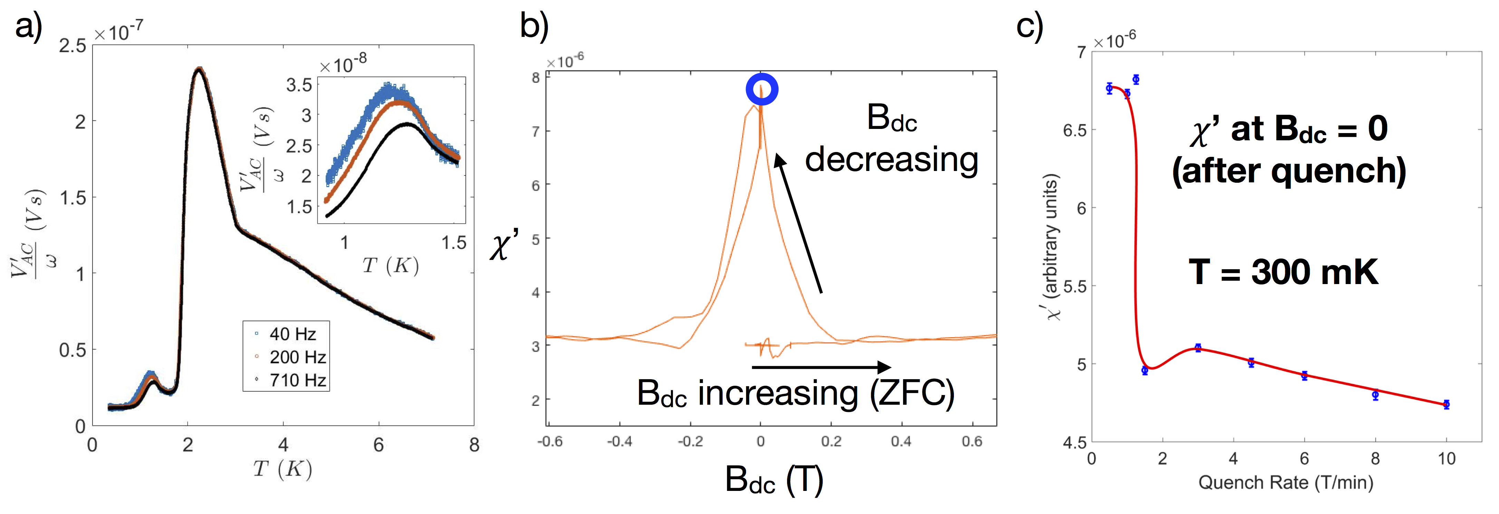
We definitively identified a freezing transition near 1.2K by measuring the frequency dependence of the ac susceptibility in B_{dc} = 0 (Fig 1 a). This freezing transition occurs below the ordering transition in CoNb₂O₆ and is therefore likely to be related to domain wall dynamics. When field quenching into this frozen state from the polarized limit, the ac susceptibility increases sharply from its zero-field cooled (ZFC) value (Fig 1 b). The height of the jump depends strongly on the quench rate (Fig 1c). Our hypothesis is that this jump indicates a ‘healing’ of whatever slowly relaxing disorder is caused by cooling into the frozen regime, and that the effectiveness of the healing is increased for lower field quench rates. This is analogous to glass vs. crystal formation in glass forming liquids; the crystal phase is formed only below a critical quench rate. This result is novel, since to our knowledge, this fundamental phenomenon in glasses has never been reported in a spin frozen material. Furthermore, in this case, the crystallization vs. glass formation is controlled by the timescale of quantum fluctuations rather than thermal fluctuations. These results thus lend new insight into the quantum dynamics of frozen quantum systems.
Fig.1 a) ac susceptibility at B_{dc}=0, evincing a freezing transition below T ~ 1.2K. b) ac response during a dc field sweep from zero (zero field cooled sample) to B_{dc} > 5.5 T, and back. Below 0.2T, an irreversibility appears; the susceptibility suddenly increases sharply. The blue point indicates the quantity that is plotted in panel c). c) The height of the jump in susceptibility at B_{dc}=0 is strongly affected by the quench rate. A critical quench rate of ~1.75 T/min is revealed. Red line is a guide to the eye.

Acknowledgements
A portion of this work was performed at the National High Magnetic Field Laboratory, which is supported by National Science Foundation Cooperative Agreement No. DMR-1157490 and the State of Florida. We gratefully acknowledge the technical support of Eun Sang Choi (National High Magnetic Field Laboratory).

References
[1] Coldea, R. et al, Science 327, 177 (2010).
[2] S. Kobayashi et a., Phys. Rev. B 60, 3331 (1999)

