Magnetization measurements in high pulsed magnetic fields to test Ru⁴⁺ ground state properties of Sr₄Ru₃O₁₀

Vecchione, A., Granata, V., Fittipaldi, R. (Univ. of Salerno, Italy); Salamon, M.B. (University of Texas at Dallas) Civale, L. (MPA-CMMS, LANL); Jaime, M. (NHMFL, LANL); Weickert, F. (NHMFL, Florida State University)

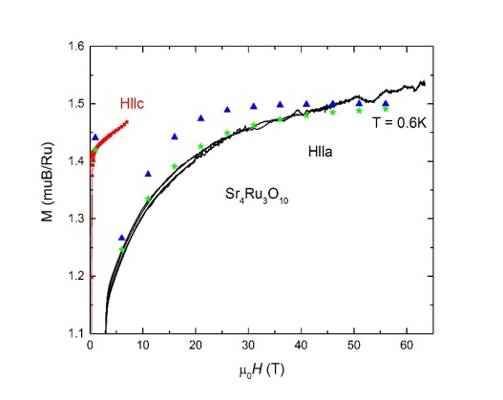
Introduction - Sr₄Ru₃O₁₀ is a 105K easy c-axis ferromagnet, which caught much attention due to its metamagnetic transition occurring inside the ferromagnetic state below 80T by applying a magnetic field in the ab-plane [1,2]. Currently, the origin of this sudden increase in the magnetization accompanied by a reduction of the overall magnetic moment is not understood and debated under the itinerant as well as localized picture of magnetic Ru⁴⁺ spins.
Experimental - We measured magnetization on oriented single crystals at the NHMFL-PFF, Los Alamos in one of the capacitor-driven short pulse magnets up to 64T magnetic field and in the temperature range between 4K and 0.6K with a standard extraction magnetometer. The goal was to take our previous low field study to higher fields and learn more about the Dzyaloshinskii-Moriya (DM) interaction that described quite nicely the behavior of the magnetization up to 7T [2]. We furthermore, wanted to test if magnetic fields up to 64T are able to alter the energy scheme of the t_{2g} ground state of the Ru⁴⁺ 4d-orbitals.
Fig. 1 Magnetization measurements up to 64T of Sr₄Ru₃O₁₀ for fields applied H ll a compared with H ll c data obtained in a SQUID magnetometer in low fields [2]. The magnetization does not saturate up to 65T and follows the prediction of a model (green star symbols) based on magnetic easy axis anisotropy and DM interactions.
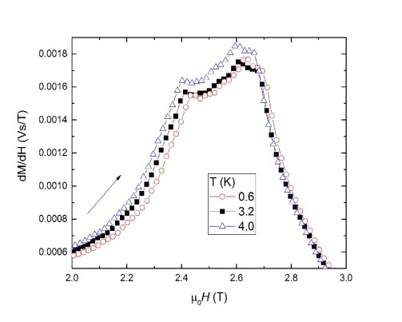
Results and Discussion - We find that the magnetization increases smoothly above the MM double transition at ~ 2.6T. It does not reveal any additional feature such as steps or kinks in higher fields to 64T as seen in Fig. 1. It reaches about 1.5µ_{B} for highest fields, which is comparable to the maximum magnetization value for H ll c. The wiggles in the data above 50T are most likely caused by mechanical vibrations in the magnet. The data were fitted with a phenomenological model including easy axis magnetic anisotropy and a DM term as indicated by the triangle and star symbols in Fig. 1.
By enlarging the low field region up to 3T as seen in the susceptibility in Fig. 2, we observe a double feature at the metamagnetic transition at H_{c1} and H_{c2} as found in previous studies, but interestingly, the shapes of the anomalies look different compared to published data taken on a different sample [2,3].
Unfortunately, we did not have enough time to measure the magnetization along the H ll b direction and we will have to submit another experiment in order to complete the set of experimental data for publication.
Conclusions - Our magnetization experiments up to 65T confirm that the magnetic behavior in Sr₄Ru₃O₁₀ is ruled by easy axis ferromagnetism combined with a DM contribution. The characteristic parameters obtained in low magnetic fields are consistent with those extracted from the high field magnetization. We do not observe a dramatic change in the magnetization that can be associated with a sudden change of the t_{2g} ground state to e_{g}. The magnetization does not saturate up to 64T.
Fig. 2 Magnetic susceptibility dM/dH for increasing magnetic fields up to 3T (H ll a) of Sr₄Ru₃O₁₀. No significant temperature dependence is observed in the measurements beteween 0.6K and 4.0K. Interestingly, dM/dH follows a different behavior as published in previous studies [2,3].
Acknowledgements - A portion of this work was performed at the National High Magnetic Field Laboratory, which is supported by National Science Foundation Cooperative Agreement No. DMR-1157490, the State of Florida and the United States Department of Energy. Work by L.C. was supported by the US DOE, Office of Science, Basic Energy Sciences, Materials Sciences and Engineering Division.
References
[1] M. K. Crawford et al., Phys. Rev. B 65, 214412 (2002).
[2] F. Weickert et al., Sci. Rep. (2017), F. Weickert et al., Physica B, (2017).
[3] E. Carleschi et al., Phys. Rev. B 90, 205120 (2014).

