High-field magnetization of free-to-rotate GdCo5

Goddard, P., Gotze, K., Pearce, M., Patrick, C., Kumar, S., Lees, M. (U. Warwick, Physics) and Singleton, J. (NHMFL, Los Alamos)

Introduction
RECo₅ materials (RE = rare earth) host strong Co magnetism together with highly anisotropic 4f electrons. Early work on SmCo₅ led to the development of the strong permanent magnets now used extensively for commercial application [1]. Recent advances in first-principles calculations have provided the ability to model the complex interplay of interactions in these materials [2]. In order to inform and extend the calculations we measured the high-field properties of GdCo₅. This system exhibits a collinear ferrimagnetic state at low fields and is known to undergo a spin reorientation above 40 T [3]. Observation of this reorientation allows the Co-Gd and Gd-Gd exchange energies to be established and compared to first-principles calculations.

Experimental
Isothermal magnetization measurements were performed in a 65 T short pulse magnet at NHMFL-LANL using a compensated-coil magnetometer located in a ⁴He refrigerator. A small (~1 mm³) plate-like single crystal was housed in a PCTFE ampoule and permitted to rotate freely during the field pulse.
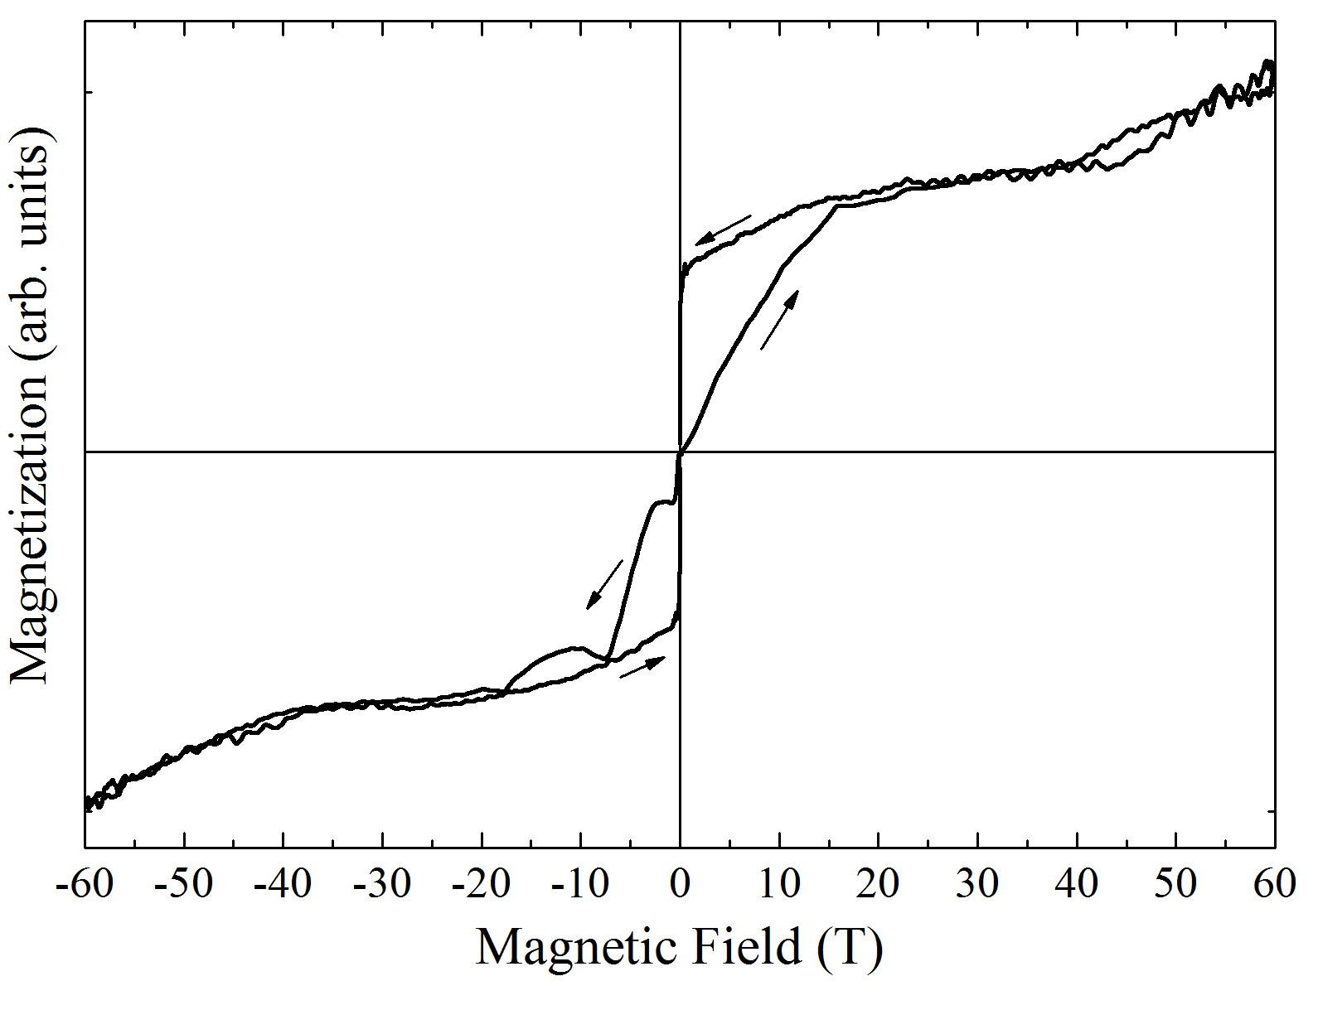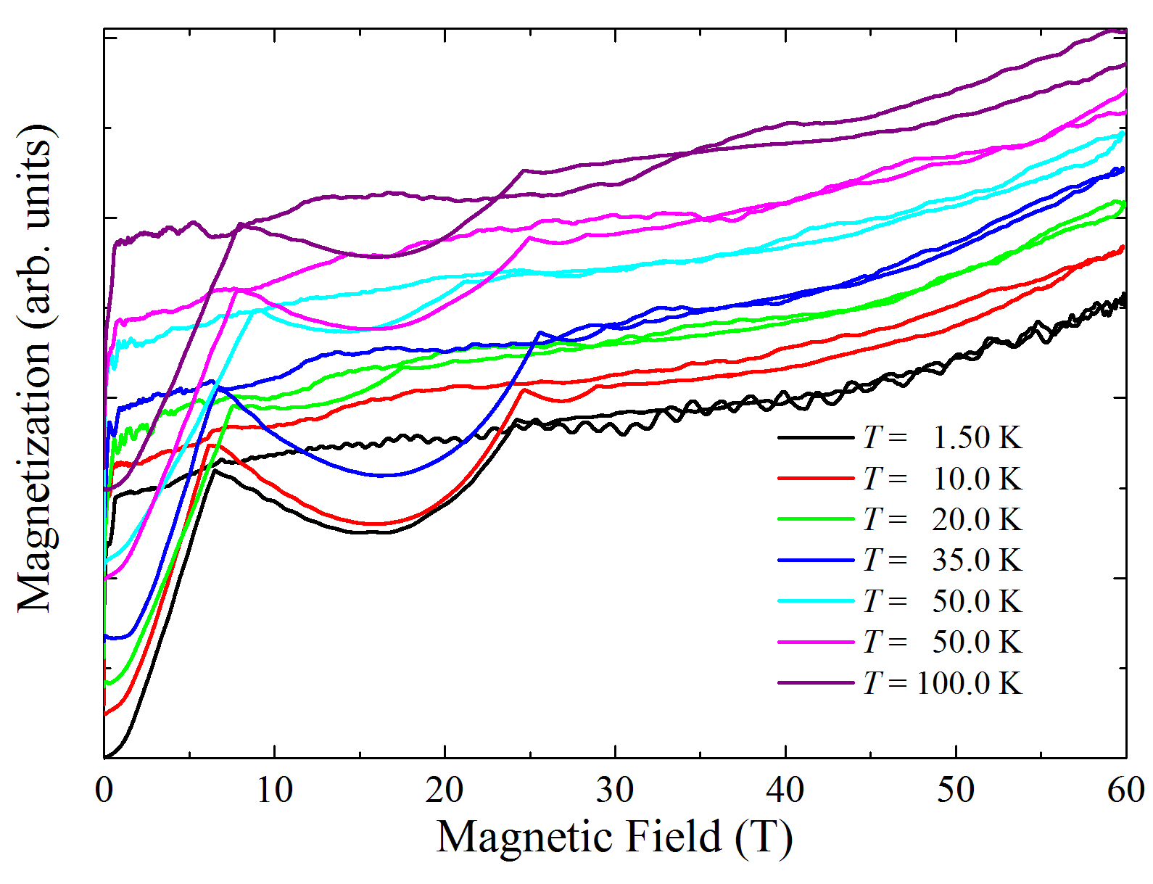
Fig.1 Magnetization of free-to-rotate GdCo5 at T = 1.5 K (upper) and at various temperatures (lower). The arrows indicate the up and down field pulses. The low-field behavior on the up sweeps is caused by mechanical reorientation of the sample.

Results and Discussion
The upper panel of Figure 1 shows the magnetization data taken during consecutive forward and reverse field pulses at 1.5 K. The low-field behavior on the up sweep is caused by the initial mechanical motion of the sample as the easy axis aligns with the applied magnetic field. At slightly higher fields a plateau-like feature is observed that corresponds to the saturated moment of the ferrimagnetic phase [2,3]. The magnetization kink observed at approximately 40 T is indicative of the expected spin reorientation. The lower panel shows further data taken at various temperatures up to 100 K.

Conclusions

At low temperatures the magnetization of free-to-rotate GdCo₅ exhibits the features expected from the ferrimagnetic ground state and the field-induced spin reorientation. A comprehensive analysis of the experimental data is underway, together with a comparison to the results of first-principles calculations.

Acknowledgements
A portion of this work was performed at the National High Magnetic Field Laboratory, which is supported by National Science Foundation Cooperative Agreement No. DMR-1157490 and the State of Florida. This project has received funding from the European Research Council (ERC) under the European Union’s Horizon 2020 research and innovation programme (grant agreement No. 681260).

References
[1] Strnat, K. et al., J. Appl. Phys. 38, 1001 (1967). [2] Patrick, C. E. et al., Phys. Rev. Materials 1, 024411 (2017).
[3] Kuz’min, M. D. et al., Phys. Rev. B 70, 172412 (2004).

