High pressure susceptibility studies on a quasi-2D metal-organic Heisenberg
antiferromagnet
Wehinger, B. (University of Geneva); Kubus, M. (Technical University of Denmark); Herringer, S., Krämer, K. (University of Bern) and Rüegg, C. (Paul Scherrer Institut and University of Geneva)

Introduction
Experimental access to quantum magnetism in low dimensions provide indispensable benchmarks for the most recent developments in the theory of quantum matter physics. Suitable materials with magnetic exchange in low dimensions can be designed by chemical synthesis or nanotechnology. Possible realizations are metal-organic materials based on coordination polymers with a metal-pyrazine network with magnetic exchange couplings of only a few Kelvin that are strongly anisotropic in space. Such insulating magnets are excellent model systems for low-dimensional quantum magnetism because the magnetic exchange couplings can be determined to high accuracy and the fundamental excitations at relevant magnetic fields are accessible with currently available experimental techniques.
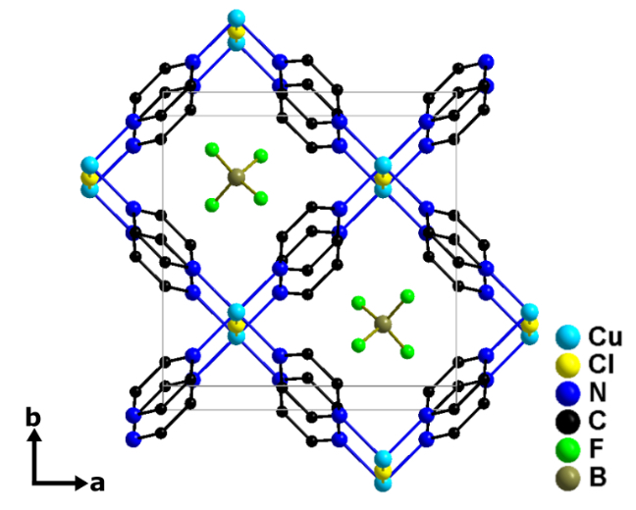
Experimental
We have investigated [CuCl(pyz)₂](BF₄) (Fig.1), an excellent realization of a spin ½ quasi-two-dimensional (Q2D) Heisenberg antiferromagnet with square lattice geometry [1]. We have measured magnetic susceptibility in fields up to 31 T as function of field and temperature using the tunnel diode oscillator technique at the NHMFL DC facility in Tallahassee (cell 9). Single crystals of size 0.8 x 1.2 x 1.5 mm were aligned with the c-axis parallel to the field, surrounded by a resonance coil, pressurized with a piston cylinder cell up to 16 kbar and cooled by a variable temperature insert for temperatures down to 1.4K.
Fig.1 Crystal structure of [CuCl(pyz)₂](BF₄). Hydrogen atoms are omitted for clarity. The unit cell is outlined by grey lines.
Results and Discussion
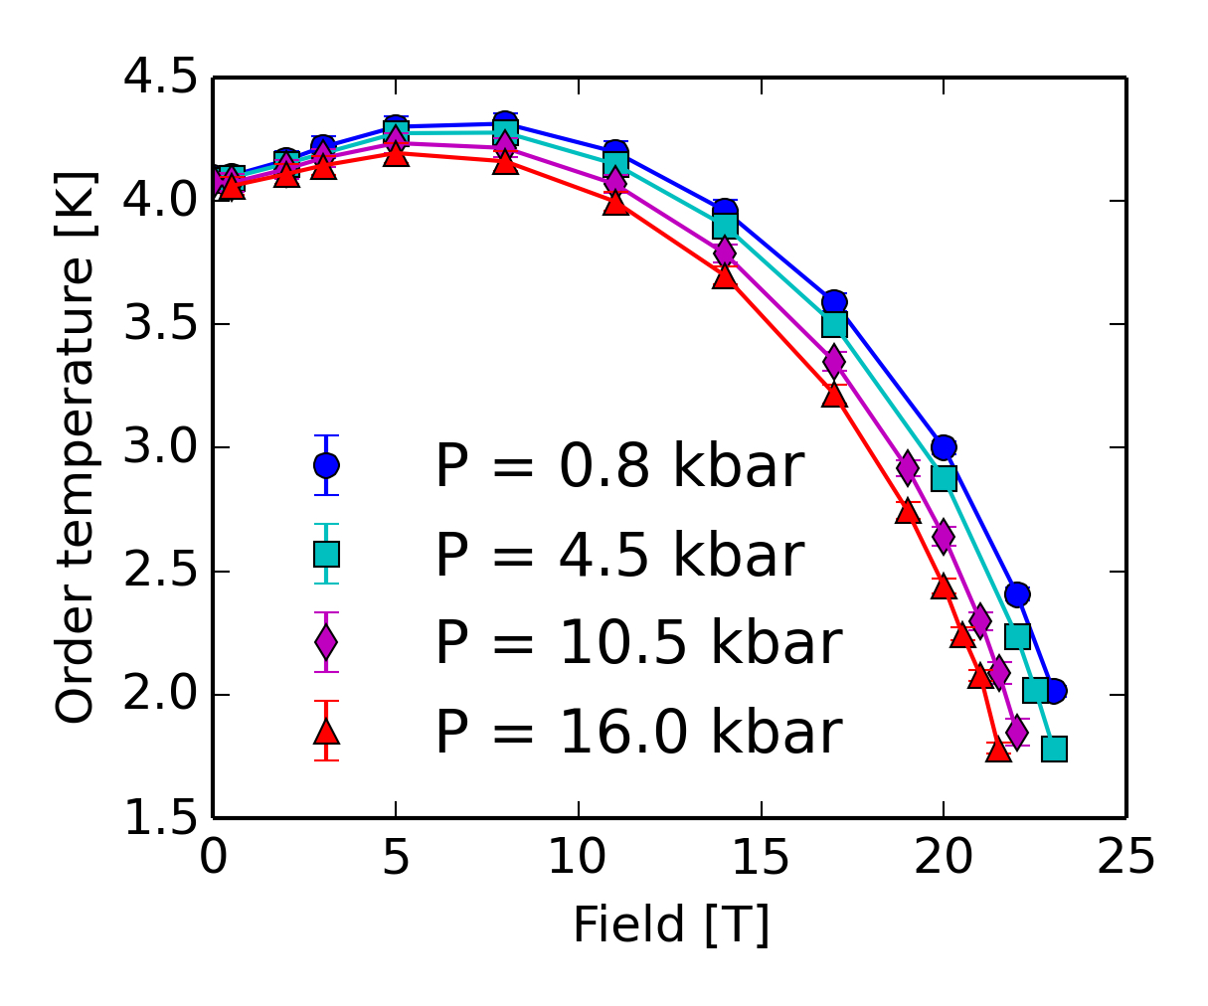
We have measured the magnetic susceptibility and determined the ordering temperature as a function of magnetic field and external pressure. This allowed for a precise measurement of the temperature-field phase diagram at various pressures (Fig.2). As expected for a spin ½ Q2D Heisenberg antiferromagnet, the ordering temperature first increases with field and then decreases. The high-precision measurements allow for direct comparison with Quantum Monte Carlo simulations and thus for a fully quantitative analysis of both the susceptibility and the phase diagram. The magnetic exchange within the ab crystallographic plane was determined to J = 9.4K. This value decreases by 10% upon application of 16 kbar external pressure. The interlayer coupling (along c) is J⊥ = 0.3 K and increases by 40% at 16 kbar pressure.

Conclusions
We have shown that the ratio between in-plane and interlayer couplings (J/J⊥) in the model square lattice spin-½ Heisenberg antiferromagnet [CuCl(pyz)₂](BF₄) can be efficiently tuned with pressure, thus allowing for direct control on the magnetic exchange. Our measurements allowed for the precise determination of the temperature-field phase diagram as function of external pressure. Our quantitative analysis with Quantum Monte Carlo simulations allow for direct comparison with recent progress in theoretical quantum matter physics.
Fig.2 Temperature-field phase diagram of [CuCl(pyz)₂](BF₄) at various pressures.

Acknowledgements
We acknowledge excellent experimental support from David Graf. Part of this work was performed at the National High Magnetic Field Laboratory, which is supported by National Science Foundation Cooperative Agreement No. DMR-1157490 and the State of Florida.

References
[1] Kubus, M. et al., accepted for publication in Inorg. Chem. (2018).

