Spintronics with Antiferromagnetic Insulators

Vaidya, P., Del Barco, E. (UCF, Physics); Lederman, D. (UCSC, Physics); Brataas, A. (Norwegian U. of Science and Technology, Trondheim, Norway, Physics) and van Tol, J. (NHMFL)

Introduction
Emerging phenomena, such as the spin-Hall effect (SHE), spin pumping, and spin-transfer torque (STT), allow for interconversion between charge and spin currents and generation of magnetization dynamics that could potentially lead to faster, denser, and more energy efficient, non-volatile memory and logic devices. Present STT-based devices rely on ferromagnetic (FM) materials as their active constituents. An alternative is to employ antiferromagnetic (AF) materials, particularly antiferromagnetic insulators. In contrast to ferromagnets, where magnetic anisotropy dominates spin dynamics, in antiferromagnets spin dynamics are governed by the interatomic exchange interaction energies which are orders of magnitude larger than the magnetic anisotropy energy, leading to the potential for ultrafast information processing and communication in the THz frequency range.¹

Experimental
The sample, MnF2 crystal capped with platinum, was grown by Lederman (UCSC). Antiferromagnetic Resonance (AFMR) measurements and spin pumping experiments were performed at NHMFL EMR facility utilizing the Heterodyne Quasi Optical Spectrometer and its 12.5 T SC magnet. Right and left circularly polarized microwaves of 120 and 240 GHz frequency were used to excite the magnetization precession of the two sub lattice magnetizations of MnF₂ and inverse spin Hall effect (ISHE) voltage was measured across platinum.

Results and Discussion
Spectroscopy measurements show no evidence of AFMR resonances at the two frequencies attempted. Likely, the AFM films are too thin to see the AFMR.
We observed a clear signal in the voltage measurements that seems to coincide with the spin flip-flop transition (around 9 T) as seen in Fig.1. There is a clear power dependence of the measured voltage signal.
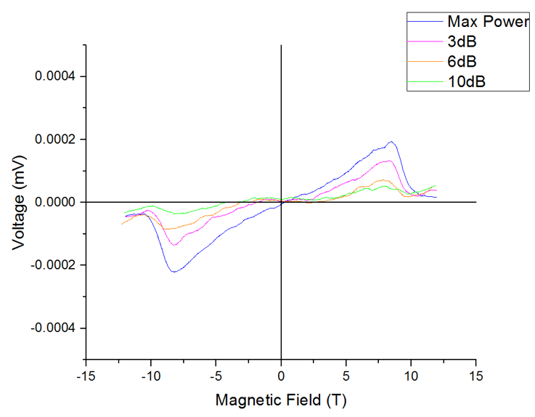
Fig.1 Voltage across Pt strip vs applied field for different microwave power. The peak positions correspond to the spin-flop transition field of 9 T. The plot is obtained after background subtraction and smoothing.
Further study is required to analyze the origin of this voltage signal. We are currently working on acquiring better crystal samples and repeating the experiment to further advance on this route.

Conclusions
The results of our experiment look promising and strongly indicate a spin Hall effect origin. We want to explore more this area and are planning to perform similar experiments on new samples of MnF₂ at NHMFL, particularly around the spin-flop region using circularly and linearly polarized microwaves.

Acknowledgements
A portion of this work was performed at the National High Magnetic Field Laboratory, which is supported by National Science Foundation Cooperative Agreement No. DMR-1157490 and the State of Florida.

References
[1] Johansen, Ø., et al., Phys. Rev. B, 95, 220408(R) (2017).

