EPR Study of Lanthanide Triple-Decker Phthalocyanine Complexes

Ghirri, A., Bonizzoni, C. (CNR-Istituto Nanoscienze, Italy); Komijani, D. (NHMFL & FSU, Physics); Klyatskaya, S., Moreno Pineda, E., Ruben, M. (Karlsruhe Institute of Technology, Germany); Hill, S. (NHMFL & FSU, Physics) and Affronte, M. (CNR-Istituto Nanoscienze, Italy)

Introduction
Lanthanide molecular nanomagnets, particularly sandwich-type complexes, have been studied extensively due to their potential application in information technologies [1]. The strong magnetic anisotropy associated with lanthanide ions originates from the large spin-orbit coupling in the 4f shell. However, shielding of the magnetic 4f electrons by filled 5p and 6s orbitals poses a significant challenge for synthesizing exchange-coupled lanthanide compounds. Among the many well-known macrocyclic molecules, phthalocyanines (Pc) and porphyrins (Por) are the most widely used to form multilayered organometallic compounds with trivalent lanthanides [2].

Experimental
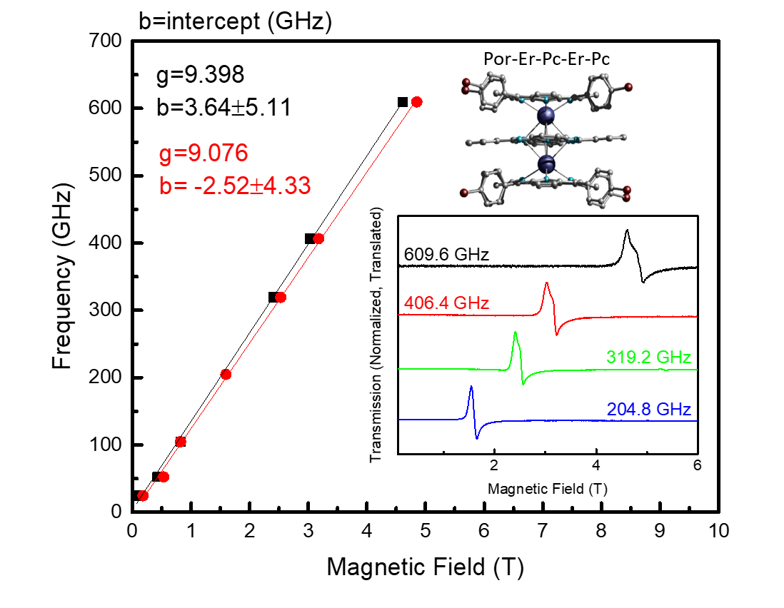

Fig.1 Frequency dependence of the resonance positions of 1 (red and black points). The solid lines show linear fits to the data used to extract the g-values for each of the Er(III) ions. The inset shows a schematic of the molecule and representative powder spectra collected at 5 K. The frequencies are indicated above each trace.

Electron paramagnetic resonance (EPR) measurements were carried out using a home-built homodyne spectrometer at the MagLab [3]. The EPR spectra of powder samples were collected at a temperature of 5 K and microwave frequencies ranging from 25 to 406 GHz, employing a transmission-type device and a 15/17 T superconducting magnet. The microwaves were generated using a phase-locked Virginia Diodes source operating at a base frequency of 12-14 GHz followed by a chain of multipliers. The response from the samples was recorded using magnetic field modulation and a liquid He cooled InSb Bolometer. To prevent alignment of crystallites in the applied magnetic field, the finely ground powders were pressed into a Teflon cup using a tightly fitting Teflon rod.

Results and Discussion
In this work, we systematically study the interactions between two lanthanide (Ln) ions in a series of symmetric and asymmetric triple-decker compounds, e.g., Por-Ln-Pc-Ln-Por, Pc-Ln-Pc-Ln-Por, etc. Such interactions are significant for the design of multi-qubit gates. EPR measurements for an asymmetric Er-Er (1) compound is shown in Fig.1. As can be seen from this plot, the two Er(III) ions in this molecule have a slightly different EPR response (red and black trace). The difference in g-values originates from the presence of porphyrin in the asymmetric molecule, thereby breaking the symmetry between the two Er(III) EPR signals.

Conclusions
This high-frequency EPR study of lanthanide triple-decker complexes offers a reliable determination of the magnetic anisotropy not available from other techniques. Further analysis is required to quantify the interaction between the lanthanide ions and the effect of porphyrin on the symmetry of the molecule.

Acknowledgements
A portion of this work was performed at the National High Magnetic Field Laboratory, which is supported by National Science Foundation (NSF) Cooperative Agreement No. DMR-1157490 and the State of Florida. We also acknowledge the support of NSF DMR-1610226 and the Air Force (AOARD Award # FA2386-17-1-4040).

References
[1] Vincent, R., et al., Nature, 488, 357-360 (2012).
[2] Ishikawa, N., et al., J. Am. Chem. Soc., 124, 11440-11447 (2002).
[3] Hassan, A.K., et al., J. Mag. Res., 142, 300-312 (2000).

