Detailed High-Field and High-Frequency EPR Study of the Single-Molecule Magnet Fe₆

Nehrkorn, J. (U. Washington, Chemistry; U. Hamburg, Chemistry; & NHMFL); Greer, S. (NHMFL & FSU, Chemistry); Krzystek, J. (NHMFL); Hill, S. (NHMFL & FSU, Physics); Malbrecht, B., Betley, T. (Harvard U., Chemistry); Herrmann, C. (U. Hamburg, Chemistry); Stoll, S. (U. Washington, Chemistry)

Introduction
Polynuclear single-molecule magnets (SMMs) can be magnetized below a certain characteristic blocking temperature, T_{B}. Up to now, the obtained values of T_{B} have been too low for potential data storage applications. The exchange coupling between constituent metal ions in a SMM gives rise to a well isolated spin ground state, provided the exchange is strong. In such cases, the magnetic anisotropy associated with the spin ground state governs the SMM properties. However, in most cases, the exchange is of the relatively weak super-exchange type and, hence, the spin states are separated by only a few kelvin. Therefore, the ([Bu₄N][(^{H}L)₂Fe₆(dmf)₂]) SMM (hereon Fe₆), is of great interest because the iron ions are coupled via strong metal-metal bonds.¹ Hence, a well separated spin ground state is anticipated. Here, we report a spectroscopic investigation of the magnetic properties of the spin ground state of Fe₆. Furthermore, we probe the influence of excited states by experiments at elevated temperatures.
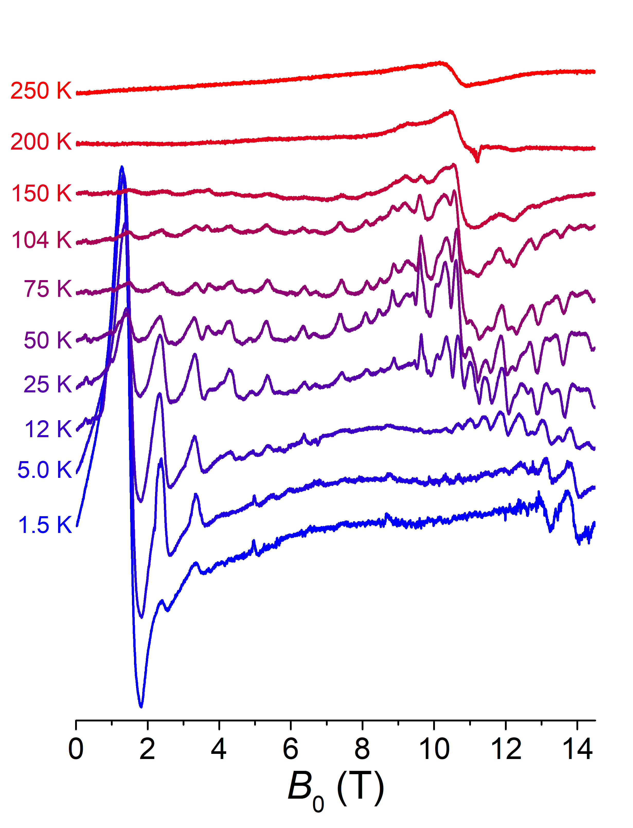
Fig.1 HFEPR spectra of Fe₆ measured at a microwave frequency of 304.8 GHz and at the temperatures indicated on the left. The data are offset for better visibility.

Experimental
Experiments were performed at the NHMFL EMR facility using the transmission spectrometer and a 15/17 T superconducting magnet. Finely ground powders of Fe₆ were investigated over a broad range of frequencies and temperatures, i.e., 48.4 to 614.4 GHz and 3 to 250 K, respectively.

Results and Discussion
The temperature dependence of the high-field EPR (HF-EPR) spectra at 304.8 GHz is shown in Fig.1. Several transitions can be observed. From their frequency (not shown) and temperature dependence, the magnetic (Hamiltonian) parameters of the spin ground state were obtained with high precision. At higher temperatures, a broad, unstructured EPR line centered at g = 2.0 is observed. This line is assigned to higher lying spin states, and a rough estimate of the separation between the ground and excited states can be made from its temperature dependence.

Conclusions
High-quality HF-EPR spectra of the SMM Fe₆ allow for a determination of the magnetic parameters of the spin ground state and provide a rough estimate of the separation between the ground and first excited spin states.

Acknowledgements
A portion of this work was performed at the National High Magnetic Field Laboratory, which is supported by the National Science Foundation Cooperative Agreement No. DMR-1157490 and the State of Florida. J.N. acknowledges financial support from the Deutsche Forschungsgemeinschaft (DFG) through a Research Fellowship (grant no. NE 2064/1-1 FOR).

References
[1] Sánchez, R.H., et al., J. Am. Chem. Soc., 137, 13949 (2015).

