Magnetoelectric coupling in Ni₃TeO₆

Musfeldt, J.L., Yokosuk, M.O., O'Neal, K.R. (Tennessee); Yang, J., Oh,Y.S., Kim, H.-.S., Haule, K., Cheong, S.W., Vanderbilt, D. (Rutgers), and Crooker, S. (LANL)

Introduction
The development of materials in which 3d transition metals coexist with heavier centers in multicomponent oxides continues to fascinate. In these systems, the 3d ions contribute narrow bandwidths, robust magnetism, and strong electron-electron interactions while 4p and 5d ions exhibit strong spin-orbit coupling, larger bandwidths, and tendencies to dimerization and band inversion. This mixture of physical and chemical properties provides a superb platform for the discovery of multiferroics, hard magnets, topological insulators, superconductors, and thermoelectrics with enhanced properties. Ni₃TeO₆ attracted our attention in this regard. We recently combined high field optical spectroscopy and first principles calculations to analyze the electronic structure of Ni₃TeO₆ across the 53 K and 9 T magnetic transitions, both of which are accompanied by large changes in electric polarization,^{1,2} and found that the color properties are sensitive to magnetic order due to field-induced changes in the crystal field environment, with those around Ni1 and Ni2 most affected. The recent discovery of a spin reorientation transition at 52 T [Fig. 1(a)] provides an opportunity to extend toward new states of matter sporting giant polarizations.³

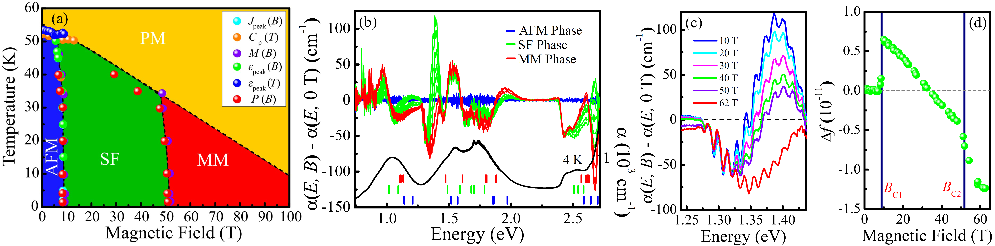

Figure 1: (a) Temperature - magnetic field phase diagram of Ni₃TeO₆ as determined by heat capacity, magnetization, polarization, and magnetostriction showing the 53 K, 9 T, and 52 transitions. Polarization develops below T_{N} and changes across the spin flop and metamagnetic transitions. The 52 T transition sports a giant change in polarization and huge magnetoelectric effect.³ (b) Optical absorption, calculated d-to-d excitations for the three different Ni sites, and absorption difference spectra [Δα = α(B) − α(0 T)] at fields up to 65 T at 4.2 K. (c, d) Close-up view of the absorption difference spectra near the edge of the ³A_{2g} →¹E_{g} excitation and oscillator strength sum rule analysis in the vicinity of this feature.

Results and Discussion
In order to investigate spin-charge coupling across the series of magnetically-drive transitions, we measured the optical properties of Ni₃TeO₆ single crystals and compared our findings with complementary first principles calculations [Fig. 1]. Field-induced changes in the Ni d-to-d crystal field excitations are strong on the leading edge of the ³A_{2g} →¹E_{g} excitation, a finding that we trace back to local lattice distortions due to spin reorientations at 9 and 52 T that modify the optical matrix elements. These findings advance the understanding of magnetoelectric coupling in materials in which magnetic 3d centers coexist with nonmagnetic heavy chalcogenide cations.

Acknowledgements
We thank the DMREF program at the National Science Foundation for support of this work (DMR-1629079 and DMR-1629059). A portion of this work was performed at the National High Magnetic Field Laboratory, which is supported by National Science Foundation Cooperative Agreement No. DMR-1157490 and the State of Florida.

References
¹ Oh, Y. S. et. al., Nature Comm. 5, 3201 (2014).
² Yokosuk, M. O. et. al., Phys. Rev. Lett. 117, 147402 (2016).
³ Kim, J. W. et. al., Phys. Rev. Lett. 115, 137201 (2015).

