Magnetostriction experiments in high pulsed magnetic fields to test Ru⁴⁺ ground state properties in Sr₄Ru₃O₁₀

Vecchione, A., Granata, V., Fittipaldi, R. (Univ. of Salerno, Italy); Salamon, M.B. (University of Texas at Dallas); Civale, L. (MPA-CMMS, LANL); Jaime, M. (NHMFL, LANL); Corvalán, C. (Univ. NTF, Buenos Aires, Argentina); Weickert, F. (NHMFL, Florida State University)
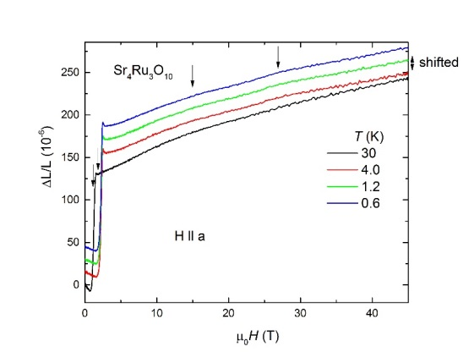
Introduction - Sr₄Ru₃O₁₀ is a 105K easy c-axis ferromagnet, which caught much attention due to its metamagnetic transition occurring inside the ferromagnetic state below 80T by applying a magnetic field in the ab-plane [1,2]. Currently, the origin of the metamagnetism is not understood and discussed in the itinerant as well as localized picture of magnetic Ru⁴⁺ spins [2,3]. Experimental studies of the lattice have shown strong magnetoelastic coupling in Sr₄Ru₃O₁₀ [4] making magnetostriction measurements the perfect tool to explore the high field region of the phase diagram.
Experimental - We measured magnetostriction with FBG technique on oriented single crystals (H ll a, H ll b) at the NHMFL-PFF, Los Alamos in one of the capacitor-driven short pulse magnets up to 64T magnetic fields. The measurements covered the temperature range between 30K and 0.6K.
Fig. 1 Magnetostriction measurements up to 45T of Sr₄Ru₃O₁₀ for fields applied H ll a for different temperatures between 0.6K and 30K. We observe clear anomalies at the metamagnetic double transition at 2.3T (positive step) and at 2.8T (negative slope) and a broad features at 15T and 27T. All anomalies are marked by arrows.
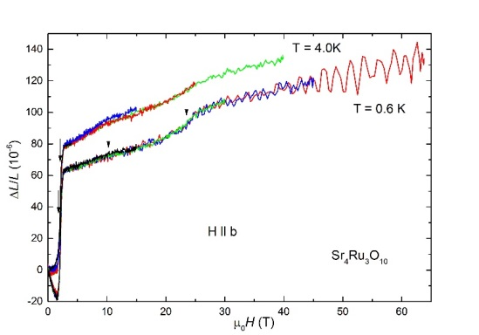
Results and Discussion - Fig. 1 shows magnetostriction data for H ll a that look different to measurements taken for H ll b as shown in Fig. 2. For H ll a, we observe a negative length change ΔL/L in low magnetic fields, a positive step at the critical field Hc1= 2.3T and a negative slope at Hc2= 2.8T. At higher fields above 5T, we resolve broad humps at about 15T and 27T in the data, which are very robust with increasing temperature. We checked carefully the reproducibility of these broad features by pulsing several times with different maximum magnetic field to exclude mechanical vibrations as origin.
For Hllb, the magnetostrictive signal is about two times smaller compared to H ll a and we do not have a clear understanding why. At Hc1, the sample shows a similar step in the length as for Hlla, but Hc2 is marked by a kink and not a negative slope as for the measurements H ll a. The high field data shows a broad bump at about 10T followed by a step at 23T.
Conclusions - It is remarkable that the in-plane magnetostriction is anisotropic by a factor of 2 between H ll a and H ll b. In previous studies, very little attention has been paid to the precise sample orientation investigating the in-plane metamagnetic transition and anisotropy was never observed before. We furthermore find that the anomalies at the two critical fields Hc1 and Hc2 strongly deviate from magnetostriction data obtained with a capacitance dilatometer for H ⊥ c [4]. The anomalies in high magnetic fields are very broad and robust for increasing temperature. Currently, we are not convinced that they are an indication of changing ground states between t_{2g} and e_{g}.
Fig. 2 Magnetostriction measurements up to 64T of Sr₄Ru₃O₁₀ for fields applied H ll b for 0.6K and 4.0K. We observe, anomalies at the metamagnetic double transition that are different compared to measurements H ll a, a positive step at 2.3T and a change of slope (kink) at 2.8T. The high field data is characterized by a broad bump at 10T and a step at 23T. All anomalies are marked by arrows.

Acknowledgements - A portion of this work was performed at the National High Magnetic Field Laboratory, which is supported by National Science Foundation Cooperative Agreement No. DMR-1157490, the State of Florida and the United States Department of Energy. Work by L.C. was supported by the US DOE, Office of Science, Basic Energy Sciences, Materials Sciences and Engineering Division.
References
[1] M. K. Crawford et al., Phys. Rev. B 65, 214412 (2002).
[2] F. Weickert et al., Sci. Rep. 7, 3867 (2017), F. Weickert et al., Physica B, https://doi.org/10.1016/j.physb.2017.09.106 (2017).
[3] E. Carleschi et al., Phys. Rev. B 90, 205120 (2014).
[4] W. Schottenhamel, Phys. Rev. B 94, 155154 (2016).

