92T Pulsed Field Magnetostriction in UPt₃
Shivaram, B. (U. Virginia); Weickert, F. (FSU, LANL); Jaime, M. (LANL, NHMFL)

Introduction
Metamagnetism characterized by a sudden rise in the magnetization at a critical field is a well established phenomenon in the hexagonal system UPt₃, first noted at µ₀H = 20 T nearly three decades ago. However recent detailed measurements of the nonlinear magnetic susceptibility have raised new questions. With a careful analysis of the existing data and utilizing a single energy scale (SES) model developed in this context one of us (BSS) [1] was able to show that there is a distinct possibility of a second MM transition at a higher field. Depending upon the parameters chosen in the model this transition is predicted to occur in the range of 60 T-100 T. Thus measurements of the magnetic and magnetoelastic properties of UPt₃ in the highest available fields are desirable.

Experimental
Fiber Bragg grating (FBG) magnetostrain experiments were carried out up to 92T on a- axis oriented single crystal UPt₃, using the 100T Multi shot magnet at the NHMFL pulsed field facility in Los Alamos in the temperature range between 0.63K and 25K.
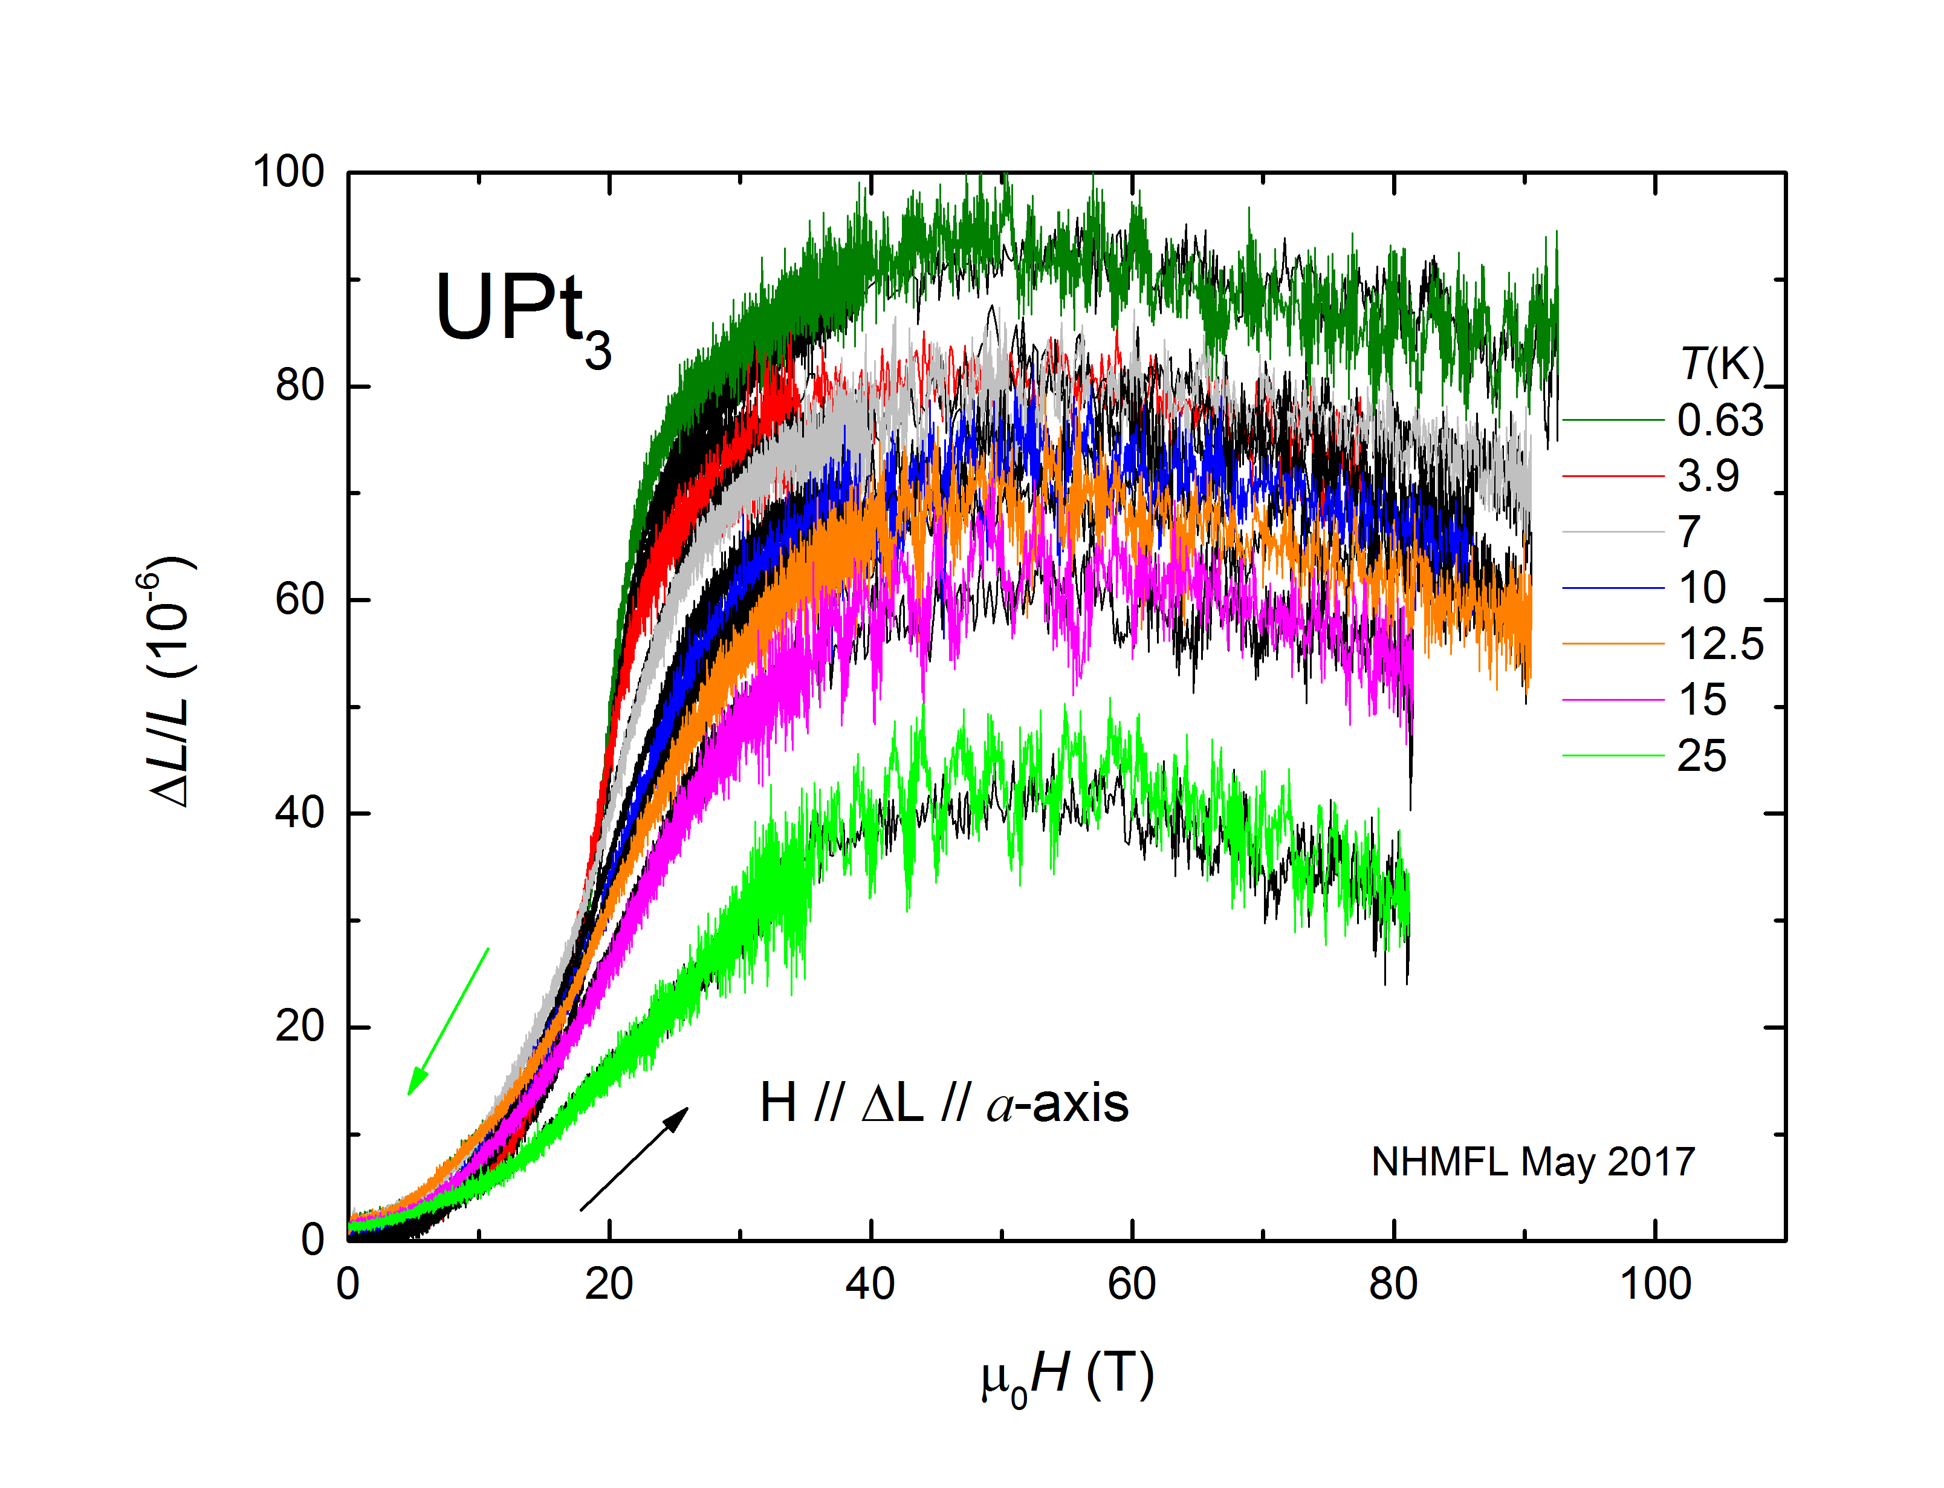
Fig. 1: Length change ΔL/L versus magnetic field H up to 92T of UPt3. We observe the previously known metamagnetic transition at 20T and a suprising decrease in sample length at fields higher than 60T.

Results and Discussion
We observe a sudden increase of the axial magnetostrain ΔL/L(H) in magnetic fields of 20T parallel to the crystalline a-axes in UPt₃ as shown in Fig.1. It sharpens with lower temperatures. A detailed analysis of this upturn has revealed that the differential magnetostrain, ∂ε/∂H, at 20 T follows a clear inverse temperature rule as expected from the phenomenological SES model [1]. Extending our magnetostrain measurements to 92T, we have uncovered a hitherto unknown decrease in sample length above 60T. This feature is quite robust in temperature and clearly observed up to 25K.

Conclusions
Previous comprehensive magnetostrain measurements in UPt₃ up to 65T for Hlla and Hllc have been extended to 92T for the crystallographic a-direction. We do not observe a second metamagnetic transition as anticipated from calculations based on the SES model. Surprisingly, we found a decrease in the magnetostrain for highest magnetic field of currently unknown origin. The gained knowledge from the experiment will help to critical overthink the parameters chosen in the SES model.

Acknowledgements
A portion of this work was performed at the National High Magnetic Field Laboratory, which is supported by National Science Foundation Cooperative Agreement No. DMR-1157490 and the State of Florida.

References
[1] B. S. Shivaram, A Model for Correlated Metamagnets: Application to UPt₃ and CeRu₂Si₂, arXiv: 1510.04755.

