NiX₂(H₂O)₂(3-fluoropyridine)₂: Possible models of the S = 1 J₁-J₂ square lattice

Manson, J.L., Ripley, J. (EWU, Chemistry); Singleton, J. (NHMFL-LANL); Goddard, P.A. (U. of Warwick, Physics)

Introduction
There is much interest in magnetic models based on interacting S = 1 particles. Among them are the spatially anisotropic J₁-J₂ model that is theorized to show a quantum tricritical point separating Néel and stripe-ordered phases depending on the J₁/J₂ ratio [1]. However, very few experimental realizations exist to test this model or perturbations arising from additional single-ion anisotropy (D). To this end, we have created a family of Ni(II)-based square lattices composed of NiX₂(H₂O)₂(3-fluoropyridine)₂ molecular units [2]. Each unit is linked together by X···H-O hydrogen bonds to form a square lattice (Fig. 1, inset) such that magnetic interactions may exist along the edges (J₁) and diagonals (J₂) of the square. Herein, we present results of pulsed-field M(H) measurements which reveal the presence of multiple field-induced phase transitions.

Experimental
Magnetization measurements were conducted at the Pulsed-Field Facility of the NHMFL-Los Alamos using a 65 T short-pulse magnet. Powder samples with masses of ~1 mg were loaded in ampoules and mounted inside the coil-set of a home-made magnetometer. Data were collected at several temperatures between 0.5 and 10 K.

Results and Discussion
Fig. 1 shows experimentally measured M(H) data for the X = Cl and Br samples. Each compound shows a field-driven phase transition near 8.8 and 10.1 T that may be attributed to a spin-flop (H_{c1}), which suggests an Ising-like ground state and D < 0. Further increasing the magnetic field induces a second transition (H_{c2}) near 15.6 and 20.2 T followed by broad magnetic saturation (H_{sat}) above 24 and 31 T for X = Cl and Br, respectively. Of interest is that H_{c1} and H_{c2} occur near 1/4H_{sat} and 3/4H_{sat}, respectively, which may be analogous to field-induced transitions found in S = 1/2 square lattices [3]. While it is presently unclear as to the nature of these transitions and, their corresponding spin arrangements, the influence of the anticipated single-ion anisotropy is yet to be determined.

Conclusions
The new NiX₂(H₂O)₂(3-fluoropyridine)₂ coordination complexes described here may serve as excellent models of the S = 1 J₁-J₂ model. Future experiments will entail synthesis of the X = F and X = I congeners as well as measurements of aligned single crystals to better define H_{c1} and H_{c2}. In addition, new phases may also be revealed. It is our intention that these materials will stimulate more theoretical interest in the S = 1 J₁-J₂ square lattice model, especially field-induced phases, which is presently lacking.
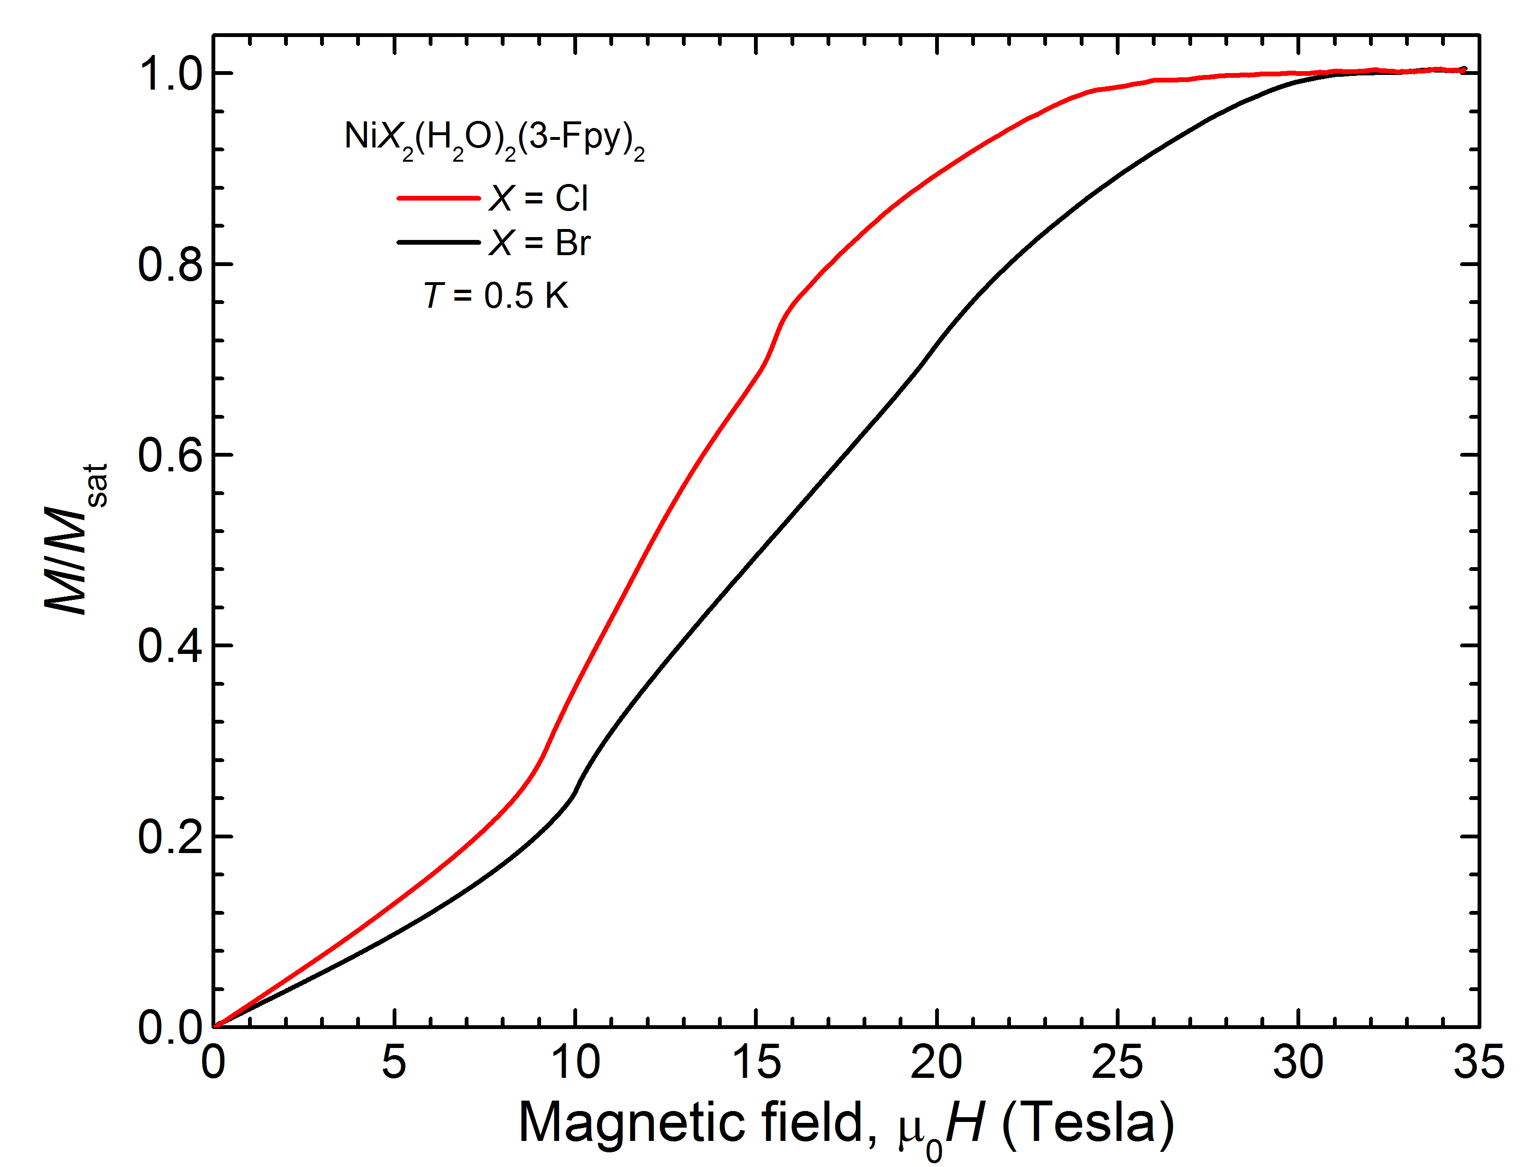
Acknowledgements
A portion of this work was performed at the National High Magnetic Field Laboratory, which is supported by National Science Foundation (NSF) Cooperative Agreement No. DMR-1157490 and the State of Florida.
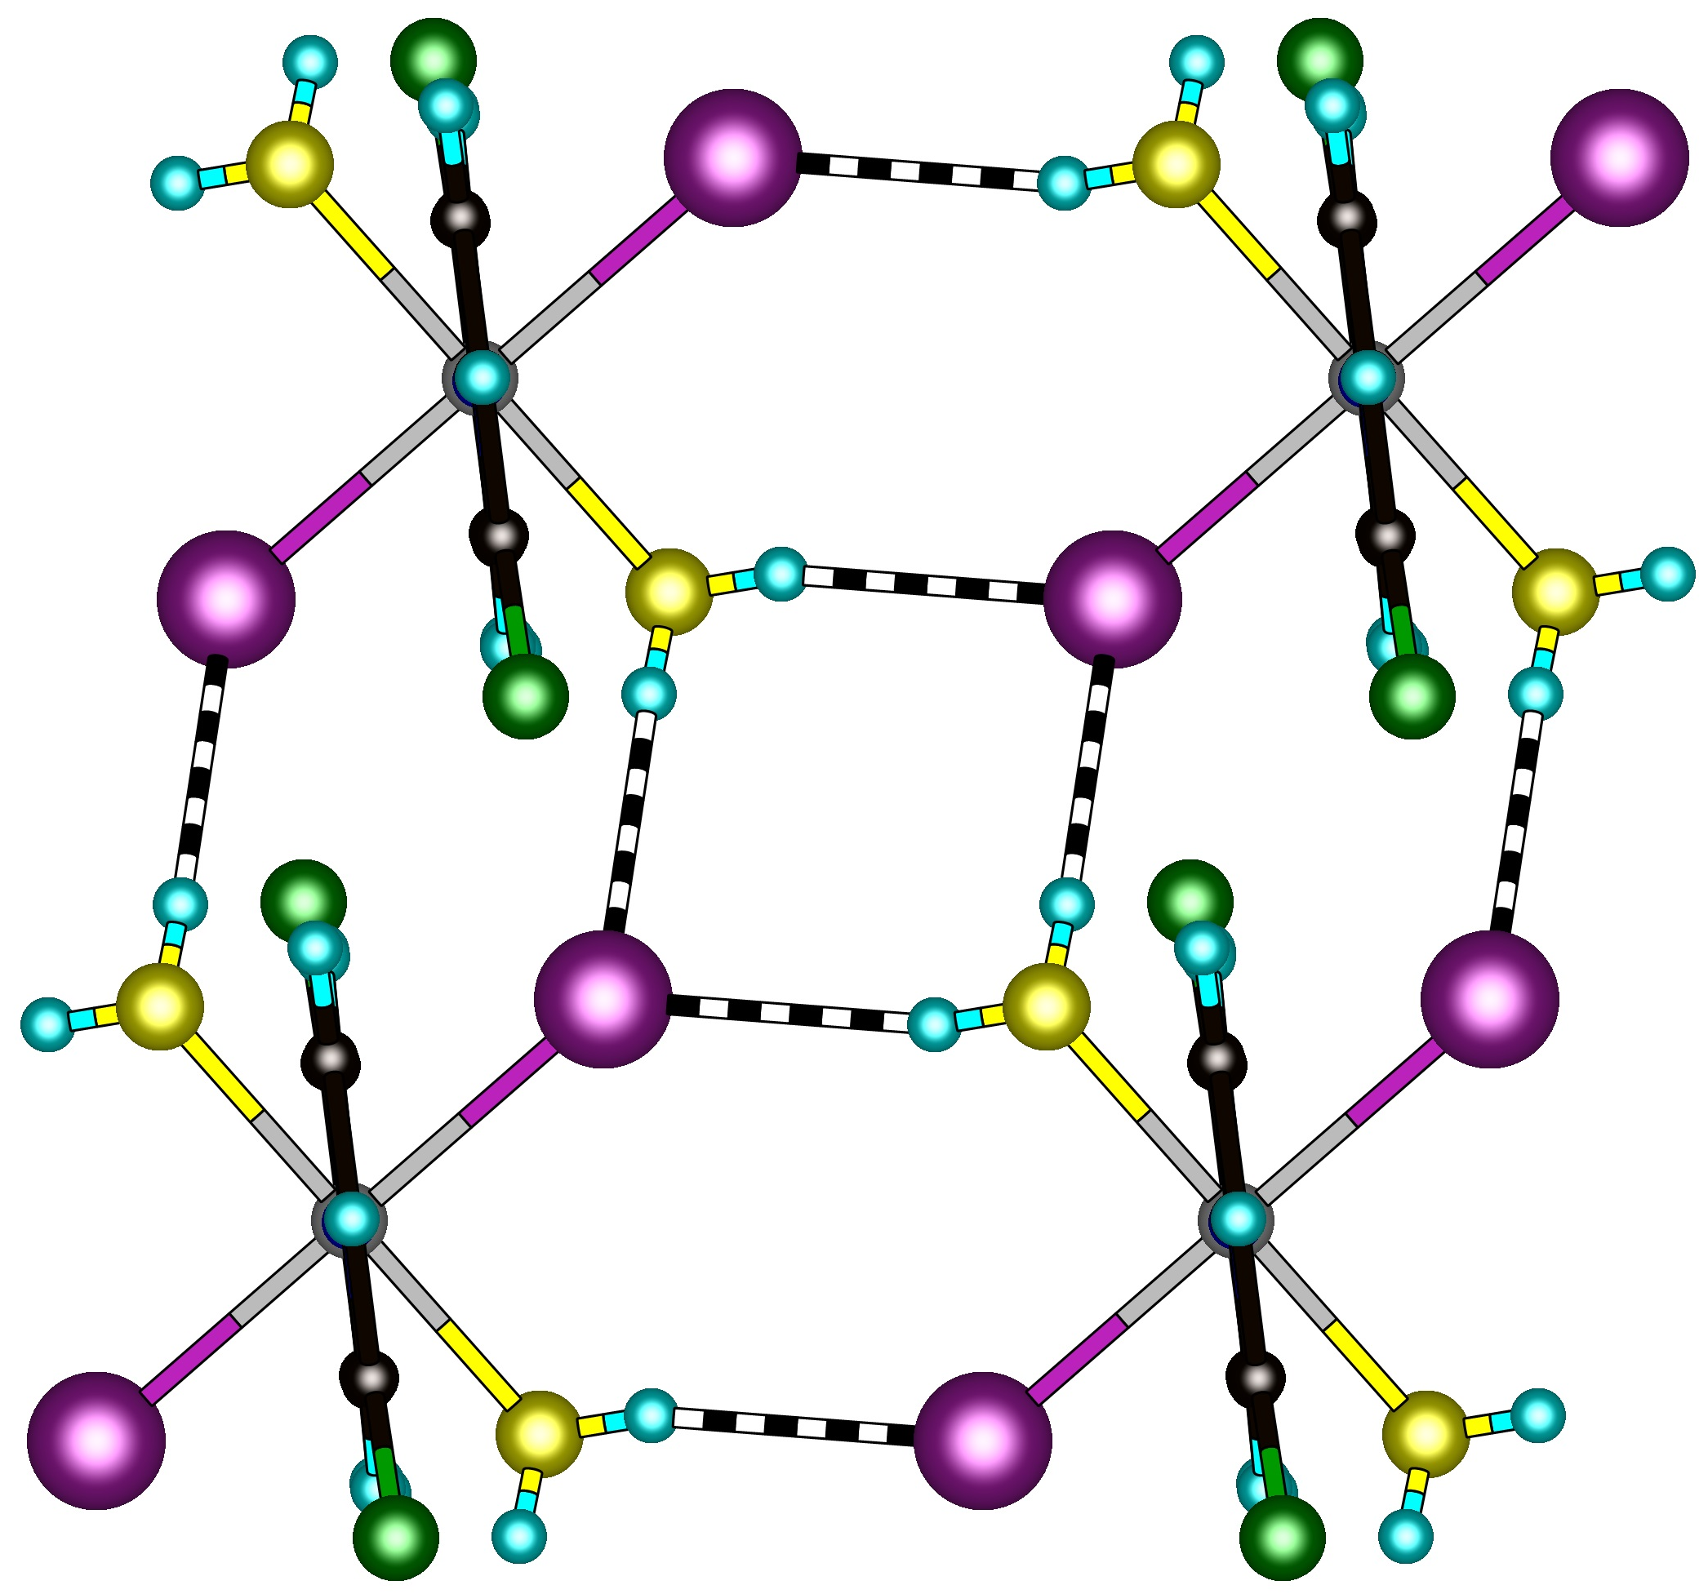
The work at EWU and the U. of Warwick was supported by NSF DMR-1703003 and EPSRC award no. 1478715, respectively.
J₁
J₂
Ni
X

References
[1] (a) Jiang, H.C., et al., Phys. Rev. B, 79, 174409 (2009). (b) Bishop, R.F., Eur. Phys. Lett., 83, 47004 (2008).
[2] Manson, J.L., et al. work in progress.
[3] Morita, K. and Shibata, N., J. Phys. Soc. Jap., 85, 094708 (2016).
Fig.1 (Inset) A portion of the 2D square lattice found in molecular NiX₂(H₂O)₂(3-fluoropyridine)₂. (Main) Pulsed-field magnetization data obtained for powder samples at T = 0.5 K.

