High magnetic field study of hexagonal rare earth indate

Kim, J.W.; Li, Y.; Cheong, S.-W. (Rutgers University); Ding, X.; Harrison, N. and Zapf, V. (NHMFL-PFF)

Introduction
The hexagonal-RInO₃ (R = rare earths) compounds are isostructural to the hexagonal-RMnO₃ that shows improper ferroelectricity in which the polarization (P) is induced by a structural instability (trimerization mode) that occur below Tc = 1300-1500 K [1]. However, unlike h-RMnO₃, the magnetism in RInO₃ is governed solely by rare earth spins making it a unique platform to study spins in 2-dimensional triangular lattice structure. Here, we report the measurement of GdInO₃ where an anomalous magnetization behavior is observed at low temperature.

Experimental
Single-crystalline samples were grown by a laser floating zone technique. Magnetization was measured using an extraction magnetometer in a capacitor-driven 65 T pulse magnet. A 3He cryostat was used to reach temperature as low as 0.5 K.

Results and Discussion
Left panel in Fig. 1 shows the M-H curve of GdInO₃ with magnetic field applied along the c axis at 0.55 K. It shows two anomalies that correspond to 1/3 and 2/3 values of saturation magnetization. The 1/3 magnetization plateau occurs at ~2.7 T and the 2/3 magnetization jump occurs at ~5.5 T. The magnetization reaches a saturation with above 8 T. Right panel shows the derivative of the magnetization as a function of magnetic field. It clearly shows a dip and a peak corresponding to a magnetization plateau and jump, respectively.
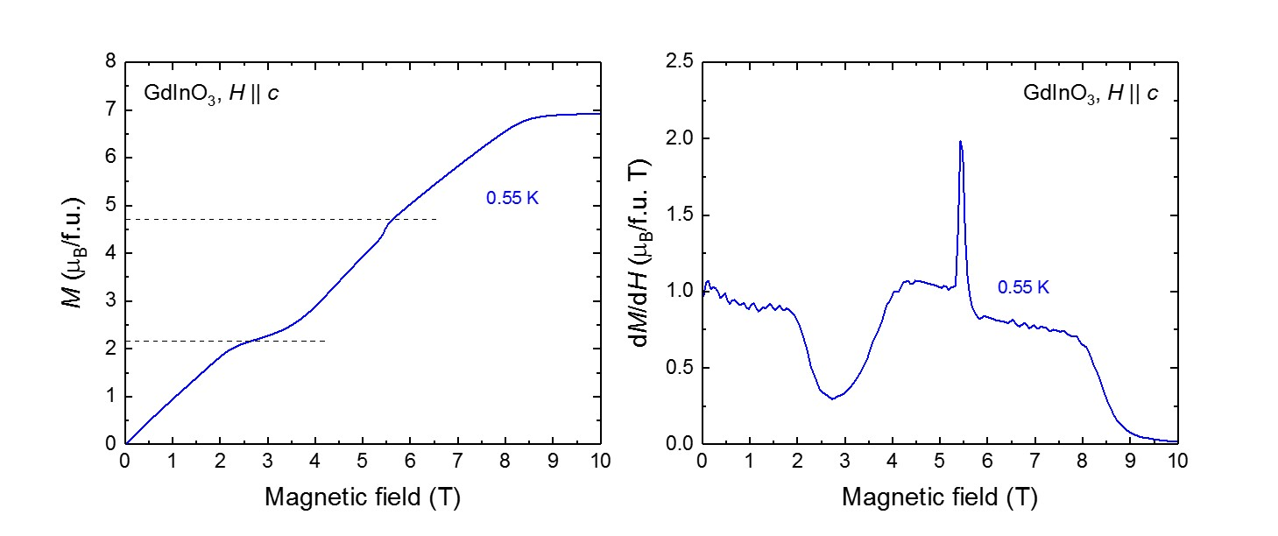
Conclusions
The pulse field data demonstrates two features at 1/3 and 2/3 of the saturation magnetization of GdInO₃. Such fractional magnetization features are characteristic of certain frustrated chain magnets [2] and quantum chain systems [3]. Combined with other measurements this data will help select a minimal spin model to model our magnetization behavior.

Acknowledgements
A portion of this work was performed at the National High Magnetic Field Laboratory, which is supported by National Science Foundation Cooperative Agreement No. DMR-1157490 and the State of Florida. The work at Rutgers University was supported by the Gordon and Betty Moore Foundation’s EPiQS Initiative through Grant No. GBMF4413 to the Rutgers Center for Emergent Materials.

References
[1] Geng, Y., et al., Nat. Mater. 13, 163 (2013).
[2] Hardy, V., et al., Phys. Rev. B, 70, 064424 (2004).
[3] Fortune, N., et al., Phys. Rev. Lett., 102, 257201 (2009).

