Search for Chiral Spin Wave Resonances in a High Mobility GaAs/AlGaAs
Heterostructure by Field-Swept Microwave Photoconductivity Spectroscopy
Tokarski, J., Bowers, C.R. (UF, Chemistry); Kovalev, A. (NHMFL); Reno, J.L. (Sandia); Maslov, D. (UF, Physics)

Introduction
There are two main mechanisms of spin orbit coupling (SOC) in semiconductor heterostructures: Dresselhaus and Rashba. In both cases, an electric field arises due to broken inversion symmetry. In the Dresselhaus case, inversion symmetry is broken by a non-centrosymmetric crystal lattice, as found in III-V semiconductors (e.g. GaAs). In the Rashba case, symmetry is broken by an interface between two dissimilar materials, e.g., between GaAs and Al_{x}Ga_{1-x}. Recent theoretical results, including those obtained in Maslov's group,¹ predict that a two-dimensional (2D) Fermi liquid (FL) with SOC supports a new type of chiral spin wave (CSW). We attempted to detect these CSWs in the high mobility 2DES in a GaAs/Al₀.₃Ga_{0.7}As heterostructure through a possible coupling to the microwave photoconductivity.
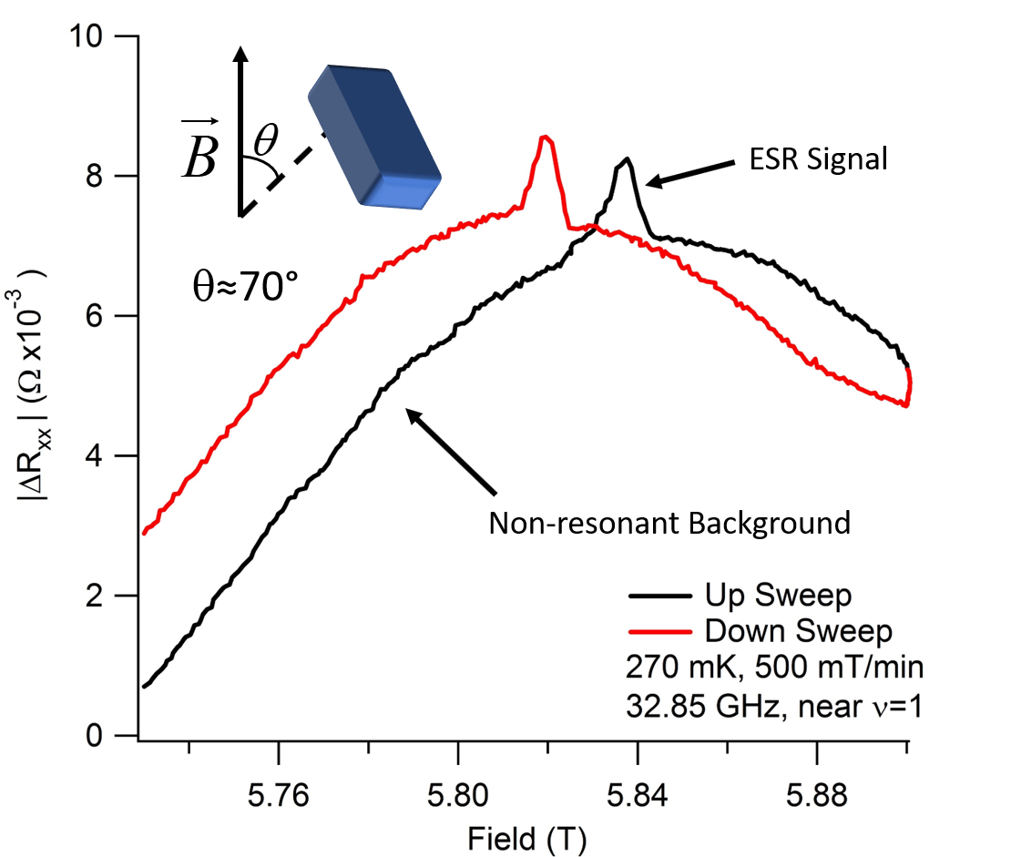 | 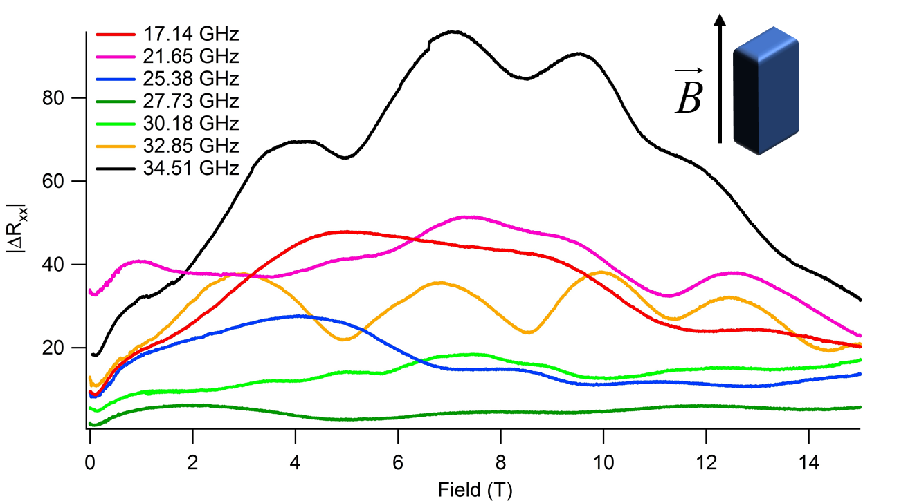
Fig. 1. Electrically detected ESR signal observed at a tilt angle of 70º at a temperature around ~50 mK. | Fig. 2. Field sweeps in the parallel magnetic field as a function of the microwave irradiation frequency.

Experimental
Experiments were performed in the NHMFL’s SCM-1 dilution refrigerator. A double lock-in detection technique was used in which the microwaves were amplitude modulated at a low frequency (7-30 Hz) while the DC current (100nA) was sine-wave modulated at around 1 kHz. The resistance change was recorded at various fixed frequencies ranging from 8-36 GHz. Measurements were repeated at several angles of the 2DES w.r.t. the static magnetic field ranging from the perpendicular (90°) to parallel (0°) orientations. The GaAs/Al_{0.3}Ga_{0.7}As heterostructure (sample EA129B) was provided by Sandia National Labs. Sample mobility and density were 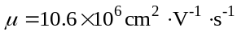 and 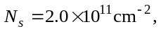 respectively. The microwave source was a phase-locked YIG oscillator (Micro Lambda MLOS 1392PA) with a tunable output of 8-20 GHz and frequency doubling amplifier (DBS model DB97-0426) with a 13 dBm output for experiments at higher frequencies.
Results and Discussion
The microwave-induced resistance changes acquired as a function of magnetic field with fixed microwave frequency are shown in Fig. 1. The ESR resonance is evident in the 90° and 70° near the 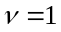 minimum. However, no resonances could be detected in the parallel orientation. However, one can see an oscillatory variation of the microwave induced magnetoresistance as a function of the static field with a period that decreases monotonically with decreasing microwave frequency.
Conclusions
The search was completed but with inconclusive results. While the microwave photoconductivity channel provides the means to observe the simple electron spin flips (g-factor around 0.41), no clear resonances could be detected in the parallel orientation. To rule out the possibility of cancellation between Rashba and Dresselhaus SOC, which have opposite signs, the experiments should be repeated in a symmetric quantum well structure.
Acknowledgements
A portion of this work was performed at the National High Magnetic Field Laboratory, which is supported by National Science Foundation Cooperative Agreement No. DMR-1157490 and the State of Florida. This work was also supported by the University of Florida Opportunity Seed Fund proposal OR-DRPD-ROF2017. Assistance from Dr. Lloyd Engel, who also provided access to instrumentation for pre-characterization of transport properties, is gratefully acknowledged.
Reference
[1] S. Maiti, V. Zyuzin, and D. L. Maslov, Phys. Rev. B, vol. 91, p. 035106, Jan 2015.

