ESR Study on the Electronic Structure of Transition Metal Penta-Telluride

Jiang, Y., van Tol, J., Smirnov, D. (NHMFL); Zhou, H.D. (U. of Tennessee, Physics); Dun, Z.L. and Jiang, Z. (Georgia Tech, Physics)

Introduction
A quantum spin Hall (QSH) insulator has topologically protected states that enable dissipation-less transport. Unfortunately, all the QSH insulators discovered to date possess a small band gap that is not useful for room temperature applications. Recently, transition-metal pentatellurides (ZrTe₅ and HfTe₅) have been predicted as possible candidates for hosting a large-gap QSH insulator phase in their monolayer form and three-dimensional topological insulators in the bulk [1]. Follow-up experimental investigations have also revealed an exceptionally low magnetic field for reaching the quantum limit and g factor as large as 24 [2]. The latter makes electron spin resonance (ESR) a suitable technique for a detailed study of their electronic structures.

Experimental
Thanks to its layered structure, HfTe₅ can be exfoliated to a thin layer by the Scotch tape method. The HfTe₅/tape composite was then placed in a Fabry-Perot cavity to enhance the measurement sensitivity. The cavity was coupled to the quasi-optical ESR spectrometer operating at 120, 240 and 336 GHz. Experiments were performed in a 12.5 T superconducting magnet and a continuous He-flow system at the EMR facility.

Results and Discussion
Fig.1 shows clear oscillation patterns in the measured ESR signals at three different microwave frequencies. Such oscillations could arise either from high-order cyclotron resonance (CR) or Shubnikov-de Haas (SdH) phenomena. Since CR requires the incident microwave frequency to match the energy spacing between Landau levels (LLs), the oscillation pattern depends on the ratio of the magnetic field and microwave frequency. On the other hand, SdH effect is associated with Fermi level moving across LLs, therefore it is only a function of the actual magnetic field. However, our data fail to meet either scenario. Specifically, the oscillations at 240 GHz and 336 GHz align only in the low normalized field region, but deviate from each other in the high normalized field region. In addition, the oscillations at 120 GHz exhibit a higher frequency compared to the other two frequencies (Fig.1). Such microwave frequency dependence of the ESR oscillation pattern has not been understood at this point. Further studies are needed.

Conclusions
We have performed ESR measurements on an emerging topological material, HfTe₅, and observed clear oscillation patterns as a function of both normalized magnetic field and magnetic field. The oscillation patterns exhibit puzzling frequency dependence, which cannot be interpreted as either SdH oscillation or CR. We plan to solve this mystery in future magnet sessions.

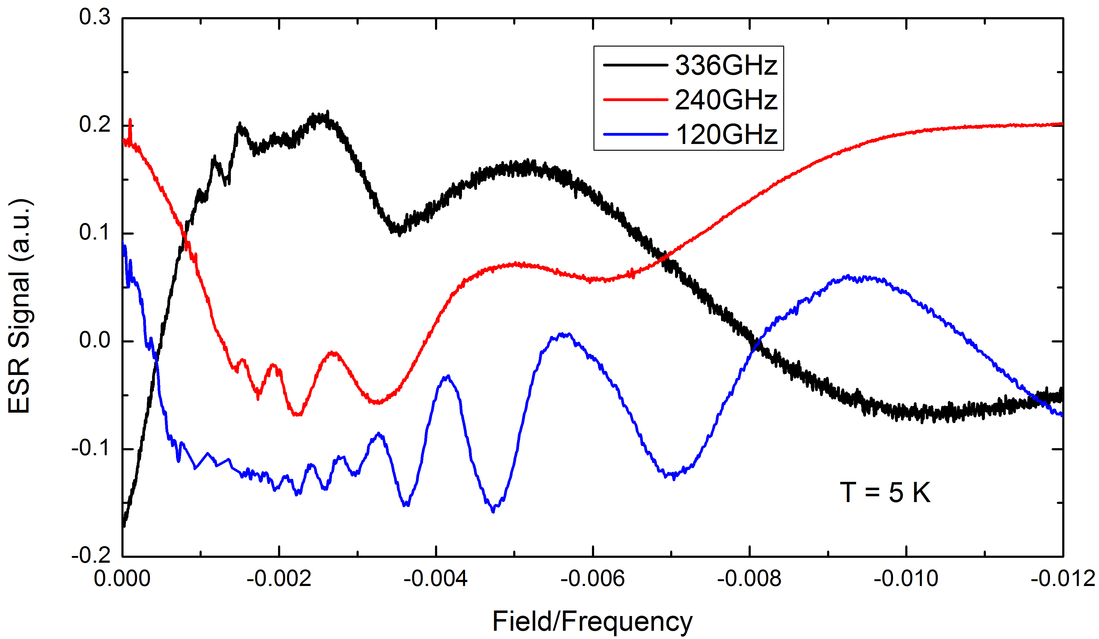
Acknowledgements
Fig.1 Oscillation pattern in ESR signal as a function of normalized magnetic field (after dividing by the microwave frequency). The measurements were taken at 5 K and at three different microwave frequencies. The curves are shifted vertically for clarity.
This work was primarily supported by the DOE (Grant No. DE-FG02-07ER46451). The HfTe₅ crystal growth at UT was supported by the NSF (Grant No. DMR-1350002). A portion of this work was performed at the National High Magnetic Field Laboratory, which is supported by National Science Foundation Cooperative Agreement No. DMR-1157490 and the State of Florida. Y.Jiang acknowledges the Jack Crow fellowship supported by the NHMFL.

References
[1] Weng, H., et al., Phys. Rev. X, 4, 011002 (2014).
[2] Jiang, Y., et al., Phys. Rev. B, 95, 045116 (2017).

